A Prescriptive Analytics-Driven Decision Support System for Pharmaceutical Demand Forecasting and Planning in MedShield Pharmaceutical Corporation

A Capstone Project Presented to the
Department of Information Systems
College of Information and Computing Sciences
University of Santo Tomas

In partial fulfillment
of the requirements for the degree of Bachelor of Science in Information Systems

Angeles, Ethan Gabriel C.
Atabelo, Kerr Lawrence T.
Benedicto, Adrian Lei M.
San Miguel, Keith Nicolai R.
Joseph Richard G. Catubag, MBA

May 2026
TABLE OF CONTENTS
Chapter 1: Introduction 8
1.1 Company Background 8
1.2 Project Context 9
1.3 Purpose and Objectives 11
1.3.1 General Objective 11
1.3.2 Specific Objectives 11
1.4 Scope and Limitations 12
1.4.1 Scope 12
1.4.2 Limitations 13
1.5 Conceptual Framework 13
1.5.1 Data Inputs 14
1.5.2 Process 14
1.5.3 Decision Support and Output 15
1.6 Project Milestones/Timeline 17
1.6.1 Capstone 1 (Proposal) 17
1.6.2 Capstone 2 (Implementation) 19
Chapter 2: Review of Related Literature, Studies, Systems, & Technologies 24
2.1 Review of Related Literature & Studies 24
2.1.1 The Pharmaceutical Industry in the Current Philippine Context 24
2.1.2 The Problem of Pharmaceutical Wastage 25
2.1.3 Importance of Digital Transformation in Sales Data 29
2.1.4 Data Analytics Applications 30
2.2 Review of Models and Technologies 31
2.2.1 Analytical Data Modeling: The Fact Constellation Schema 31
2.2.3 Seasonal Demand Forecasting in Pharmaceutical Supply 33
2.2.4 Epidemiological and Meteorological Data Integration 34
2.2.4.1 Engineered External Demand Features: DII and RSI 35
2.2.5 Pareto Principle and the 80/20 Analysis 36
2.2.6 ABC Analysis 37
2.2.7 Rule-Based Encoding for Area and Industry Types 38
2.2.8 Seasonal Forecasting and Regression Models 39
2.2.8.1 ARIMA and SARIMA 40
2.2.8.2 SARIMAX 41
2.2.8.3 Holt-Winters Exponential Smoothing 42
2.2.8.4 Facebook Prophet 43
2.2.8.5 Comparative Review of Seasonal Forecasting Models 44
2.2.9 XGBoost 46
2.2.10 Inventory Optimization: Economic Order Quantity, Reorder Point, and Safety Stock 49
2.2.11 Multi-Criteria Decision Analysis for Regional Prioritization 51
2.2.12 Linear Programming for Stock Allocation Optimization 52
2.2.13 Collaborative Filtering for Product-Region Matching 53
2.2.14 Alert-Based Analytics 54
2.2.14.1 Rule-Based Statistical Thresholding for Procurement Alerts 55
2.2.14.2 Scenario-Based Decision Alerts for Typhoon Contingency 55
2.2.15 Evaluation Metrics for Model Validation 56
2.2.16 Analytical Infrastructure: Tools and Technologies 57
2.3 Overview of Data Mining Process Frameworks 59
2.3.1 CRISP-DM 59
2.3.2 SEMMA 60
2.3.3 The Hybrid Application of CRISP-DM and SEMMA 61
2.4 Overview of Decision Support Systems 63
2.4.1 The Utilization of Decision Support Systems 64
2.4.2 Decision Support Application in Pharmaceutical Contexts 65
2.5 Synthesis 66
Chapter 3: Methodology 67
3.1 Data Gathering and Understanding 69
3.1.1 Data Sources 69
3.1.2 Research Framework: CRISP-DM + SEMMA 71
3.1.3 Data Collection and Integration Plan 75
3.2 Data Preparation 82
3.2.1 Data Source Layer 84
3.2.2 Staging Area 84
3.2.3 ETL Process 84
3.2.3.1 Extract 85
3.2.3.2 Transform 85
3.2.3.3 Load 86
3.2.4 Analytical Storage 86
3.2.5 Orchestration and Data Governance 87
3.3 Data Design: Fact Constellation Schema 87
3.3.1 Fact Tables 88
3.3.2 Dimension Tables 89
3.3.3 Schema Relationships 90
3.4 Business Analytics Framework 90
3.4.1.1 Descriptive Methods and Models 91
3.4.1.1.1 Rule-Based Encoding 91
3.4.1.1.1.1 Area Encoding 92
3.4.1.1.1.2 Industry Type Encoding 92
3.4.1.2 STL Decomposition 92
3.4.1.2.1 Sales Data Analysis 93
3.4.1.2.2 Seasonal Trend Analysis 93
3.4.1.3 80/20 Analysis 93
3.4.1.3.1 Customer Concentration Analysis 94
3.4.1.3.2 Product Prioritization 94
3.4.2 Predictive Analytics 95
3.4.2.1 Predictive Models 95
3.4.2.1.1 Facebook Prophet with External Regressors 96
3.4.2.1.1.1 Baseline Demand Forecasting 97
3.4.2.1.1.2 Disease-Adjusted Forecasting 97
3.4.2.1.1.3 Weather-Adjusted Forecasting 98
3.4.2.1.2 XGBoost 99
3.4.2.1.2.1 Product Performance Classification (ABC Analysis) 99
3.4.2.1.2.2 Demand Urgency Scoring 100
3.4.3 Prescriptive Analytics 101
3.4.3.1 Prescriptive Models and Alerts 101
3.4.3.1.1 Multi-Criteria Decision Analysis (MCDA) for Regional Prioritization 102
3.4.3.1.2 Linear Programming for Product Allocation Optimization 102
3.4.3.1.3 Economic Order Quantity 103
3.4.3.1.4 Reorder Point 104
3.4.3.1.5 Safety Stock 104
3.4.3.1.6 Collaborative Filtering for Product-Region Matching 105
3.4.3.1.7 Alert-Based Analytics 106
3.4.3.1.7.1 Rule-Based Thresholding 106
3.4.3.1.7.2 Typhoon Contingency Alerts 107
3.5 Risk Assessment and Mitigation 107
3.5.1 Project-Level Risk Management 107
3.5.2 Business Analytics Solution-Level Risk Management 110
3.6 Model Evaluation 112
3.6.1 Baseline Definition 113
3.6.2 Evaluation Metrics 114
3.7 Tools and Technologies 118
3.8 System Output 121
References 141
LIST OF EQUATIONS
(1) STL Decomposition 92
(2) 80/20 Analysis Cumulative Concentration 94
(3) Prophet with External Regressors 96
(4) Disease Intensity Indicator (DII) 97
(5) Lagged Disease Intensity Indicator (DII) 98
(6) Rainfall Severity Index (RSI) 98
(8) XGBoost Urgency Score 101
(9) MCDA Priority Score 102
(10) Linear Programming Objective Function 103
(11) Economic Order Quantity (EOQ) 104
(12) Reorder Point (ROP) 104
(13) Safety Stock Calculation 105
(14) Collaborative Filtering Cosine Similarity 105
(15) Rule-Based Procurement Alert 106
(16) Alert-Adjusted Demand Multiplier 106
LIST OF FIGURES
Figure 1.1 Conceptual Framework 14
Figure 1.2 Gantt Chart for Capstone 1 (Project Initiation) 17
Figure 1.3 Gantt Chart for Capstone 1 (System Analysis & Design) 18
Figure 1.4 Gantt Chart for Capstone 1 (Chapter 1-3 Documentation and Prototype) 19
Figure 1.5 Gantt Chart for Capstone 2 (System Creation) 20
Figure 1.6 Gantt Chart for Capstone 2 (Formulation of Chapter 4) 21
Figure 1.7 Gantt Chart for Capstone 2 (Formulation of Chapter 5) 21
Figure 1.8 Gantt Chart for Capstone 2 (System Integration and Final Consolidation) 22
Figure 1.9 Gantt Chart for Capstone 2 (Final Documentation and Submission) 23
Figure 3.1 Combined CRISP-DM + SEMMA Framework with BA Process 71
Figure 3.2 Portion of MedShield Sales Summary Report (2025) 75
Figure 3.3 An excerpt of Morbidity Week 53 of DOH EDCS data for 2025 76
Figure 3.4 FOI request for DOH epidemiological dataset 77
Figure 3.5 DOH epidemiological dataset as received via FOI (COVID-19 excerpt) 77
Figure 3.6 PAGASA Probabilistic Forecast (October 2026) 78
Figure 3.7 Excerpt of the Climate Data Request for Students and Researchers Form 78
Figure 3.8 Excerpt of PAGASA Daily Data for Tayabas, Quezon AWS 79
Figure 3.9 Data Pipeline 83
Figure 3.10 Data Model Design 88
Figure 3.11 MedShield Pharmaceutical Dashboard Home Page 121
Figure 3.12 Filter for Comparison 122
Figure 3.13 Overview Content Description of MedShield Dashboard 122
Figure 3.14 Historical baseline for revenue and net income 123
Figure 3.15 Monthly demand movement before forecasting 124
Figure 3.16 Territory share used for area planning and prioritization 125
Figure 3.17 Average seasonal pattern used by the forecast layer 125
Figure 3.18 Navigation Bar 126
Figure 3.19 Page Overview of Sales Diagnostic 126
Figure 3.20 Statistics Output of Sales Diagnostic 127
Figure 3.21 Monthly Revenue month-by-month breakdown 127
Figure 3.22 Quick view of yearly acceleration or slowdown 128
Figure 3.24 Page Overview of Product Prioritization 129
Figure 3.25 Unique Products Count, 80/20 Concentration Bands, Top Product 129
Figure 3.26 Top Revenue drivers and 80/20 Concentration 130
Figure 3.27 Product Classes Ranked by revenue contribution 131
Figure 3.28 Product Performance Table 132
Figure 3.29 Product and region matches 132
Figure 3.30 Page Overview of Area Prioritization 132
Figure 3.31 Area Prioritization Description 133
Figure 3.32 Territory revenue ranking used for region scoring 133
Figure 3.33 Net Income by Territory Profitability Comparison 134
Figure 3.34 Area Assignment Summary 134
Figure 3.35 Ranked regional priorities for procurement and sales action 135
Figure 3.36 Page Overview of Forecast Modeling 135
Figure 3.37 Simulated 2026 Demand Forecast 136
Figure 3.38 Seasonality Index: Months that lift or suppress baseline demand 136
Figure 3.39 External disease and weather signals used to adjust forecasts 137
Figure 3.40 Priority Product Forecasts for the Year 137
Figure 3.41 Model Evaluation Summary 138
Figure 3.42 Page Overview of Prescriptive Planning 138
Figure 3.43 Active Alerts 139
Figure 3.44 Scenario-based contingency actions 139
Figure 3.45 EOQ Reorder Recommendation 140
Figure 3.46 Page Overview of Data Upload 140
Figure 3.47 Uploading Sales CSV / JSON 140
Figure 3.48 Upload Status and Validation 141
LIST OF TABLES
Table 2.1: Year-by-Year Pharmaceutical Wastage Rate Trajectory Across Referenced Studies (Ethiopia case) 26
Table 2.2 MedShield’s Spoilage Impact Per Year during 2021-2025 period 28
Table 2.3 Comparative Summary of Seasonal Forecasting Models for Pharmaceutical Demand Forecasting 44
Table 2.4 XGBoost Application Roles in the MedShield DSS 47
Table 2.5 Inventory Optimization Models in the MedShield DSS 50
Table 2.6 Comparison of CRISP-DM, SEMMA, and the Hybrid Frameworks 61
Table 3.1 Mapping of CRISP-DM/SEMMA Phases to MedShield DSS Activities 72
Table 3.2 Data Collection Procedures by Source 79
Table 3.3 Project-Level Risk Management Matrix 108
Table 3.4 Business Analytics Solution-Level Risk Management Matrix 111
Table 3.5 Model Training and Evaluation Summary 116
Table 3.6 Tools and Technologies Summary 120

Chapter 1

Introduction
The chapter will present the Capstone Project Proposal's basic foundation, including MedShield Pharmaceutical Corporation's operational challenges as well as the suggested analytical fixes. It will outline the company's history, the particular issues with demand and inventory planning, and the strategic goals the project will seek to accomplish using descriptive, predictive, and prescriptive analytics. The approach and system design presented in the succeeding chapters will be based on the fundamental framework.
The pharmaceutical industry faces substantial obstacles in inventory management because its supply chain operations are complex and its medication distribution requires season-based scheduling based on demand forecasting. A cornerstone of effective inventory optimization, demand forecasting remains one of the most persistent obstacles facing organizations within the sector, particularly in emerging healthcare markets where data infrastructure and analytical capabilities are still developing, including MedShield Pharmaceutical Corporation. The company has moved from basic paper records to modern digital spreadsheet systems, which is what most other businesses in emerging healthcare markets do. The company experienced major analytical challenges after it transitioned its historical data system because these challenges stopped the business from discovering useful information in its historical records. The need for efficient decision-support systems that use historical data patterns, external epidemiological information, and advanced analytical methods has reached an urgent level. The capstone project will help MedShield achieve its strategic goal by developing data-driven demand forecasting solutions that will support its operations and will help it meet its December 2026 and beyond sales objectives.

1.1 Company Background
The company background will describe the organization's history, core ideals, and its operational scope, providing context for the system's deployment.
MedShield Pharma Corp. is a licensed pharmaceutical and medical supply distribution company, a single branch in Lucena, Quezon City that operates its main business activities in CALABARZON which is known as Region IV-A and in MIMAROPA which is known as Region IV-B, founded with the objective of catering to the ever-increasing need for a reliable and compliant healthcare supply chain in Southern Luzon. The company has built a strong reputation since its establishment which has allowed it to become a trusted name in healthcare services that supply various medical institutions and healthcare professionals. The company operates its business according to three core principles which include maintaining product integrity and adhering to legal standards and providing affordable access to all customers who need medical products and services.
The company distributes a wide range of health products which include prescription drugs and over-the-counter medications, ranging from generic medicines and branded drug products to vitamins and nutritional supplements, to even specialty drugs that treat chronic diseases and various medical supplies and devices. Their medical supplies also consist of consumable items which include syringes and IV sets and wound care materials and personal protective equipment (PPE) together with diagnostic equipment and monitoring equipment and hospital-grade infection control products. The diverse product range that MedShield Pharma Corp. provides allows the company to function as a complete procurement solution for healthcare providers who require various medical supplies.
Apart from distribution of healthcare products, MedShield also provides services to an ever-growing customer base, which includes healthcare organizations from both the public and private sectors. MedShield serves various clients, including government hospitals, district health centers, rural health units (RHUs), barangay health stations, private hospitals and clinics, specialty clinics, lying-in and maternity clinics, community pharmacies, non-government organizations (NGOs) that deliver health services, and local government units (LGUs) that purchase drugs and supplies for their communities. MedShield demonstrates its distribution capabilities by serving multiple clients who have different requirements for their delivery processes and their compliance with regulations.
The company's background output defines the size of operations used as input for the Project Context to identify specific operational needs.

1.2 Project Context
The project context will serve as the organization's current technical environment and the specific operational gaps the proposed system will bridge.
The Capstone Project Proposal will be a Decision Support System (DSS) based on analytics, designed to help transform MedShield Pharma Corporation’s current spreadsheet-based, manual inventory system into a more data-driven one. Being a distributor of pharmaceutical and medical supplies to healthcare clients in Regions IV-A and IV-B, the business caters to a complex chain of operations with varying costs of acquisition and fixed prices. The key gaps in the business operations, such as the continued shortage of supplies due to unpredictable demand and the huge financial losses due to expired medical supplies, are now attributed to the lack of a centralized digital platform, which has created a major problem for MedShield, making it difficult to maintain inventory health, monitor profit-expense bridges, and make informed procurement decisions. The Capstone Project Proposal will correlate PAGASA meteorological data and DOH health statistics to determine how weather-driven illness cycles drive fluctuations in pharmaceutical demand. As a result, these environmental elements will be required as external regressors to increase forecasting accuracy.
To assist in removing these operational limitations, the proposal’s goal will be to develop a DSS for MedShield, which will include predictive demand forecasting and prescriptive optimization. The technology will be able to recognize seasonal sales patterns, categorize products, and conduct 'what if' analyses, and will assist the company's management in making accurate decisions about the inventory, thus enhancing the company's efficiency and helping it meet its objective of to improve their decision-making to increase sales and collections, particularly for 2026.
The three levels of analytics that would be operational in the DSS will consist of the descriptive, predictive, and prescriptive analytics. 80/20 Analysis will be applied in the descriptive layer to rank observations by cumulative revenue contribution, while ABC classification will be carried out by the XGBoost classifier in the predictive layer. The DSS will also track seasonal peaks and the contributions of the regions to identify the time periods when net income is negative. Time series forecasting would be implemented in the predictive analytics domain based on the historical data from 2021 to 2025 to forecast the income. Also included will be forecasting demand increases in regional bidding cycles or health epidemics by using event-based forecasting. Lastly, prescriptive analytics will enable decision-making based on data-driven recommendations such as Restock Alerts, and "Stop Purchasing" recommendations for dead stock. All together, they will form a complete framework for decision-making that will enhance MedShield.
The project context will identify the operational needs that will be addressed through the structured goals outlined in the Purpose and Objectives section.

1.3 Purpose and Objectives
The Purpose and Objectives section will provide the purpose of developing a data-driven Decision Support System (DSS) for MedShield Pharmaceutical Corp. It will also include the objectives of the project that will be used as a guide in the development of the system. The purpose of the business analytics solution will also be highlighted, emphasizing its capability to utilize descriptive, predictive, and prescriptive analytics in analyzing the sales patterns of the products.

1.3.1 General Objective
To design and develop a Decision Support System (DSS) for MedShield Pharmaceutical Corporation that integrates descriptive, predictive, and prescriptive analytics by December 2026, in order to improve demand visibility and reduce expiry-driven wastage for MedShield's planning cycle for December 2026 onwards.

1.3.2 Specific Objectives
In order to achieve the general objective, the project will seek to attain the following specific objectives:
- To analyze MedShield's 2021–2025 sales performance across CALABARZON, MIMAROPA, and Bicol in order to establish a baseline for all subsequent analyses year-over-year per territory using STL decomposition in the Sales Diagnostic module.

- To identify MedShield's service territories and client accounts based on sales volume, revenue contribution, and demand growth in order to concentrate capital on revenue-driving SKUs and flag slow movers using 80/20 Analysis in the descriptive layer and ABC classification through the XGBoost classifier in the predictive layer in the Product and Area Prioritization modules.

- To forecast territory-level pharmaceutical demand for December 2026 and onwards and to provide weighted scoring for product urgency in order to allow procurement teams with quantified demand visibility using Facebook Prophet with DII (Disease Intensity Indicator) and RSI (Rainfall Severity Index) external regressors and XGBoost in the Forecast Modeling module.

- To optimize procurement decisions in order to reduce losses from expired stock and improve inventory turnover, targeting expiry-driven wastage ≤ 5% of the overall coverage baseline, using EOQ, ROP, and linear programming allocation under MCDA-weighted criteria (revenue rank, demand growth, outbreak risk) in the Prescriptive Planning module.

- To present five modules, i.e. Sales Diagnostic, Product Prioritization, Area Prioritization, Forecast Modeling, and Prescriptive Planning, in order to enable evidence-based procurement and inventory decisions for MedShield's December 2026 and future planning cycles, using a dashboard with CSV upload validation, PAGASA Signal-2 typhoon alerts, and collaborative filtering recommendations.

1.4 Scope and Limitations
The scope and limitations will define the boundaries of the Capstone Project Proposal, specifying the data parameters, geographical reach, and the inherent constraints of the analytical models. The defined scope and limitations will establish the boundaries within which the conceptual framework will operate.

1.4.1 Scope
The Capstone Project Proposal will examine MedShield Pharma Corp.’s sales records from 2021 to 2025 to identify demand patterns and seasonal variations, evaluate product success, and analyze other sales-related data, upon the proponents’ coordination with the client, and to capture sufficient historical information across different business cycles while working with the data that the company can provide. Additionally, the Capstone Project Proposal will focus on the operations within the Philippines, specifically covering CALABARZON (Region IV-A), MIMAROPA (Region IV-B), and the Bicol Region (Region V). The Capstone Project Proposal will draw on both the company's internal sales data, data originating from the businesses and industries which MedShield distributes its supplies, and relevant external information from Philippine health and weather authorities, namely, the Department of Health (DOH) and the Philippine Atmospheric, Geophysical and Astronomical Services Administration (PAGASA). Additionally, the project will utilize WeatherAPI for additional validation that will support the PAGASA data. The proposal will aim to produce forecasts and recommendations that will help the company achieve its goals by December 2026 onwards.

1.4.2 Limitations
The Capstone Project Proposal will be restricted to data provided for CALABARZON, MIMAROPA, and the Bicol Region, which may not reflect pharmaceutical trends in other Philippine regions. Furthermore, the proponents will be limited to a five-year historical dataset (2021–2025), representing the extent of the digital records provided by the client for modeling. Data integrity will also be constrained by the historical transition from manual paper records to digital spreadsheets, as unorganized or non-chronological legacy entries may affect model validity. Additionally, the predictive models will be limited by the granularity of DOH health data, which is primarily accessible at regional or provincial levels rather than facility-specific levels. The business analytics solution, which is in the form of a Decision Support, will also not be able to accurately forecast demand for new medical products, known as cold-start items, that lack sufficient historical sales data within the defined Capstone Project Proposal period. PAGASA data will be cross-validated against WeatherAPI to reduce dependency on a single meteorological source, but that WeatherAPI serves a supporting validation role only. Finally, the effectiveness of weather-based demand forecasting will be dependent on the specific data formats and the consistency of environmental records provided by PAGASA.

1.5 Conceptual Framework
The conceptual framework will illustrate the logical structure of the Decision Support System, detailing how raw data will be transformed into strategic insights through specific analytical models and tools.

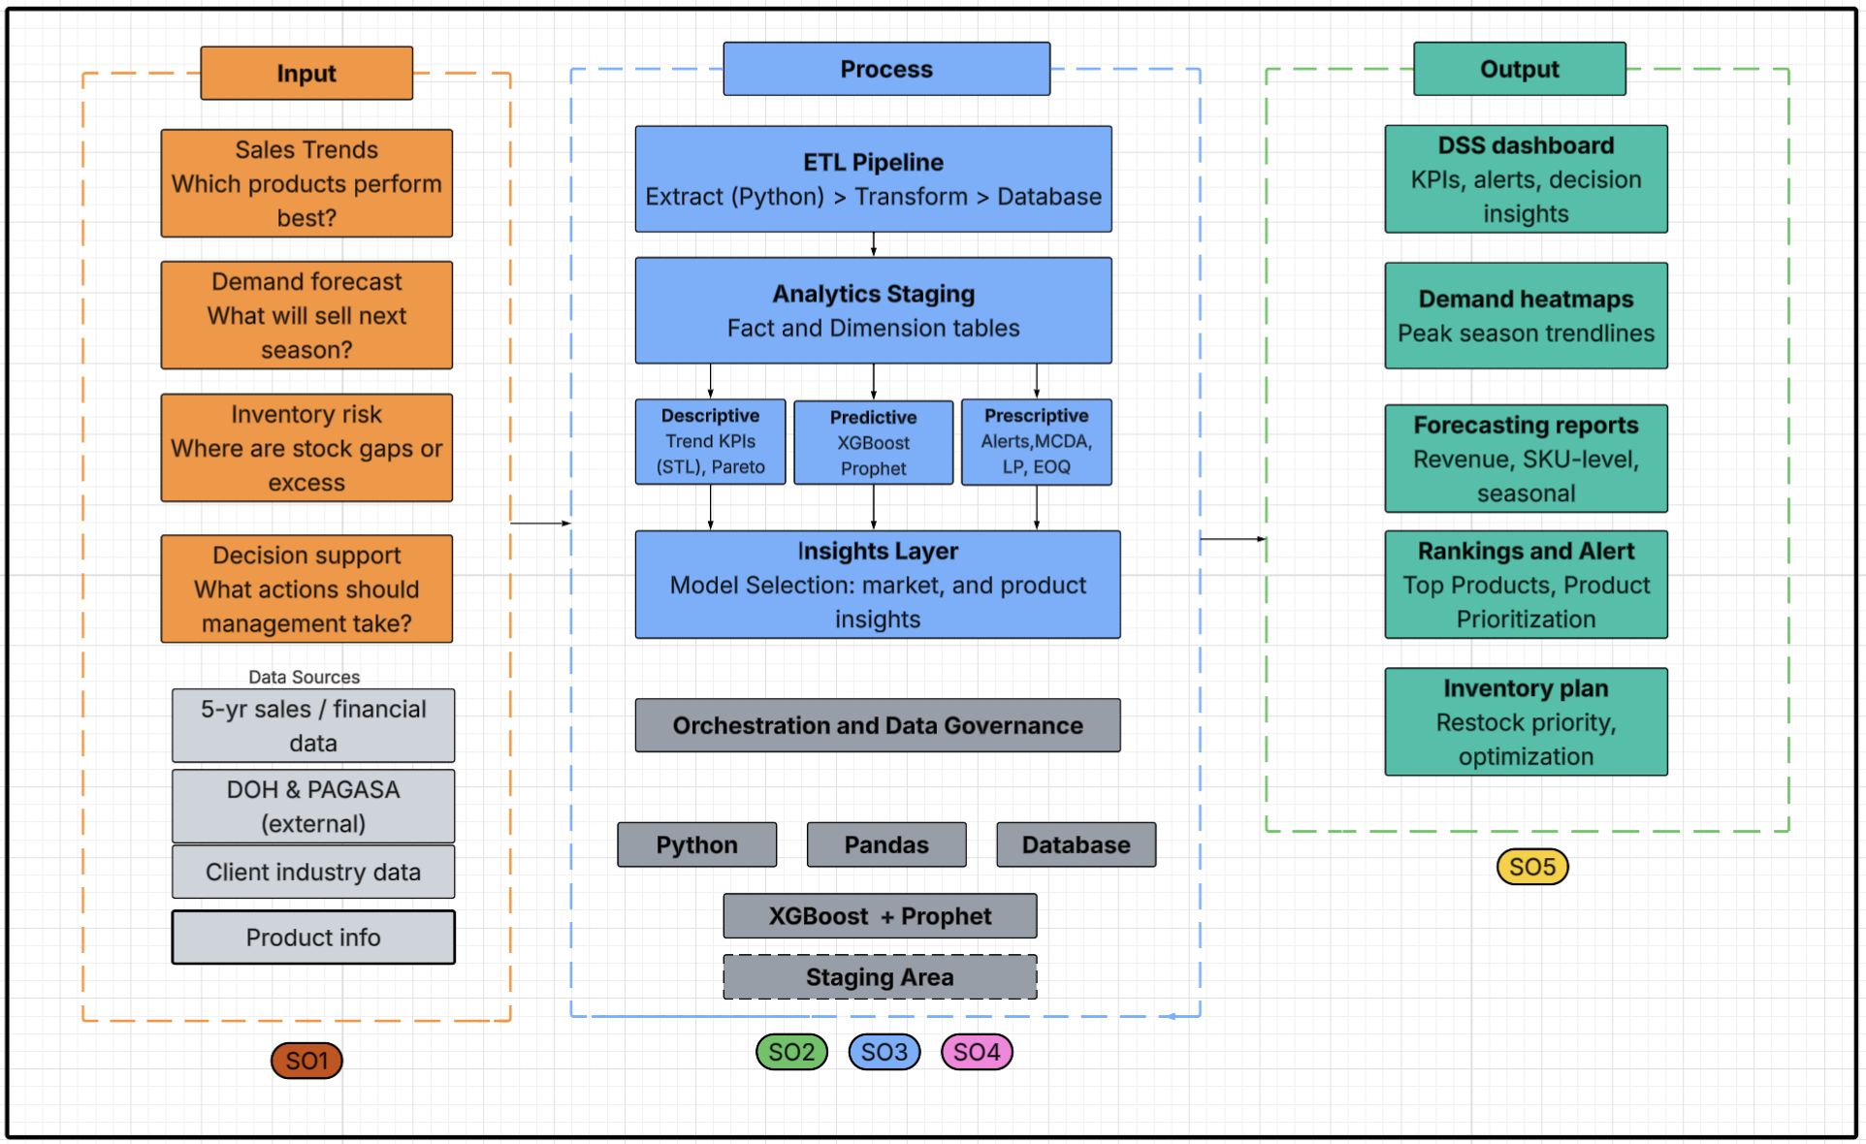
Figure 1.1 Conceptual Framework
Figure 1.1 will show the conceptual framework of MedShield Pharmaceutical Corporation's Decision Support System (DSS) and will give a concise picture of the flow of data through the business analytics solution's processing flow and will identify the core components of its sales strategy driven by analytics for inventory optimization.

1.5.1 Data Inputs
Some of the core business questions that will support the DSS's analytic capabilities include the following: “What products are performing best?”, “What will sell next season?”, “What product do we have too much or too little of?”, and “What are the corresponding business actions required?” Each question will be addressed with the help of one of four inputs: historical and financial data for the last 5 years, DOH & PAGASA environmental data, and a client name list. All future processing performed by the DSS will make use of all the inputs; for example, performance records as well as influences from outside the DSS will be factored into the analytics performed by the DSS.

1.5.2 Process
The process layer of the DSS will comprise four interrelated layers governed by the orchestration and data governance framework ensuring the structural integrity of the data throughout its flow. First will be the Data Pipeline with the ETL process (Extract, Transform, Load,) which will take in the input from all four sources via the use of Python scripts. Data will then be transformed to a uniform format before being loaded into a data store for further processing. Second, Analytics Staging will read from the data store and model data into dimension and fact tables in order to prepare the necessary environment for the models.
Third will be the analytic models themselves, operating on three dimensions concurrently:
- Descriptive Analytics: Utilizing STL Decomposition and 80/20 analysis to analyze current KPIs and seasonal trend patterns.
- Predictive Analytics: Projecting future performance based on data from XGBoost (for ABC) and Prophet models.
- Prescriptive Analytics: Generating recommendations for stock level adjustments through the MCDA, Linear Programming, EOQ calculation, and Collaborative Filtering for business alerts.
Finally, the Insights Layer will summarize the outputs of the three analytics models. Python, Pandas, database, XGBoost, Prophet and data staging will be utilized in the process layer.

1.5.3 Decision Support and Output
The Decision Support System (DSS) will produce five primary forms of outputs that will be viewed on a dashboard interface, providing actionable insights for MedShield’s management. First, the Sales Diagnostic will provide an easy-to-view summary of key performance indicators, alerts, and decision support insights for executive personnel. Second, the Area Prioritization will feature demand heatmaps that show which parts of each season peak to help prepare for and order during specific timeframes. Third, the Forecast Modeling module will give an outlook on estimated revenues, future demand for each SKU, and data on seasons and the trends that apply to them. Fourth, the Product Prioritization module will list products which sold the most and help management decide where to focus resources. Finally, the Prescriptive Planning module will outline the final inventory plan, detailing what products to restock and the optimal timing for procurement.
The conceptual framework establishes the technical and logical flow that will be realized according to the milestones detailed in the project timeline.

1.6 Project Milestones/Timeline
The MedShield Pharmaceutical Corp.'s Decision Support System will be designed according to a well-planned timeline, which will be divided into two major academic periods. The transition from the start of the proposal to the final implementation of the business analytics solution will be well-elaborated in the following subsections.

1.6.1 Capstone 1 (Proposal)
The Capstone 1 will be the proposal phase for the project, extending from January to May 2026, or during the second term of A.Y. 2025-2026. In the phase, the proponents will define the direction for the project by choosing an appropriate client, beginning a relationship with MedShield, and forming the theoretical base and methodology of the project. The chapters dealing with the introduction, review of related literature and methodology will be developed and finalized through discussions with the Technical Adviser (TA). By the end of the phase, a functional prototype will have been produced to show the feasibility of the Capstone Project Proposal. It will be followed by the mock and final proposal defenses.

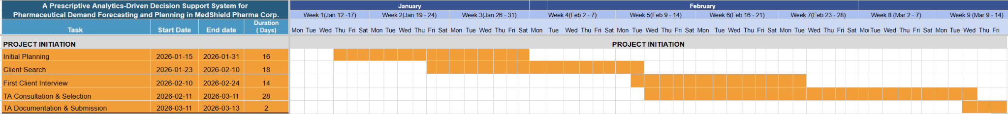
Figure 1.2 Gantt Chart for Capstone 1 (Project Initiation)

Figure 1.2 will show the fundamental activities of the Capstone Project Proposal that will constitute the major focus of the phase, which will be implemented from January to March 2026. The phase will comprise preliminary preparation, finding a proper customer, and initial interviews with MedShield. The selection of the Technical Advisor (TA) and submission of the project paperwork will constitute the end of the phase.
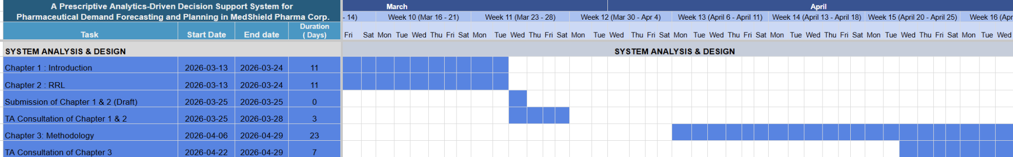

Figure 1.3 Gantt Chart for Capstone 1 (System Analysis & Design)
Figure 1.3 will show the second phase, to be implemented from mid-March to late April 2026, which will comprise the major academic foundation of the Capstone Project Proposal. In the phase, Chapter 3, which will comprise the methodology of the DSS, including the technological architecture and analysis, will be written. In addition, Chapter 1, which will comprise the introduction, and Chapter 2, which will comprise the review of related literature, will also be written.
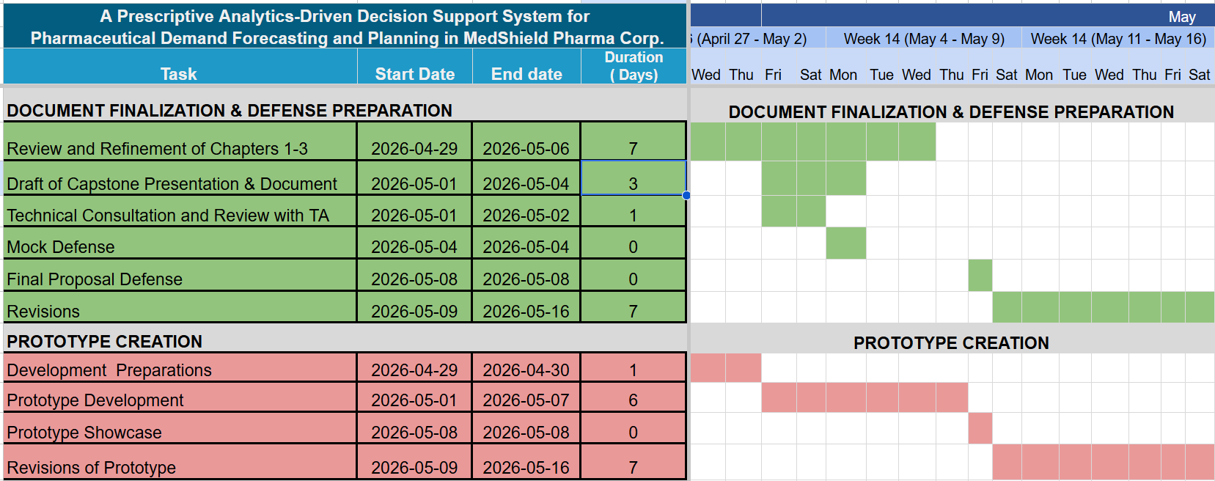

Figure 1.4 Gantt Chart for Capstone 1 (Chapter 1-3 Documentation and Prototype)

Figure 1.4 will be the third phase, which will define the period of early to mid-May 2026 and will constitute a transitional phase before the final proposal defense. In order to demonstrate the viability of the proposed analytics, a prototype will be designed in conjunction with the refinement of Chapters 1-3 and mock defenses with the TA.

1.6.2 Capstone 2 (Implementation)
Capstone 2 will be the implementation stage, from June through November 2026. The stage will be an expansion from a proposal into the development of the DSS, covering the term break and the majority of the first term of A.Y. 2026-2027. Specifically, the phase will include the completion of the development of the DSS, the presentation of the results and conclusions, the integration and acceptance testing, and the compilation and submission of the final capstone paper. Capstone 1 is also the basis for Capstone 2.
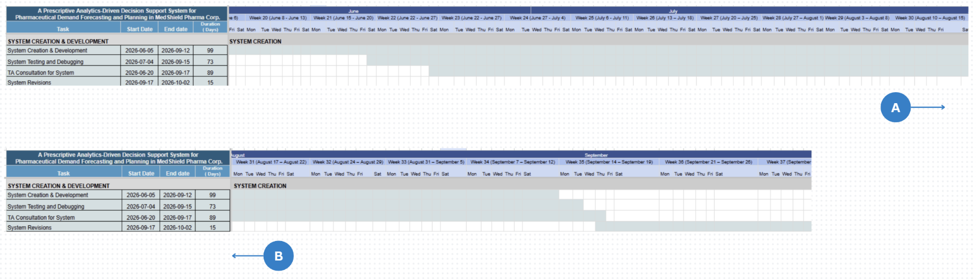

Figure 1.5 Gantt Chart for Capstone 2 (System Creation)

Figure 1.5 will be the beginning of the Capstone 2 era, ideally by June 2026 and is dedicated to the full-scale development of the MedShield DSS, including backend and frontend coding of the system, system testing, and debugging cycles with the help of iterative technical talks with the TA. Considering any unforeseen circumstances that may affect the development process, the project may be accomplished to no later than mid-September 2026, with revisions lasting until the start of October.

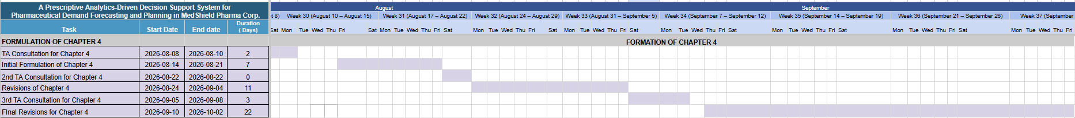
Figure 1.6 Gantt Chart for Capstone 2 (Formulation of Chapter 4)

Concurrent with the system development, Figure 1.6 will mark the results era of the Capstone Project Proposal from August to early October 2026. The results of the data-driven Capstone Project Proposal and the performance of the predictive and prescriptive models will be formulated in Chapter 4 of the Capstone Project Proposal. Iterative reviews by the TA will be a part of the stage to ensure that the interpretation of the data is correct.
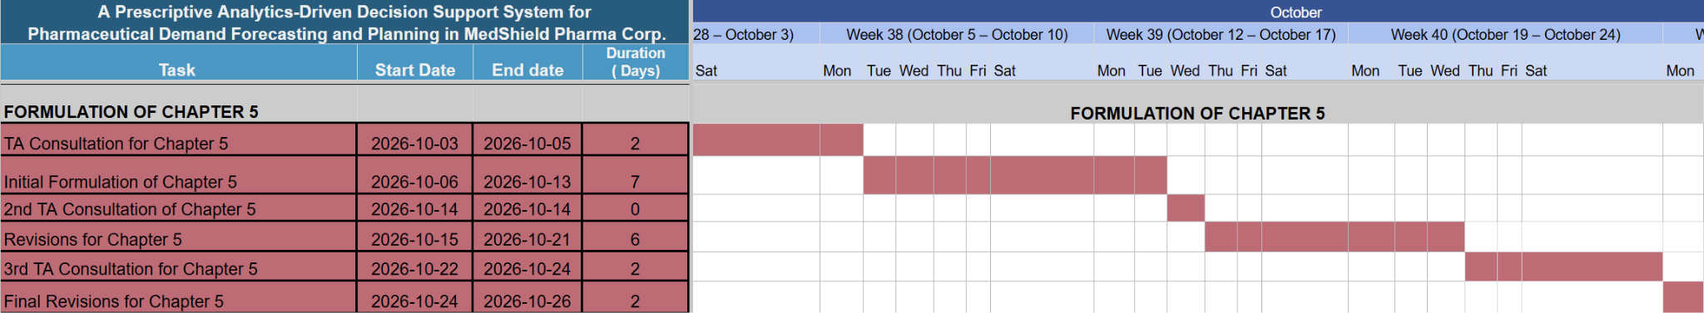

Figure 1.7 Gantt Chart for Capstone 2 (Formulation of Chapter 5)

Figure 1.7 will mark the synthesis era of the Capstone Project Proposal and focuses on the formulation of the Capstone Project Proposal's conclusions and suggestions based on the data collected in the Capstone Project Proposal and presented in the earlier chapters.
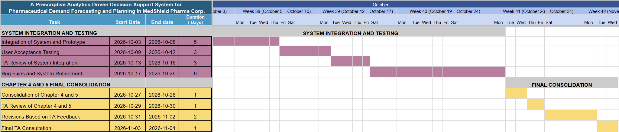

Figure 1.8 Gantt Chart for Capstone 2 (System Integration and Final Consolidation)

Figure 1.8 will mark the time of consolidating the different chapters and parts of the system into a whole in October and November 2026. the includes the final bug patches for the system and the inclusion of Chapters 4 and 5 into the complete narrative of the Capstone Project Proposal and User Acceptance Testing (UAT) for the Capstone Project Proposal, which will as well be simultaneous with the drafting of Chapter 5.

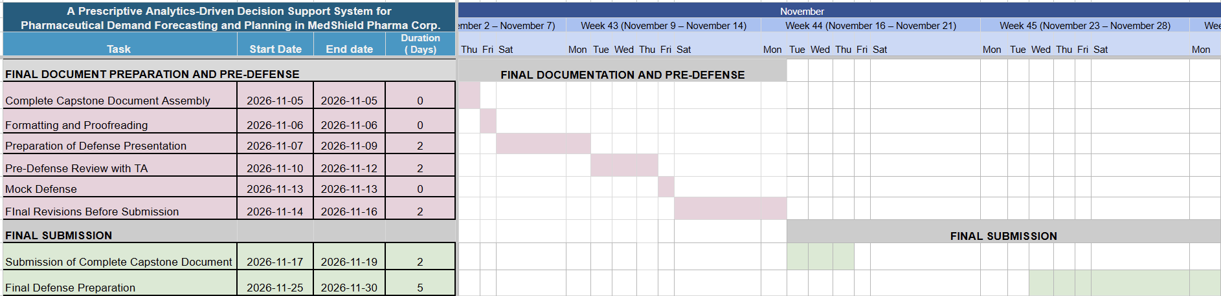
Figure 1.9 Gantt Chart for Capstone 2 (Final Documentation and Submission)

Figure 1.9 will mark the complete compilation of the capstone document and the submission of the completed document for the Final Defense in late November 2026.

Chapter 2

Review of Related Literature, Studies, Systems, & Technologies
The chapter will divide into relevant sections that help further understand the context of the proposed capstone project. It will synthesize current research on pharmaceutical demand analysis, decision support systems, data analytics methodologies, and implementation frameworks relevant to MedShield’s objective of achieving at least the December 2026 sales targets through data-driven insights.

2.1 Review of Related Literature & Studies
The section will present essential definitions and pharmaceutical industry frameworks that specifically apply to the Philippine context. The project proposal will connect these concepts to the client by showing how their organizational operations must adapt to various industry structures, regulatory frameworks, and market trends.

2.1.1 The Pharmaceutical Industry in the Current Philippine Context
The nature of MedShield’s operations is that it is a distributor of pharmaceuticals and medical supplies, and to understand further their business and its demand patterns, there should also be a thorough understanding of the pharmaceutical industry in the Philippines, and to be more specific, it should be within the lens of the procurement process. Abrigo et al. (2021) detailed how institutional structures, regulatory frameworks, procurement mechanisms, and budgetary constraints influence pharmaceutical supply chains in the public sector. Demand in pharmaceutical supplies was shaped here not by pure consumer preference but rather enforced by policy decisions in prioritization, such as which medications should receive the most funding and which industry type, such as which industry is most in need of supplies. In the case of MedShield, the company usually distributes and supplies its products to other hospitals and businesses. The procurement process which operates through government policies creates advantages for both public entities and private businesses. The policy decisions which establish drug pricing methods and reimbursement procedures and generic substitution practices and essential medicine lists directly affect pharmaceutical companies' sales performance and their inventory requirements. (Ball & Salenga, 2017). The foundational works establish that pharmaceutical demand in the Philippines cannot be understood solely through sales data, as contextual understanding of policy and industry purchasing patterns is essential for accurate demand analysis.

Likewise, the ongoing implementation of the Philippines’ Pharma Industry Roadmap, as reported by the Board of Investments (2025), revolves around a similar narrative. Government initiatives regarding manufacturing capacity, generic drug promotion, intellectual property considerations, and export promotion create a dynamic market environment where demand patterns may shift to respond to policy changes rather than purely clinical or consumer-driven factors, affecting organizations such as MedShield, in which such forecast methods operating must note potential policy-driven demand shifts.

2.1.2 The Problem of Pharmaceutical Wastage
One of the most quantifiable impacts of mismanagement of pharmaceutical inventory is medicine wastage, a reduction in pharmaceutical value by expiry, spoilage, or obsolescence. A crucial measure of supply chain performance, waste reflects the aggregate failure of forecasting, procurement, stock rotation, and inventory monitoring. Documented trends in pharmaceutical waste rates within public health systems provide crucial context regarding the role of data-driven decision support systems in supply chain management.

Outside the Philippines, in a case within the Federal Democratic Republic of Ethiopia, its Ministry of Health set the national pharmaceutical waste target at <2%, an accepted international standard for "Excellent" supply chain performance at all public health facilities (Federal Democratic Republic of Ethiopia, Ministry of Health, 2015). Even the low rates achieved by facilities under the Auditable Pharmaceutical Transactions and Services (APTS) program, as low as 1.1%, demonstrate that data-accountable systems can meet the benchmark and provide the evidence-based upper limit for best practice in pharmaceutical distribution (Mohammed et al., 2021). Despite the given threshold, medical facilities across Ethiopia show the same year-over-year increase in medicine waste without systematic support, rates consistently far exceeding the national target. Mohammed et al. (2021) tracked three years of pharmacy waste rates at public health facilities in Dessie, North East Ethiopia, from fiscal years 2015 to 2017. Overall waste rates increased year-over-year from 2.70% in Year 1 (2015) to 4.29% in Year 2 (2016), peaking at 4.53% in Year 3 (2017). Across the three years, the average rate of 3.68% and over USD 159,762.66 in lost pharmaceutical value. Expiration accounts for over 92% of waste in all three years of their Capstone Project Proposal; a finding that can be attributed to flaws in forecasting and intake planning, not storage or handling issues, indicating that facilities within the Warning band (3.6-5%) cannot self-correct their waste rates without some analytical intervention.

Table 2.1: Year-by-Year Pharmaceutical Wastage Rate Trajectory Across Referenced Studies (Ethiopia case)
Status | Wastage Rate | Year | Capstone Project Proposal Context | Key Driver | Source
Excellent (<2%) | 1.1% | 2014/15 | APTS-implementing hospitals, Amhara | Structured accountability and APTS data systems | Mohammed et al. (2021)
Excellent | <2% | National Target | All public health facilities, Ethiopia | HSTP-II government performance benchmark | Ministry of Health (2015)
Normal (2.1–3.5%) | 2.70% | CY 2015 (Yr 1) | Dessie public health facilities | Expiry dominant (92.05%) | Mohammed et al. (2021)
Warning (3.6–5%) | 4.29% | CY 2016 (Yr 2) | Dessie public health facilities | 59% increase from Year 1; escalation without intervention | Mohammed et al. (2021)
Warning (3.6–5%) | 4.53% | CY 2017 (Yr 3) | Dessie public health facilities | Continued rise; expiry >92% across all three years | Mohammed et al. (2021)
Warning (3.6–5%) | 4.8% | 2012–2014 (avg) | Federal & Addis Ababa hospitals | Systemic issues; ETB 11,078,910 lost | Guadie et al. (2023)
Critical (>5%) | 6.5% | EFY 2011 | South Gondar Zone, Ethiopia | Expiry (99.3%); poor forecasting and procurement | Guadie et al. (2023)
Critical (>5%) | 5.9% | EFY 2012 | South Gondar Zone, Ethiopia | Slight reduction; transient — no structural fix in place | Guadie et al. (2023)
Critical (>5%) | 6.5% | EFY 2013 | South Gondar Zone, Ethiopia | Rebounded to baseline; improvement did not sustain | Guadie et al. (2023)
Critical → Normal progression | 7.57% → 3.1% | EFY 2011–2013 | Hadiya Zone, Ethiopia (IPLS rollout) | IPLS implementation drove consistent reduction (−4.47 pp) | Guadie et al. (2023)

Guadie et al. (2023) showed a similar pattern in a wider regional Capstone Project Proposal: public health facilities in South Gondar Zone, Amhara Regional State, Ethiopia averaged 6.3% waste over three years. Their facilities clearly reside within the Critical band (>5%), with 6.5% in EFY 2011, dipping slightly to 5.9% in EFY 2012, then returning to 6.5% in EFY 2013. The 99.3% share of expired medicine and the transient nature of the decrease at EFY 2012 demonstrate that some small improvement in waste rate does not become systemic without an analytical foundation. Even well-resourced APTS baseline facilities in Federal and Addis Ababa had averaged 4.8% wastage over a three-year period (2012-2014), indicating ETB 11,078,910 in lost pharmaceutical value and nearing the Warning band threshold without data-driven assistance.

In stark contrast to these patterns, improvements did occur in medicine waste rates when the Integrated Pharmaceutical Logistics System (IPLS) implementation was strengthened. Wastage in facilities in Hadiya Zone declined from 7.57% to 6.44% to 3.1% over three years (EFY 2011-2013) with a system-driven improvement of over 4 percentage points attributable to enhanced logistics information systems (Guadie et al., 2023). An improvement only persisted where IPLS implementation remained strong; sites with reduced implementation sustained wastage above 5% as demonstrated previously. In the context of MedShield, the following presents company’s spoilage impact per year across the available five-year period (2021-2025):

Table 2.2 MedShield’s Spoilage Impact Per Year during 2021-2025 period
Year | Spoilage Loss | Profit w/o Spoilage | % of Revenue | % of Income
2021 | ₱707,419 | ₱51,305,100 | 0.90% (Excellent) | 1.40% (Excellent)
2022 | ₱323,736 | ₱42,461,899 | 0.51% (Excellent) | 0.77% (Excellent)
2023 | ₱13,070,577 | ₱58,702,095 | 17.46% (Critical) | 28.64% (Critical)
2024 | ₱3,970,033 | ₱32,195,088 | 6.76% (Critical) | 14.07% (Critical)
2025 | ₱3,388,510 | ₱94,024,701 | 1.83% (Excellent) | 3.74% (Warning)
TOTAL | ₱21,460,275 | ₱278,688,884 | 4.66% (Warning) | 8.34% (Critical)

Taken together, the findings of Mohammed et al. (2023) and Guadie et al. (2023) demonstrate three critical, data-driven insights that are relevant to the current operational context for MedShield. Firstly, that medicine wastage is a trackable metric that will predictably increase if not continuously monitored. Secondly, that expiration, a function of time, is not the sole reason for waste and that other components such as improved forecasting, monitoring of stock levels near expiry and inventory alert systems all influence expiration and wastage, which is manageable by a decision support system. Lastly, the reduction of medicine waste rates from year to year is possible if appropriate data-accountable systems are in place and properly utilized. For a distributor contracting to supply medications to institutions, directly managing medicine waste, rather than solely treating its financial repercussions, indicates an efficiency that is built on improved forecasting and inventory management systems, the core of the Capstone Project Proposal's intended contribution.

2.1.3 Importance of Digital Transformation in Sales Data
As a result of sudden shifts in demand and global disruptions, as well as addressing the problems of wastage in the supply chain, conventional methods of forecasting based on regression analysis and moving averages are becoming irrelevant in the pharmaceutical industry, which has undergone a transition from a manual-based process, which is known as digital transformation. The World Health Organization (2024), in its publication entitled Digital Transformation Handbook for Health Supply Chain Architecture, expands on the concept, noting that the resilience and accessibility of medications depend on shifting from manual spreadsheet models to a digital one. Sun (2025), in his work titled Data Analytics for Business Intelligence, further supports the idea by demonstrating that the new standard for converting raw data into actionable intelligence involves the fusion of cross-sector data (e.g., weather and health). Digital transformation helps provide better analytics in order to prevent the making of "ad hoc" purchases, which lead to considerable financial damage and drug shortages that can be seen today in pharmaceuticals, as Williams (2022) observes in Supply Chain Management (Elements of Quality and Safety in Healthcare).

The digital transformation of sales functions emphasizes the critical role of technology adoption in sales enablement. (Fahad & Kollwitz, 2025). Most businesses and organizations involved usually see themselves converting their paper records to digital format as essential progress, but in the case of MedShield, most of its operations are now recorded in digital spreadsheets. While such an upgrade represents significant infrastructure improvement, it lacks the analytical depth and systematic structure needed to extract meaningful patterns from historical sales data and identify opportunities for revenue optimization and according to the company, not all data have been transferred digitally and remain in the more manual, paper-based format.

Fahad and Kollwitz (2025) argue that organizations that merely digitize existing processes without redesigning for analysis fail to realize the full benefits of digital transformation and that a successful digital transformation requires analytical capabilities that convert raw transactional data into actionable insights, which directly supports MedShield’s need to evolve beyond spreadsheet recording toward structured decision support. MedShield's current state, which involves transactions digitized into spreadsheets but not yet structured for analysis, is an example of what Fahad and Kollwitz (2025) describe as the underperforming midpoint of digital transformation. The Capstone Project Proposal's response will not be further digitization but analytical structuring: the constellation schema designed in Chapter 3 will organize MedShield's transaction records into queryable fact and dimension tables, and the three-tiered analytics pipeline will convert those records into the descriptive summaries, demand forecasts, and procurement recommendations that constitute genuine decision support.

2.1.4 Data Analytics Applications
An analysis by Nguyen et al. (2021) examined data-driven applications in pharmaceutical supply chains that include demand forecasting, inventory optimization, supply chain visibility, cost reduction, and risk management, which identifies both established processes, such as regression and time series forecasting, combined with the emerging approaches of machine learning and artificial intelligence as viable in pharmaceutical contexts. However, there are still implementation challenges, including but not limited to data quality issues, difficulty integrating disparate data sources, organizational capacity limitations, and resistance to behavioral change when analytical recommendations contradict established practices. The challenges directly reflect MedShield's current situation and will be addressed through the data governance layer and the multi-source data alignment procedures detailed in Chapter 3.

Data-driven applications also use prescriptive analytics, which go beyond describing what happened or predicting what will happen by recommending specific actions and expected outcomes. (Lepenioti et al., 2019). The framework establishes that organizations seeking maximum value from analytics must progress to the prescriptive level, translating analysis into organized, data-driven insights that may provide reasonable actions. Such a hierarchy that consists of descriptive, then predictive, then prescriptive, will be the direct blueprint for Chapter 3's analytical architecture which is based on by Lepenioti et al. (2019). MedShield's DSS will not stop at summarizing past sales or predicting future demand and it will generate specific, actionable reorder quantities, territory priority scores, and procurement alerts that management can act on without additional analytical translation.

2.2 Review of Models and Technologies
The section will examine specific models, analytical methodologies, and technological platforms that enable modern pharmaceutical demand analysis and decision support, as well as assessing whether or not they are important and relevant to MedShield's organizational context. The technologies reviewed, from statistical methods to software platforms, will provide the practical foundation for implementing analytical capabilities for the next chapter.

2.2.1 Analytical Data Modeling: The Fact Constellation Schema
Before analytical models can operate on integrated data, that data must be organized into a schema that makes multi-dimensional queries efficient, avoids data redundancy, and can handle multiple categories of measurable events, in MedShield's case transactional sales records and external epidemiological and meteorological indicators, within the same analytical environment.
The fact constellation schema, also known as the galaxy schema, extends the conventional star schema by supporting multiple fact tables that share a common set of dimension tables. Kimball and Ross (2013) establish the constellation schema as the standard data modeling approach for enterprise analytics environments that must support multiple analytical subject areas, including sales performance, inventory management, and external risk monitoring, through a single integrated data store. the design enables analytical queries that cross-reference different categories of events without requiring redundant copies of the shared dimensional data, which is the defining analytical need of MedShield's DSS.
For MedShield, the constellation schema will comprise three fact tables, one for transactional sales events, one for external DOH and PAGASA indicators, and one for model-generated analytical results, all sharing four dimension tables organized by time, product, geographic area, and customer type. the design will enable the DSS to answer cross-dimensional analytical questions, such as how dengue incidence in a given province correlates with antiparasitic medication sales in the same period, through straightforward queries rather than complex data transformations at runtime.
2.2.2 Time-Series Decomposition: STL
Prior to training a predictive model on a pharmaceutical sales time series, a preliminary step that must be performed is to isolate and identify structural components (trend, seasonality, residuals) of the time series. Training a predictive model on a non-decomposed series is prone to blending a true seasonal demand pattern with short term randomness and single period demand shocks, resulting in a structurally misspecified forecast no matter how technically adept the model training methodology may be.
Seasonal and Trend decomposition using Loess (commonly abbreviated STL) can be utilized as an additive decomposition method. Introduced by Cleveland et al. (1990), STL is an iterative technique that isolates the three components-trend, season, and remainder-that comprise a time series. The trend is estimated by a locally weighted regression smooth, while the season is obtained by repeated application of a seasonal component estimate on the detrended data. The remaining variation, or remainder, is also known as residuals. One of the key features of STL is its robustness to outliers because the Loess smoother is locally weighted, meaning that a single erroneous value in a particular season will only have a local impact on the remainder estimate. the robustness makes STL an ideal component decomposition technique for pharmaceutical sales time series, where single period outliers such as event-driven demand spikes or seasonal marketing campaigns are common.
The relevance of STL for supply chain and logistics contexts is reinforced by the work of Wolny and Kmiecik (2025). These researchers applied STL decomposition to forecast error time series obtained from a third party logistics provider responsible for both pharmaceutical and household appliances distribution channels. Their Capstone Project Proposal determined that STL decomposition consistently isolates seasonal and trend components of error time series on both channels with non-systematic patterns and heterogeneous demand (pharmaceutical channels where seasonal demand is not systematically observed but trend components were identified on specific channels). These findings are a testament that decomposition must precede model training. It is when the systematic components that are not visible on a global aggregate performance metric like forecast error series that decomposition of the series yields informative components used in model construction. Further evidence for the approach is provided by Rekabi et al. (2025), who use STL-based demand prediction in a pharmaceutical supply chain network design context. They integrate a multi-objective optimization model for a pharmaceutical distributor with demand forecasting for customer demands that utilize the Loess-based seasonal-trend decomposition method in a forecasting horizon, ultimately leading to a reduction in shortage quantities on their network. Their Capstone Project Proposal emphasizes that STL-based demand forecasts are not just diagnostics for a series, but active generators of demand that improve subsequent supply chain models.
For MedShield, STL will be used to decompose the 2021-2025 monthly sales data for each product-territory combination. Trend component estimates will guide the revenue/volume outlook over time, reflecting the longer term demand trajectory in the sales diagnostics. Seasonal component estimates will determine what consistent recurring spikes exist in sales (e.g. December-January spike in antiparasitic medication demand with amihan season) and will be directly translated to structural seasonal components in the Prophet model's seasonality configuration. Residual component estimates will highlight anomalies in demand (e.g. outbreak-driven surges) that cannot be explained by systematic patterns, serving as a red flag for further governance evaluation. The components derived from the STL procedure are not terminal outputs in themselves; they are structural inputs that will form part of the predictive layer of analysis, as in the supply chain forecasting context explored by Wolny and Kmiecik (2025).

2.2.3 Seasonal Demand Forecasting in Pharmaceutical Supply
Martinez (2018) examines seasonal cycles of infectious diseases and epidemiological patterns with fundamental evidence where pharmaceutical demand exhibits strong seasonal variation driven by disease incidence patterns. The research demonstrates that specific product categories show pronounced seasonality. For example, respiratory treatments for cough, such as suppressants or expectorants, peak during the winter flu season, while gastrointestinal treatments are popular during warmer months when bacterial gastroenteritis incidence increases, while antihistamines, on the other hand, are mostly sold during the spring allergy season. the directly supports the pattern observed in MedShield, with the Antizoal IV infusion among the highest-selling products in the December-January period from 2021-2025, driven by increased sales of treatment for bacterial infections. The Capstone Project Proposal proves that pharmaceutical products’ demand forecasting does not assume constant demand throughout the seasons, and seasonality has to be explicitly included in the model. To understand the patterns, it is not enough to look at historical sales.
Dela Cruz et al. (2025) present a data-driven approach to forecasting medical supply shortages and preventing overstock situations based on case Capstone Project Proposal evidence from SLU-Sacred Heart Medical Center. Their research proves the effectiveness of analyzing historical patterns, seasonal patterns, and external factors in enhancing the accuracy of forecasting, which in turn decreases the chances of shortages and overstocking. The authors suggest the importance of data-driven forecasting over intuitive forecasting, which is supported by empirical evidence proving the effectiveness of quantitative forecasting over expert opinion forecasting. The results of the case Capstone Project Proposal showed a 34% reduction in shortage cases and a 28% reduction in obsolete stock when moving from traditional forecasting to data-driven forecasting. Critically, these studies validate the capstone project's proposed approach of integrating external data sources with internal demand history, demonstrating that forecast models incorporating external variables significantly outperform models using demand data in isolation.

2.2.4 Epidemiological and Meteorological Data Integration
The Philippine Department of Health (DOH) provides detailed epidemiological data documenting disease incidence patterns across regions that include external data sources informing pharmaceutical demand forecasting. These external sources are helpful in integrating with operational systems that improve decision-making effectiveness in healthcare contexts. (Tiongson & Kummer, 2020). For MedShield, DOH data on respiratory infection incidence, gastrointestinal disease outbreaks, and seasonal disease patterns provides external validation and context for historical sales data. When respiratory infection incidence increases in specific regions, corresponding increases in cough suppressant and antipyretic demand logically follow. By incorporating DOH epidemiological data into demand models, MedShield can improve forecast accuracy by capturing demand drivers beyond historical patterns alone.
Attadjei et al. (2018) examine decision phases within supply chain management and propose frameworks integrating external information sources with internal operational data. the implies that pharmaceutical distributors like MedShield can utilize epidemiological data, meteorological data, and policy data in conjunction with internal data regarding sales. the multi-source integration creates more robust forecasting models that capture demand drivers operating at different system levels, from individual disease patterns to national policy decisions. The capstone project implements the multi-source approach by combining MedShield's 2021-2025 sales data with DOH epidemiological information and PAGASA weather data to create demand models accounting for diverse demand drivers.
Applying the multi-source approach, raw DOH disease case counts and PAGASA rainfall probability forecasts will not be used directly in the Capstone Project Proposal but are converted to two engineered variables, namely, the Disease Intensity Indicator (DII) and Rainfall Severity Index (RSI), that scale the raw external signals to a regional baseline of historical data and render them as indices appropriate for the external regressor component of the forecasting model. The DII accounts for the degree to which disease activity in the current region/time instance deviates from expected historical levels, and the RSI categorizes meteorological risk based on the likelihood of above-normal rainfall. Further explanation of the DII and RSI will be discussed further in the section below.

2.2.4.1 Engineered External Demand Features: DII and RSI
Epidemiological and meteorological data do not arrive in a form that can be passed directly to a forecasting model. DOH PIDSR records are reported as raw weekly case counts by disease type and region; PAGASA data is structured as probabilistic rainfall forecasts expressed as percentage probabilities across different outcome categories. Before these external sources can function as model inputs, they must be transformed into normalized, model-compatible feature representations.
Feature engineering, the process of constructing new analytical variables from raw data that capture domain-relevant signals in a format appropriate for the model at hand, is a fundamental step in applied machine learning and forecasting practice. Specifically for pharmaceutical demand forecasting, Nguyen et al. (2021) have identified engineering external context features as having one of the largest effects on the accuracy of supply chain forecasts. The Disease Intensity Indicator will be defined as the normalization of the number of cases in a given time period, region, and disease by the historic number of cases for that given region and disease to create a unit-less indicator of relative activity relative to one. A lagged version of the indicator will also be constructed to account for the delay between disease onset and observable changes in pharmaceutical procurement. The Rainfall Severity Index will be constructed from PAGASA probabilistic forecast data and classified into low, moderate, and high risk tiers that serve as a categorical regressor in the Prophet model. Both features will be constructed during the ETL transform stage and stored within the analytical schema, ensuring that the engineered values are auditable and consistently available to all analytical layers.

2.2.5 Pareto Principle and the 80/20 Analysis
Juran (1954) established 80/20 analysis from the Pareto principle as a descriptive concentration tool, observing that a small proportion of inputs consistently accounts for the majority of outcomes. His formalization grounded the 80/20 Analysis as a ranking and diagnostic instrument for management decision-making, distinct from any classification or labeling function. Puruhito and Falani (2021) demonstrate the application of 80/20 principle as a descriptive ranking tool for pharmaceutical supply management, enabling organizations to identify which products require detailed forecasting attention and which can be managed through simpler approaches. Their findings confirm that the Pareto principle surfaces revenue concentration patterns across a product portfolio, enabling focused analytical effort on high-impact items while applying simpler approaches to low-impact ones. This is consistent with the objective of MedShield to optimally handle hundreds of different drugs, with high levels of forecasts required for top-selling drugs such as paracetamol, cough medicines, and antibiotics, while less refined approaches are applied to slow-moving specialty drugs.
Dela Cruz et al. (2025) further demonstrate the applicability of data-driven ranking approaches to Philippine pharmaceutical supply chains, confirming that concentration-based analysis of medical supply data surfaces actionable prioritization insights for inventory planning. Their findings establish that identifying which products drive the majority of revenue or consumption is a prerequisite for effective stock management and shortage prevention in the Philippine healthcare distribution context.
In Chapter 3, the 80/20 Principle will serve a strictly descriptive role, ranking MedShield's full product portfolio of 3,631 SKUs and its client accounts by cumulative revenue contribution to surface concentration patterns. The analysis will reveal that the top 80% of revenue is driven by a concentrated group of products, with the remainder contributing progressively less. These revenue concentration findings will serve as reference data for the XGBoost product performance classifier in the predictive layer, and the top revenue-contributing products identified will inform inventory prioritization and replenishment planning in the prescriptive layer. The output of this analysis is strictly descriptive, cumulative revenue rankings and concentration patterns. No categorical labels or performance groupings are assigned at this stage; those outputs are produced by the ABC classifier in Section 3.4.2.1.2.1.

2.2.6 ABC Analysis
Juran (1954) introduced ABC inventory classification as a distinct downstream step that follows from contribution ranking, treating the two as separate analytical functions with different purposes. First, the 80/20 analysis ranks by cumulative contribution, then ABC governs inventory policy through categorical groupings. Flores and Whybark (1986) further establish ABC Analysis as a formal multi-criteria classification framework whose categorical outputs, A, B, and C designations, are predefined based on cumulative revenue contribution thresholds and directly determine differentiated inventory policies across the product portfolio. Umadevi and Umamaheswari (2023) demonstrate that combining ABC Analysis with VED classification in a hospital pharmacy context produces an operationally complete product prioritization system, confirming that ABC groupings directly inform procurement frequencies and safety stock levels. Their findings establish that ABC classification produces actionable categorical outputs that govern downstream inventory decisions, reinforcing its role as a classification framework distinct from the descriptive concentration patterns surfaced by 80/20 Analysis alone.
In Chapter 3, ABC classification will be carried out exclusively by the XGBoost product performance classifier in the predictive layer, not by the traditional 80/20 Analysis. While products with sufficient sales history can be ranked by the principle, new and low-history SKUs lack sufficient transaction records for direct rankings. XGBoost addresses this gap by learning the relationship between a product's observable features and its observed revenue performance, then independently assigning ABC groupings to all 3,631 SKUs. As they are predefined revenue concentration bands grounded in the Pareto principle, and as Juran (1954) established, ABC classification is a downstream step with predetermined category boundaries rather than an unsupervised grouping exercise such as k-means which would produce clusters optimized for feature similarity rather than business-meaningful revenue thresholds, potentially misaligning inventory policy with actual sales performance. In the prescriptive layer, the ABC groupings produced by XGBoost and its urgency scores will jointly determine which products receive reorder recommendations, ensuring that inventory optimization effort is concentrated on the SKUs where it produces the greatest financial return.

2.2.7 Rule-Based Encoding for Area and Industry Types
Before any analytical model can be trained or evaluated on MedShield's sales data, each transaction record must carry a consistent, machine-readable label for the geographic territory it belongs to and the institutional customer type it was sold to, which is not a classification problem in the machine learning sense, because the labels are not being predicted or discovered; they already exist as structured fields in MedShield's sales records. The task is encoding: converting those pre-existing categorical fields into a standardized, queryable format that all downstream analytical layers can consume consistently.
Dong and Liu (2018), in their foundational treatment of feature engineering for machine learning and data analytics, define categorical features as variables whose domain is a set of discrete values with no inherent order among them, and establish that categorical features require specialized handling before they can serve as inputs to analytical models. They note that care is particularly needed when representing categorical variables numerically, because any numerical assignment implies an ordering relationship that is typically meaningless for nominal categories. Geographic delivery territories such as Batangas, Quezon, or Marinduque carry no inherent rank relative to one another; neither do institutional customer types such as Government, Hospital, or Pharmaceutical. Both sets of categories are nominal by definition. Bolikulov et al. (2024) establish that for nominal categorical data where no semantic ordering exists among categories, the encoding method must preserve the independence of each category without imposing false numerical relationships between them. When categories are fully predefined and exhaustive within a structured source field, as they are in MedShield's sales records, the encoding task reduces to a direct lookup: matching each record's source field value to its corresponding standardized label using a fixed mapping table. No algorithm is required, and no discovery is involved.
Attadjei et al. (2018) establish that stable, auditable classifications derived from structured operational data are a prerequisite for decision-support systems in procurement-sensitive environments, where practitioners who hold procurement authority must be able to trace and verify every system output. the auditability requirement is what makes deterministic rule-based encoding the appropriate method here over any algorithmic alternative. Applying an unsupervised method such as clustering to pre-labeled data would be methodologically circular, producing groupings that already exist by definition in the source fields rather than revealing any new structure. Applying a supervised classifier would be unnecessary overhead, since classifiers are designed for situations where labels must be inferred for unlabeled inputs, not retrieved for inputs that already carry the label in a structured field. Amuta et al. (2022) further demonstrate that territory classification based on a combination of epidemiological and market criteria produces more actionable territory management decisions than purely volume-based rankings, because it surfaces territories where demand is likely to grow due to disease dynamics rather than waiting for growth to appear in historical revenue figures.
For MedShield, the area and customer type encodings produced by the step will form the geographic and institutional dimensions of the descriptive analytics layer, enabling the system to disaggregate sales volume, revenue contribution, and demand behavior by territory and buyer type. These encoded labels will also feed directly into the downstream predictive and prescriptive layers, where they serve as segmentation keys for territory-level Prophet forecasts, customer concentration inputs to the 80/20 Analysis module, and regional priority inputs to the MCDA scoring model.

2.2.8 Seasonal Forecasting and Regression Models
Pharmaceutical demand is shaped by recurring seasonal cycles, long-term trends, and episodic demand shocks driven by disease outbreaks and weather events. Time series forecasting models are the appropriate primary engine for demand projection in MedShield's DSS. The models reviewed in the subsections below represent the primary seasonal forecasting approaches that will meet MedShield's specific data environment requirements. A baseline demand forecast, which will be generated solely from MedShield's internal sales history without any external regressor inputs, will serve as a necessary reference point across all model evaluations. Without a baseline, it will be impossible to quantify how much of the forecasting accuracy will be attributable to external epidemiological and meteorological signals, and how much would have been achieved by historical patterns alone. The baseline forecast will also serve as the fallback mode of the deployed system when external data is unavailable or has not yet been refreshed for the current period.

2.2.8.1 ARIMA and SARIMA
The AutoRegressive Integrated Moving Average model, formalized within the Box-Jenkins framework by Box and Jenkins (1970), was the dominant approach to time series forecasting for several decades and remains a standard baseline in pharmaceutical demand forecasting literature. ARIMA characterizes a time series through three parameters, the autoregressive order p, the degree of differencing d required to achieve stationarity, and the moving average order q, and produces forecasts by modeling the linear relationship between a current observation and its own lagged values and lagged forecast errors. The model requires the series to be stationary, meaning that its mean, variance, and autocorrelation structure must not change over time, and achieves the through differencing when the raw series is non-stationary.
SARIMA extends ARIMA by adding a seasonal component, introducing an additional set of parameters, including P, D, Q, and the seasonal period m, that capture the autocorrelation structure at seasonal lags. Bacani et al. (2024) demonstrate SARIMA's practical effectiveness in a Philippine pharmaceutical context through the BOTika system, where properly specified SARIMA models achieved a mean absolute percentage error of 8–14% and contributed to a 31% reduction in stockout incidents and a 19% reduction in inventory carrying costs. Burinskiene (2022), in a Capstone Project Proposal of forecasting models constructed specifically for the pharmaceutical retail sector in Lithuania, establishes that ARIMA-class models deliver acceptable short-term accuracy under relatively stable demand conditions but show degraded performance when prescription drug sales fluctuate irregularly across planning periods, a condition structurally analogous to MedShield's multi-territory, multi-product environment where disease-driven demand surges and policy-driven procurement shifts produce irregular variation that Box-Jenkins differencing cannot fully absorb.
However, SARIMA's suitability for MedShield's specific data environment is constrained by three structural limitations. First, it assumes stationarity, which MedShield's five-year sales history does not consistently exhibit, as the presence of multiple overlapping seasonal cycles, trend shifts coinciding with the post-COVID demand recovery, and episodic disease-driven demand spikes all represent forms of non-stationarity that differencing alone cannot fully address. Second, SARIMA accommodates only a single seasonal period, whereas MedShield's data exhibits both intra-year seasonality driven by disease cycles and multi-year demand trajectory shifts that a single seasonal parameter cannot simultaneously represent. Third, SARIMA cannot incorporate external regressors, meaning that the epidemiological and meteorological signals central to the Capstone Project Proposal's forecasting design cannot be used within a SARIMA framework without extending it to SARIMAX, reviewed in the following section.

2.2.8.2 SARIMAX
SARIMAX, or Seasonal AutoRegressive Integrated Moving Average with eXogenous variables, extends SARIMA by incorporating one or more external input variables as additional regressors alongside the model's internal autoregressive and moving average terms. the extension is the most direct statistical analog to the forecasting design proposed in the Capstone Project Proposal, where DOH disease incidence indicators and PAGASA rainfall severity signals are incorporated as external regressors alongside MedShield's internal sales history. Evaluating SARIMAX is therefore essential to establishing why Prophet was selected over the natural statistical extension of the SARIMA baseline.
Hyndman and Athanasopoulos (2021) demonstrate that SARIMAX outperforms pure SARIMA models when external variables carry genuine causal information about demand variation that is not already encoded in the series' lagged values. In pharmaceutical contexts, Fattah et al. (2018) apply the non-seasonal variant (known as ARIMAX) to pharmaceutical demand forecasting and find that models incorporating external demand drivers achieve forecast accuracy improvements of 12–19% over pure time series baselines, supporting the general principle that external regressor integration adds meaningful predictive value when the regressors are causally related to the outcome. Burinskiene (2022) reinforces the in the pharmaceutical retail context, demonstrating that forecasting models that account for external influences on drug demand, including seasonal disease patterns and prescribing policy changes, consistently outperform internal-data-only approaches across multiple planning horizons, directly motivating the external regressor design of the Capstone Project Proposal's forecasting architecture.
Despite these advantages, SARIMAX inherits the core limitations of the SARIMA framework, which constrain its suitability for MedShield. The stationarity requirement applies not only to the endogenous sales series but also to the exogenous regressors themselves, meaning both the DII and RSI inputs would require stationarity testing and potentially transformation before use, adding complexity to the data preparation pipeline. SARIMAX retains the single-seasonality constraint of SARIMA, leaving MedShield's multi-seasonal demand structure only partially captured. Parameter identification through ACF and PACF analysis requires statistical expertise and becomes substantially more complex when external regressors are present, increasing the risk of misspecification in a multi-SKU forecasting environment with 3,631 products. Finally, the exogenous regressors in SARIMAX enter the model as linear additive terms, which may inadequately capture threshold and interaction effects, such as the non-linear demand surge observed when disease incidence crosses a critical level, which the DII and RSI are designed to capture.

2.2.8.3 Holt-Winters Exponential Smoothing
Holt-Winters exponential smoothing, introduced by Winters (1960), building on the work of Holt (1957/2004), models time series with both trend and seasonality by maintaining three smoothing equations updated recursively at each time step: one for the level of the series, one for its trend, and one for its seasonal component. The model does not require stationarity and makes no assumptions about the distributional form of the error term, making it more robust to the kind of structural shifts present in MedShield's five-year data than SARIMA-based approaches. In the pharmaceutical retail context, identifies Holt-Winters methods are identified as producing accurate one-year period forecasts for drug sales and specifically recommend weekly availability review using exponential smoothing approaches at the individual pharmacy level, establishing empirical precedent for Holt-Winters in drug demand forecasting across planning hierarchies comparable to MedShield's territory-level structure. (Burinskiene, 2022).
For MedShield, Holt-Winters offers genuine advantages over the SARIMA family in robustness and ease of implementation, particularly for the large number ofmid-contributing and low-contributing groups of SKUs where complex model specification would not be cost-effective. However, Holt-Winters does not support the incorporation of external regressors. The DII and RSI inputs, which carry the epidemiological and meteorological demand signals that distinguish the Capstone Project Proposal's forecasting design from a purely historical baseline, cannot be integrated into the Holt-Winters framework in any form. The limitation is disqualifying for the primary forecasting role in MedShield's DSS, where external signal integration is a core design requirement rather than an optional enhancement. Holt-Winters remains relevant as a potential lightweight alternative for lower-priority SKUs where the computational overhead of Prophet is disproportionate to the forecasting benefit, but it is not suitable as the primary model.

2.2.8.4 Facebook Prophet
On the other hand, Facebook Prophet is an additive decomposition model introduced by Taylor and Letham (2018) and published in The American Statistician, designed for business time series characterized by multiple seasonality periods, trend changepoints, irregular event effects, and missing data. The model decomposes observed demand into distinct trend, seasonality, holiday, and residual components, estimating each through a flexible additive framework rather than the linear autoregressive structure of Box-Jenkins models. A defining feature of Prophet is its automated changepoint detection mechanism, which identifies structural shifts in the trend component without requiring manual intervention, making it robust to the kind of changes present in MedShield's post-COVID sales trajectory.
Prophet does not require stationarity, accommodates multiple simultaneous seasonality periods through Fourier series representations, and natively supports the addition of external regressors through a built-in parameter that extends the additive model without requiring the stationarity transformation that SARIMAX demands of its exogenous inputs. Prophet outperforms SARIMA on datasets with strong multi-seasonality, frequent structural breaks, and non-linear trends. (Kwarteng and Andreevich, 2024; Chango et al., 2025). These characteristics are precisely the conditions present in MedShield's 2021–2025 sales history. Prophet is then also applied specifically to monthly tablet drug expenditure forecasting in a pharmaceutical installation in Indonesia, using five years of historical data from 2020 to 2024, and reports a mean absolute percentage error of 4.93% and a mean absolute error of 3,621.25 units, placing the model in the good accuracy category. (Maulana et al., 2025). the particular Capstone Project Proposal confirms that Prophet effectively captures the seasonal patterns, non-linear trends, and data anomalies, including those introduced by the COVID-19 pandemic period, that are present in pharmaceutical consumption time series, and demonstrates its practical suitability for drug demand planning in settings where manual forecasting methods have produced overstocking and stockout conditions. The model's component plots are interpretable by non-technical stakeholders, allowing MedShield's management to understand and interrogate the seasonal and trend signals driving individual forecasts without requiring statistical expertise.
In the analysis, two external regressors will be added to Prophet to encode causal demand signals not embedded in past demand information: Disease Intensity Indicator, which will cause demand forecasts to increase when disease incidence exceeds a certain historical value in a particular area, and which does so while modeling the lead time between the incidence and procurement response; Rainfall Severity Index, which will apply heterogeneous adjustments depending on levels of weather risk and the greatest positive adjustments to antibiotics, anti-leptospirosis medicine and IV fluids, applying particularly high multipliers in prolonged, severe weather risk; a full model set up and three forecasting tasks-baseline, weather, and disease-adjusted-are detailed in Chapter 3.

2.2.8.5 Comparative Review of Seasonal Forecasting Models
The three model families reviewed in the section are evaluated below against the full set of forecasting requirements imposed by MedShield's data environment. Prophet is selected as the primary model because it is the only approach that satisfies all requirements simultaneously.

Table 2.3 Comparative Summary of Seasonal Forecasting Models for Pharmaceutical Demand Forecasting
Criteria | ARIMA / SARIMA | SARIMAX | Holt-Winters | Facebook Prophet
Theoretical Basis | Box-Jenkins autoregressive framework with optional seasonal differencing; requires stationary data | SARIMA extended with exogenous regressors; stationarity required for both endogenous and exogenous series | Recursive exponential smoothing of level, trend, and seasonal components; no stationarity assumption | Additive decomposition of trend, seasonality, holidays, and external regressors; no stationarity assumption
Stationarity Required | Yes | Yes | No | No
Seasonality Handling | Single fixed seasonal period | Single fixed seasonal period | Single seasonal period | Multiple simultaneous seasonalities via Fourier series
External Regressors | No | Yes — linear additive terms; stationarity transformation required for regressors | No | Yes — no stationarity constraint on regressors
Trend Modeling | Linear via differencing; structural breaks require manual intervention | Linear via differencing | Additive or damped trend via smoothing | Piecewise linear or logistic; automated changepoint detection
Parameter Specification | Manual ACF/PACF; statistical expertise required | Complex; compounded by exogenous inputs | Automated via information criteria; minimal expertise required | Automated; intuitive configuration; minimal expertise required
Interpretability | Moderate | Moderate | High | High
Accuracy | 8-14% MAPE for well-specified pharmaceutical models (Bacani et al., 2024); outperformed by machine learning on non-linear demand (Atanda et al., 2024) | 12-19% improvement over ARIMA baseline when regressors are causally valid (Fattah et al., 2018) | Accurate for one-year pharmaceutical planning horizons; degrades without external demand drivers (Burinskiene, 2022) | 4.93% MAPE on pharmaceutical drug expenditure (Maulana et al., 2025); outperforms SARIMA and ARIMA in multi-seasonal contexts (Kwarteng & Andreevich, 2024)
Pharmaceutical Precedent | Demonstrated in Philippine pharmaceutical context — BOTika system (Bacani et al., 2024); pharmaceutical retail, Lithuania (Burinskiene, 2022) | Pharmaceutical demand forecasting with external drivers (Fattah et al., 2018) | Pharmaceutical retail planning, Lithuania (Burinskiene, 2022) | Tablet drug expenditure forecasting, Indonesia (Maulana et al., 2025); antidiabetic drug demand forecasting (Kwarteng & Andreevich, 2024)
Suitability for MedShield | Low — stationarity and single-seasonality constraints; no external regressors | Moderate — handles external regressors but retains stationarity and single-seasonality constraints | Low for primary role — no external regressor support; viable for lower-priority SKUs | High — satisfies all requirements simultaneously

2.2.9 XGBoost
XGBoost (Extreme Gradient Boosting), introduced by Chen and Guestrin (2016), is a gradient boosting algorithm that builds an ensemble of decision trees in sequence, where each successive tree learns to correct the residual errors of the preceding ensemble. The final prediction is the sum of contributions across all trees in the ensemble. The additive structure enables XGBoost to capture non-linear interactions between features without requiring distributional assumptions about the input data, and its regularization terms prevent overfitting on small or imbalanced training sets. XGBoost consistently outperforms alternative gradient boosting implementations in both speed and predictive accuracy on structured tabular datasets. (Chen & Guestrin, 2016) In pharmaceutical and supply chain contexts, machine learning methods such as XGBoost are among the most effective emerging approaches for demand scoring and priority classification tasks, particularly where multiple interacting features jointly determine urgency in ways that no single feature can capture independently. (Nguyen et al., 2021).
Pharmaceutical demand forecasting at the product level presents a different analytical structure than territory-level time series forecasting. Where territory-level demand aggregates across hundreds of SKUs and exhibits clear seasonal and trend patterns suitable for time series modeling, individual product demand is shaped by a combination of categorical product attributes, including therapeutic category, dosage form, and demand volatility class, and continuously updating external signals from disease surveillance and weather data. The feature-rich, heterogeneous input structure is better suited to ensemble machine learning on tabular data than to time series decomposition, which is the primary reason XGBoost serves the product-level analytical roles in the Capstone Project Proposal while Prophet serves the territory-level forecasting role. Within the Capstone Project Proposal, XGBoost is applied to two distinct product-level tasks summarized in the table below.

Table 2.4 XGBoost Application Roles in the MedShield DSS
Dimension | Demand-Based Product Classification | Demand Urgency Scoring
Task Type | Supervised classification | Regression
Output | Revenue concentration grouping assigned | Continuous urgency score ranking each product by inventory priority
Input Features | Sales velocity, demand volatility, revenue contribution, therapeutic category, DII score, RSI flag | Same feature vector as classification task
Training Labels | Revenue concentration groupings: 449 top-contributing, 835 mid-contributing, 2,347 low-contributing products, based on cumulative ranking | Continuous score derived from feature interactions
Supporting Literature | Umadevi and Umamaheswari (2023) establish that classifying drugs by cost and demand pattern into priority tiers enables proactive shortage detection and differentiated inventory policy | Nguyen et al. (2021) and Chen and Guestrin (2016) establish that XGBoost's ensemble structure captures non-linear interactions between demand volatility, revenue, and external risk signals that simpler scoring methods miss
Role in Pipeline | Applies ABC classification to all 3,631 SKUs, including those lacking sufficient transaction history for direct ranking, using revenue concentration patterns surfaced by 80/20 Analysis as training reference | Flags highest-urgency products for priority attention; outputs feed into EOQ and LP allocation
Evaluation Metrics | Accuracy, precision, recall, F1-score per tier | MAE, RMSE, MAPE against 2025 actuals
Each of the two XGBoost tasks serves a structural deficiency that 80/20 Analysis and Prophet cannot overcome. 80/20 Analysis ranks products based on past revenue but cannot assign groupings to products with no or little sales history. ABC classification, carried out by the XGBoost classifier, fills this void by applying performance groupings to all 3,631 SKUs regardless of sales history, ensuring no product enters the prescriptive module without a prioritization assigned. The urgency scoring task fills the second void by providing an individual product priority score accounting for past behavior as well as current disease and weather data thereby pushing prioritization to products that may become stockouts under actual demand in the near future. Together, the classification and scoring from the two XGBoost modules control which products MedShield's EOQ reorder calculations, LP allocations, and dashboards are to flag as important thereby connecting the descriptive segments to the prescriptive logic.

2.2.10 Inventory Optimization: Economic Order Quantity, Reorder Point, and Safety Stock
Pharmaceutical inventory management requires solving two interdependent problems: how much to order for each reorder cycle, and when to initiate that order. Ordering too much ties up capital in holding costs and exposes slow-moving items to expiry risk; ordering too little results in stockouts that interrupt supply to hospitals and government health facilities. The Economic Order Quantity, Reorder Point, and Safety Stock models address these problems in sequence, with each model's output feeding into the next and collectively supplying the constraint parameters that govern the prescriptive layer's stock allocation optimization.
Harris (1913) formally derived the EOQ formula as the reorder quantity that minimizes total inventory cost by balancing ordering frequency against holding volume. The Reorder Point extends the by determining the inventory level at which a new order must be placed to prevent stockout during supplier lead time, incorporating a Safety Stock buffer calibrated to a wastage rate target of 5% or below. the target is grounded directly in the wastage evidence reviewed in Section 2.1.2, as Mohammed et al. (2021) document that expiry-driven waste escalates consistently in facilities without systematic inventory controls, and Guadie et al. (2023) confirm that data-accountable logistics systems sustain measurably lower wastage rates. The 5% ceiling sets the buffer at the inventory floor that covers demand uncertainty during lead time without accumulating quantities that push slow-moving SKUs past their shelf-life window.
In previous studies, EOQ and ROP-based reorder practices has reduced stockout frequency by 22–35% in healthcare supply chains compared to experience-based approaches and DSS-integrated inventory optimization has achieved simultaneous cost reduction and service level improvement by making holding cost and fulfillment trade-offs explicit and selectable by management. (Woosley et al., 2009; Bello et al., 2026). Below is the summary of the following models to be used for the capstone proposal:

Table 2.5 Inventory Optimization Models in the MedShield DSS
Dimension | Economic Order Quantity | Reorder Point | Safety Stock
Problem Addressed | How much to order per reorder cycle | When to place a new order | How much buffer to maintain during lead time
Core Logic | Minimizes total inventory cost by balancing ordering frequency against holding volume | Determines the inventory level triggering a new purchase order to avoid stockout during supplier lead time | Absorbs demand and lead time variability while keeping expiry-driven wastage at or below 5%
Demand Input | Prophet monthly forecast | Prophet forecast disaggregated to daily level | Historical demand variability from 2021–2025 records
Key Parameter | Ordering cost and holding cost per unit from MedShield's procurement records | Average daily demand and supplier lead time in days | 5% wastage rate ceiling grounded in Mohammed et al. (2021) and Guadie et al. (2023)
Supporting Literature | Harris (1913); Woosley et al. (2009) — 22–35% stockout reduction in healthcare supply chains | Woosley et al. (2009); Bello et al. (2026) — simultaneous cost reduction and service level improvement | Mohammed et al. (2021); Guadie et al. (2023) — wastage escalates without systematic inventory controls; data-accountable systems sustain lower rates
Role in Pipeline | Supplies reorder quantity parameters to LP allocation model | Surfaces as reorder trigger thresholds on the DSS dashboard per SKU | Enforced as minimum allocation constraints in LP stock distribution module
Update Frequency | Recomputed monthly as new Prophet forecasts are generated | Recomputed monthly as new Prophet forecasts are generated | Updated as demand variability changes across rolling data windows
For MedShield, these inventory optimization models will be applied to the highest-priority products identified through 80/20 Analysis and the XGBoost classifier. Demand inputs will be drawn from Prophet's monthly forecasts, ensuring that reorder quantities reflect expected future demand rather than historical averages. The computed reorder quantities and trigger thresholds will be updated monthly as new forecasts are generated, and the safety stock levels will be enforced as minimum allocation constraints in the stock distribution optimization module.

2.2.11 Multi-Criteria Decision Analysis for Regional Prioritization
Pharmaceutical procurement allocation across multiple service territories requires ranking those territories in a way that reflects multiple, simultaneously relevant criteria, not just historical revenue, but also demand growth trajectory and outbreak risk. Single-criterion rankings systematically misclassify territories: a pure revenue ranking will always favor established high-volume territories over emerging ones with strong demand growth, and will ignore territories where disease-driven demand surges are imminent. Multi-Criteria Decision Analysis provides the methodological framework for combining multiple criteria into a single transparent, auditable priority score.
MCDA computes a weighted priority score for each alternative by combining normalized performance scores across multiple criteria, where the weights reflect the relative importance that decision-makers assign to each criterion. Lepenioti et al. (2019) establish that the distinguishing value of MCDA in prescriptive analytics is precisely the property: it makes the trade-off logic explicit and auditable, allowing management to understand and if necessary contest why a particular territory was ranked above another. Halim et al. (2019) demonstrate that MCDA-weighted objective functions in pharmaceutical supply chain optimization improve not only decision quality but stakeholder acceptance, because the weighting process itself engages management in the analytical design and produces a system they understand and trust.
In order to determine the regional priority score for MedShield’s services areas, the MCDA shall consider three weighted criteria: revenue rank, demand growth rate, and an outbreak risk index derived from current epidemiological surveillance data. These weights reflect the relative importance attributed to each criterion based on the literature and will be finalized through stakeholder consultation with MedShield management before deployment, ensuring that the final scores reflect operational priorities that management recognizes as their own. The priority scores produced by MCDA will then serve as objective weights in the stock allocation optimization model, directly linking procurement priorities to the epidemiological and commercial conditions in each territory.

2.2.12 Linear Programming for Stock Allocation Optimization
Linear Programming is the optimization engine of the prescriptive layer. It receives the MCDA regional priority scores as objective weights and determines the optimal distribution of available stock across MedShield's territories, maximizing MCDA-weighted demand fulfillment subject to real-world operational constraints. Halim et al. (2019) present linear programming as a proven framework for pharmaceutical supply chain network optimization, demonstrating that LP-based allocation reduces procurement costs while maintaining service levels across complex, multi-territory distribution environments.
The LP formulation will allocate stock to MedShield’s territories in a way that maximizes fulfillment of the highest-priority demand while respecting four constraint types: the available supply per SKU, the total procurement budget, minimum safety stock levels per product per region, and warehouse capacity limits per territory. Reorder quantities and safety stock values computed in the inventory optimization modules will inform the supply constraint parameters, and the allocation plan will be recomputed monthly as updated forecasts and priority scores are generated. The monthly recomputation ensures that the allocation plan remains aligned with the latest demand signals and epidemiological conditions rather than drifting from current reality over the planning horizon.

2.2.13 Collaborative Filtering for Product-Region Matching
A pharmaceutical distributor operating across multiple territories faces a pattern-recognition problem that goes beyond forecasting: identifying which products, currently absent or underrepresented in a given territory, are likely to succeed there based on the historical demand behavior of similar territories and products. The pattern-recognition problem is structurally analogous to the product recommendation problem in information systems, where collaborative filtering identifies items a user has not yet encountered by finding other users with similar preference histories and recommending what those similar users engaged with.
Collaborative filtering is an early recommendation technique that produces recommendations by comparing entities (users or items) by using similarity values computed using historical user behavior patterns, not content properties. As a comparative Capstone Project Proposal of collaborative filtering approaches for product recommendations, Patoulia et al. (2023) show that the item-based collaborative filtering, which find similarities between items from user usage histories and recommends not yet viewed items, whose consumption patterns can closely approximate those of the currently-viewed ones, always yields a lower transaction cost and a better decision quality by providing the desired information that might not otherwise be retrieved without a deep review of choices. The result can prove that the value of such approaches comes from being able to expose to users an unanticipated combination of product and user based on past behavior similarity instead of insight or categorization-based assumption.
In the supply chain and inventory management context, the same logic applies to product-region pairings. A product not currently stocked in a territory may exhibit demand dynamics highly similar to an established, high-performing product-region combination elsewhere in the network, making it a strong candidate for introduction. Cosine similarity is the standard metric used to quantify the relationship, measuring the angular distance between two demand vectors in a way that captures directional similarity regardless of scale differences between territories. Sari and Yilmaz (2025) demonstrate that collaborative filtering applied to pharmaceutical product-market matching in a decision support system context produces actionable expansion recommendations that territory managers found credible and operationally useful, because the recommendations are grounded in historical demand similarity rather than top-down category logic or management intuition alone.
For MedShield, collaborative filtering will be applied in the prescriptive analytics layer to identify product-region pairings that are not currently active but exhibit strong demand similarity to established high-performing pairings across the company's nine delivery territories. The module will operate independently of the LP stock allocation pipeline, focusing specifically on unstocked SKUs that could represent market expansion opportunities rather than on optimizing existing inventory distribution. The customer concentration outputs from the 80/20 Analysis will provide the account-level demand history that drives the similarity computation, linking the collaborative filtering recommendations back to the descriptive analytics layer. Products flagged by the module will be surfaced on the DSS dashboard as potential new stocking recommendations, giving MedShield's management a data-grounded basis for territory expansion decisions that currently depend entirely on sales representative judgment and anecdotal client feedback.

2.2.14 Alert-Based Analytics
Alert-based analytics is a prescriptive mechanism that operates in parallel with the optimization pipeline, converting incoming external signals into immediate, rule-triggered procurement interventions rather than generating forecasts or optimizing allocations. Predictive models generate point forecasts that reflect expected demand under normal conditions. They do not, by design, raise an alarm when conditions depart sharply from historical norms in ways that require immediate procurement action. An alert-based analytics layer fills the gap by continuously monitoring external demand signals and triggering procurement interventions when those signals cross predefined thresholds that indicate a statistically significant or operationally critical departure from baseline conditions. For MedShield, alert-based analytics operates through two distinct but related mechanisms: statistical thresholding for disease outbreak conditions and scenario-based contingency alerts for typhoon events.

2.2.14.1 Rule-Based Statistical Thresholding for Procurement Alerts
The standard statistical threshold for anomaly detection in health surveillance contexts is the two-standard-deviation rule, under which an observation is flagged as anomalous when it exceeds the historical mean by more than two standard deviations, corresponding to a high confidence level under a normal distribution assumption and ensures that only substantial surges trigger an alert rather than normal fluctuations. The threshold is consistent with the Philippines' own DOH disease surveillance protocol, where the PIDSR system applies similar statistical boundaries to identify epidemic-prone disease surges requiring public health response. Tiongson and Kummer (2020) demonstrate that integrating the surveillance logic into healthcare supply decision systems enables proactive procurement response rather than reactive resupply after stockouts occur.
For MedShield, the rule-based alert module will monitor DOH disease case counts per region-disease pair at each monthly data ingestion cycle. When case counts for a given disease and region exceed the statistically defined threshold derived from the 2021–2025 baseline, the DSS will trigger a procurement alert, identify the pharmaceutical product categories associated with the alerted disease, and apply a demand multiplier to the affected territory's forecast for those product categories. The alert-adjusted demand will also feed back into the regional priority scoring, increasing the priority of the affected region in the next stock allocation cycle.

2.2.14.2 Scenario-Based Decision Alerts for Typhoon Contingency
MedShield's service territories in Southern Luzon, including CALABARZON, MIMAROPA, and the Bicol Region, are among the most typhoon-exposed regions in the Philippines. Typhoon events disrupt pharmaceutical distribution through two simultaneous mechanisms: they generate acute demand spikes for wound care materials, antibiotics, oral rehydration salts, and respiratory medications as trauma and waterborne disease incidence rises; and they impair logistics infrastructure, extending effective lead times and reducing the reliability of normal resupply channels.
Scenario-based decision making is addressed by pre-specifying a set of response protocols, including alternative demand assumptions, safety stock adjustments, and lead time modifications, that are activated automatically when a defined trigger condition is met. Rather than requiring management to improvise a procurement response during an active typhoon event, the system encodes the response logic in advance and activates it at the moment the trigger fires. Williams (2024) establishes that pharmaceutical supply chains in disaster-prone environments require pre-defined contingency protocols as a standard operational safeguard, and the World Health Organization (2024) identifies automated contingency activation as a key feature of resilient health supply chain architecture.
For MedShield, the typhoon contingency module will activate automatically when WeatherAPI detects strong winds and heavy rainfall that is at a defined severity level for any province within the service areas before a formal PAGASA-issued signal warning would be issued. Upon activation, the DSS will apply pre-calibrated demand multipliers to typhoon-sensitive product categories, increase minimum stock floors for affected provinces, and extend assumed lead times to account for logistics disruption. These protocol parameters will be reviewed and validated with MedShield management before deployment.

2.2.15 Evaluation Metrics for Model Validation
The evaluation metric used for each analytical layer of the DSS depends on the output. One metric alone will not provide sufficient feedback on a model's accuracy since each metric highlights a different portion of an error's performance that other metrics can obscure and metrics should not be chosen independent of the model being tested and how various errors may impact the model in production.
Three major error measures have been used in the forecasting context to evaluate the performance of the forecasting models: MAE, RMSE and MAPE. The Mean Absolute Error measures on average how big the error in prediction is in the same units as the forecast. The Root Mean Squared Error heavily punishes large errors in prediction and is more useful in selecting models which perform poorly but only occasionally have large errors. The Mean Absolute Percentage Error measures how big the prediction error is as a percentage of the actual forecast. It can be useful when comparing forecasting performance between different products or territories which operate at different levels of demand. Atanda et al. (2024) demonstrated how both RMSE and MAE, in their evaluation of ARIMA, SARIMA and XGBoost models, reveal different weaknesses of a particular forecast when any single error measure would partially mask the results of another. They conclude that a multi-metric approach is necessary for any sales forecasting comparison if you intend to understand both outlier sensitivity and average accuracy.
The dependence on the channel and demand structure in any choice of metrics is clear when Kmiecik (2025) examines forecast error time series for ten pharmaceutical and household appliance distribution channels and shows how "general error measures like MAPE and MAE can mask the existence of systematic components within forecast errors" which, upon decomposition of the error time series itself using STL, became apparent. Such observation provides direct motivation for using residual analysis as well as general error metrics to evaluate MedShield's forecasts. Imece and Beyca (2022) also stated that MAE, RMSE and MAPE can be used together as a standard evaluation methodology when examining hybrid forecast models in pharmaceutical contexts as their sensitivities differ greatly enough to show unique insights in the error metrics.
Continuous operational evaluation is possible as demonstrated by Belghith et al. (2024) who implemented MAE and MAPE into their Rolling Forecast Horizon framework and monitored them with a DSS dashboard, and found that "detecting and correcting accuracy degradation before it leads to stockouts or overstocks…allowed a reduction of forecast error up to 75% and a reduction in stock levels up to 50%". For classification and rule-based modules, Sokolova and Lapalme (2009) conclude that per-class precision, recall and F1-score are adequate for evaluating performance on highly imbalanced multi-class classifier and that Davis and Goadrich (2006) found precision and recall, as opposed to accuracy alone, more completely characterise rule-based detection performance when the condition which triggers an alert is much rarer than normal.

2.2.16 Analytical Infrastructure: Tools and Technologies
The analytical pipeline requires an infrastructure capable of processing MedShield's multi-source dataset, training and evaluating multiple model families, and delivering results in a form accessible to non-technical decision-makers. The DSS will be built using open-source and freely available technologies selected based on analytical effectiveness, extensibility, and appropriateness for the academic project environment.
Python will serve as the core programming language and Python-based analytics pipelines are the primary vehicle through which the fusion is achieved in practice, which has been established as the new standard for converting raw data into actionable business intelligence that involves the fusion of cross-sector data sources. (Sun, 2025). Pandas and NumPy will be adopted as essential libraries to support the manipulation, cleaning, and transformation of data. The Pandas DataFrame structure enables efficient handling of MedShield's multi-year transactional records alongside DOH epidemiological and PAGASA meteorological datasets, facilitating the data alignment and feature engineering steps required by the forecasting models. Facebook Prophet is selected as the core time-series forecasting model for its capacity to handle seasonal patterns, missing data, and external regressors within a single unified framework, as established by Taylor and Letham (2018), whose design of Prophet specifically targets the multi-seasonality, changepoint, and regressor integration requirements that characterize business demand forecasting in environments where domain knowledge must be incorporated directly into model configuration. XGBoost and Scikit-learn are employed for product demand scoring, classification, and segmentation operations. Chen and Guestrin (2016) demonstrate that XGBoost consistently outperforms alternative gradient boosting implementations in speed and predictive accuracy on structured tabular datasets, making it the appropriate engine for the product-level classification and urgency scoring tasks in the Capstone Project Proposal. Model development and iterative experimentation will be conducted within Databricks, which supports integrated documentation of analytical logic and visual inspection of intermediate outputs throughout the development cycle.
Data persistence will be managed through PostgreSQL hosted via Supabase, which provides a structured and scalable relational database environment compatible with the DSS’s constellation schema data model. Supabase's cloud infrastructure supports concurrent access and consistent data availability across the DSS pipeline without requiring significant on-premise infrastructure investment (Oguntiloye, 2025). For visualization and business intelligence, Power BI will be utilized to deliver interactive dashboards that translate analytical outputs into accessible, decision-ready formats for MedShield's management and operational staff. Belghith et al. (2024) propose and validate a rolling forecasting framework for a pharmaceutical company that integrates Python-based forecasting models with Power BI dashboards for monitoring forecast accuracy and managing stock levels, demonstrating that the integration architecture produces measurable reductions in forecast error and stock imbalance while maintaining the interpretability required for management-level decision support. Their finding that keeping the full analytical pipeline within a single visualization ecosystem reduces cross-platform synchronization lag and maintenance complexity directly informs the tool selection in Chapter 3, where the same Python-to-Power BI pipeline architecture is adopted within MedShield's resource constraints.
Data ingestion into the DSS will follow a monthly cycle aligned with the DSS recomputation schedule. MedShield's internal sales records will be extracted from existing digital spreadsheets and loaded via custom Python ETL scripts. The DOH external epidemiologic data will be extracted from the published health statistics and reports that can be seen on DOH website (doh.gov.ph/health-statistics). Any not released data will be through a FOI request from the FOI portal (foi.gov.ph). The PAGASA meteorologic data will be extracted from the currently published seasonal outlook and from the currently released seasonal forecast data posted in the PAGASA website (pagasa.dost.gov.ph/climate/climate-prediction/seasonal-forecast). If there is historical meteorological data needed and it is not posted in the website, formal requests will be filed with PAGASA Climate and Agrometeorological Data Section (CADS). All three sources will be aligned to a shared temporal granularity (at least weekly) and loaded into the constellation schema before each recomputation cycle. The infrastructure configuration positions MedShield to move from its current state of digitized but analytically unstructured spreadsheet records toward a governed, continuously updated decision support environment where procurement recommendations are driven by current data rather than accumulated experience alone.

2.3 Overview of Data Mining Process Frameworks
Alongside analytical models, tools, and technologies, the effective execution of a data or business analytics project requires a governing process framework that structures how raw data is progressively transformed into validated, deployable decision-support outputs. Without such a guide, any project would risk producing outputs that are misaligned with its objectives and the main business problem. discusses the different data mining frameworks applicable to the Capstone Project Proposal and how they will be used throughout the development process. Two such frameworks, namely, CRISP-DM and SEMMA, are reviewed for use as an integrated, hybrid process model for the future MedShield decision support system.

2.3.1 CRISP-DM
Formally established by Chapman et al. (2000), CRISP-DM is a vendor-independent process standard for data mining projects and provides the data mining process with six cyclical phases: business understanding, data understanding, data preparation, modeling, evaluation, and deployment. A distinctive feature of CRISP-DM is that it explicitly links the business objectives with the analytical activities by requiring the business goals to be redefined in terms of measurement criteria prior to commencing any data mining activity. The framework's cyclical design accommodates the practical reality that discoveries made during Modeling may expose gaps in Data Preparation, and Evaluation findings may require the original problem to be reframed.

Schröer et al. (2021), drawing on a systematic review of 67 empirical studies, confirmed that CRISP-DM remains the dominant process model in applied data science, with its phase structure holding up in advanced predictive and prescriptive contexts. Shimaoka et al. (2023) note that its iterative architecture is particularly well-suited to projects integrating heterogeneous data sources, and Candeias (2024) demonstrated its practical effectiveness in a pharmaceutical sales analytics context, governing the full pipeline from objective-setting through to operational deployment.
Its limitation is well-documented. CRISP-DM specifies that models should be built but says little about how. For projects requiring multiple model families to be constructed, validated, and refined in sequence, the absence of internal modeling guidance becomes a genuine methodological liability, leaving the pipeline exposed to inconsistent feature engineering, premature model selection, and insufficient validation before deployment (Azevedo & Santos, 2008).

2.3.2 SEMMA
SEMMA, developed by SAS Institute, is an execution-level framework that prescribes the internal sequence for moving from a prepared dataset to a validated analytical model across five steps: Sample, Explore, Modify, Model, and Assess. (SAS Institute, 2025). Each step targets a specific failure mode. Sample enforces data partitioning before model fitting. Explore requires distributional analysis and outlier detection before any transformation is applied. Modify formalizes feature engineering and variable selection. Assess enforces performance evaluation against held-out data before any output moves downstream.
Azevedo and Santos (2008) characterize SEMMA as the most technically prescriptive of the three dominant data mining frameworks, noting that its disciplined sequencing of exploration and transformation before model training substantially reduces the risk of premature model fitting. Palacios et al. (2017) found that SEMMA's Explore and Modify steps produced more reliable outputs than CRISP-DM alone when applied to a dataset requiring substantial feature engineering. the finding is extended to a pharmaceutical analytics context, where structured preprocessing pipelines corresponding to SEMMA's middle steps were consistently associated with higher model validity. (Silveira et al., 2024).
However, SEMMA’s limitations mirror those of CRISP-DM's. SEMMA begins after the analytical problem has already been defined and a prepared dataset is in hand. Business objective-setting, data governance, and operational deployment fall outside its scope entirely (Azevedo & Santos, 2008). Applied in isolation, it can produce technically rigorous models with no defined path to the decision-makers who need them.

2.3.3 The Hybrid Application of CRISP-DM and SEMMA
The two frameworks' limitations are structurally complementary. CRISP-DM's underspecified Modeling phase is what SEMMA was designed to fill while SEMMA's absence of project governance and deployment coverage is what CRISP-DM was designed to provide.
Firas (2023) demonstrated that a combined approach handles iterative, multi-model construction more effectively than either framework independently, with the SEMMA Assess step functioning as a quality gate that prevents suboptimal models from propagating to CRISP-DM's Evaluation and Deployment phases. Palacios et al. (2017) attributed the combined framework's performance advantage to SEMMA's feature engineering discipline, enforcing a more rigorous preparation process than CRISP-DM's Data Preparation guidance alone would require. Azevedo and Santos (2008) state the theoretical basis plainly: the two frameworks operate at different levels of abstraction and integrate without conflict, together providing end-to-end coverage from business problem framing to operational output delivery.

Table 2.6 Comparison of CRISP-DM, SEMMA, and the Hybrid Frameworks
Dimension | CRISP-DM | SEMMA | Hybrid (proposed for MedShield)
Overview
Origin | Chapman et al. (2000); vendor-independent industry standard | SAS Institute; tied to the SAS analytics platform | Integrated from both frameworks
Level of abstraction | Project governance & lifecycle | Execution & internal modeling pipeline | End-to-end coverage
Structure | 6 cyclical phases | 5 sequential steps | CRISP-DM governs; SEMMA fills the Modeling phase
Phases / Steps
Phases or steps | Business understanding → Data understanding → Data preparation → Modeling → Evaluation → Deployment | Sample → Explore → Modify → Model → Assess | All phases and steps active at their respective levels
Strengths
Business alignment | Explicitly links business goals to analytic criteria before any modeling begins | Not addressed — assumes problem is already defined | Provided by CRISP-DM layer
Iterative design | Cyclical; discoveries in later phases can trigger revision of earlier ones | Linear within a single modeling cycle | Iterative at governance level; structured at execution level
Feature engineering rigor | Limited — Data Preparation guidance is high-level | Strong — Explore and Modify steps enforce distributional analysis and formal variable selection before training | SEMMA's discipline applied inside CRISP-DM's Modeling phase
Modeling pipeline structure | Underspecified — how to build and validate models is left open | Prescriptive — Sample enforces partitioning; Assess enforces held-out evaluation | SEMMA's Assess step acts as quality gate before CRISP-DM's Evaluation and Deployment
Deployment coverage | Full — includes operational delivery to decision-makers | None — ends after model assessment | Provided by CRISP-DM layer
Heterogeneous data sources | Well-suited — iterative architecture accommodates multi-source integration (Shimaoka et al., 2023) | Not addressed at project level | Handled by CRISP-DM governance across MedShield's 5 data sources
Limitations
Key limitation | Specifies that models must be built but not how; leaves model construction, validation sequence, and feature engineering to the practitioner | No business objective-setting, data governance, or deployment pathway; cannot stand alone in a production project | No unresolved limitations — the frameworks' gaps are structurally complementary (Azevedo & Santos, 2008)
Applicability to MedShield
Role in MedShield DSS | Governs the full lifecycle: revenue targets → DSS objectives → data integration → dashboard deployment | Structures the three-layer analytics stack (descriptive, predictive, prescriptive) into a reproducible internal pipeline | Primary methodology — selected as most defensible approach for the full project
Supporting evidence | Schröer et al. (2021); Candeias (2024) | Palacios et al. (2017); Silveira et al. (2024) | Firas (2023); Azevedo & Santos (2008)
For MedShield, the hybrid framework shall operate in two levels. First, at the governance level, revenue targets must be translated into DSS objectives, five heterogeneous data sources must be integrated and quality-assured, and validated models must be deployed into a management-facing dashboard, based on CRISP-DM's existing lifecycle architecture. Meanwhile, at the execution level, a three-layer analytics stack spanning descriptive, predictive, and prescriptive methods must be built through a reproducible modeling pipeline, requiring SEMMA's internal discipline. Further discussion of the combined hybrid model for implementing the project shall be provided in the next chapter.

2.4 Overview of Decision Support Systems
Decision support systems (DSS) represent the integrated application of analytical methods, forecasting models, and technological platforms, guided by analytical frameworks, to translate raw data into actionable organizational guidance. The section specifically focuses on the theoretical foundations of DSS design and the practical implementation of pharmaceutical-specific DSS, establishing the conceptual and technical framework for the future DSS prototype development in the Capstone Project Proposal.

2.4.1 The Utilization of Decision Support Systems
The Capstone Project Proposal will involve creating a decision support system, which comes after commencing and completing the data analytics process. By definition, a decision support system is a computer-based system that aids decision-making, and such computerized elements depict a successful report of a company or organization. (Fernando & Baldelovar, 2022). In general, a DSS may be document-driven, model-driven, communication-driven, data-driven, knowledge-driven, or a hybrid of the five types, as long as it satisfies a business goal and solves a business problem. Such systems can mainly impact business practices, ultimately creating a systematic effect on advanced production.
Going back to the context of digital transformation, albeit outside the pharmaceutical context, a system was created for personnel of the Armed Forces of the Philippines (AFP) called AFProTrack that consolidates training records into a central database with features such as dashboards, certificate validation, automated notifications, and secure role-based access, aiming to improve their current siloed, manual data reporting capabilities while streamlining record management and decision-making processes. (Primo & Mariano, 2025). The importance of a decision support or a similar system is later highlighted in a direct comparative analysis of AI-driven decision support systems versus traditional spreadsheet approaches, evaluating accuracy and consistency in business intelligence applications. (Mohamed, 2025). The Capstone Project Proposal quantifies reliability improvements: DSS systems showed 23-47% improvements in forecast accuracy compared to traditional manual processes, providing substantial evidence for organizational investment in decision support technology.

In the pharmaceutical and healthcare sector, Giebel et al. (2024) focus on AI-based clinical decision support systems. The interview-based research explores critical implementation challenges, which go beyond technical considerations. To be effective, a DSS needs to be integrated into existing processes, support transparent decision-making, engage stakeholders, provide training and support, promote an organizational culture that supports evidence-based decision-making, and provide mechanisms for system refinement. These insights inform the Capstone Project Proposal's approach to DSS prototype development. Shang et al. (2008) present a landmark case Capstone Project Proposal of a decision support system at GlaxoSmithKline, demonstrating that sophisticated DSS reduced inventory holding costs by 8-12% while maintaining service levels, establishing proven precedent for the effectiveness of pharmaceutical DSS, and Woosley et al. (2009) extend the analysis to healthcare supply chain management more broadly, demonstrating that DSS principles are generalizable across different organizational contexts.

2.4.2 Decision Support Application in Pharmaceutical Contexts
Several studies support the implementation and use of a decision support system in the medical and pharmaceutical industries. In pharmaceutical manufacturing, risk management was guided by the development of an excipient risk assessment system by Bejarano et al. (2019) that compares different formulations of several medicines and the factors that affect formulation design within a dedicated central database and also manages selections for creating formulation scenarios and assigning risk to assess compatibility among excipients, functionality, dosage forms, and manufacturing methods selected for formulation.
In supply chains, Halim et al. (2019) present a decision support framework and system specifically designed for a sustainable network design, demonstrating how DSS principles apply to strategic pharmaceutical planning. While the application addresses network design rather than demand forecasting, the methodological approach to systematically integrating multiple data sources and objectives into structured decision frameworks provides valuable design principles applicable to demand-driven decision support. Their framework performs systematic data integration with transparent decision-making processes and it uses measurable standards which decrease subjectivity while involving stakeholders to design systems which meet their actual decision-making requirements.
On the other hand, the research work by Bello et al. (2026) constructs decision support systems which specifically address inventory control requirements in pharmaceutical retail environments. Sari & Yilmaz (2025) then present decision support systems for developing pharmaceutical marketing strategies, integrating market analysis, demand forecasting, and profitability analysis into strategic recommendations. The pharmaceutical distribution business MedShield uses its product management approaches which handle various products and changing customer demand patterns in all business situations. Both studies, including the non-pharmaceutical systems discussed in the previous section, show that decision support systems enable organizations to pursue multiple objectives. For the pharmaceutical industry, such systems include cost reduction and service maintenance and cash flow enhancement through structured decision frameworks that display all trade-off metrics in an understandable way. These works suggest potential expansion of the proposed capstone project's DSS prototype toward comprehensive market strategy support alongside demand forecasting and inventory optimization.

2.5 Synthesis
The literature reviewed in the chapter collectively establishes both the problem context and the analytical solution architecture for the proposed MedShield DSS, and the synthesis makes that connection explicit by mapping the evidence reviewed to the specific design choices to be made in Chapter 3.
The Philippine pharmaceutical procurement context established by Abrigo et al. (2021) and Ball and Salenga (2017) explains why MedShield's demand cannot be read from sales history alone, motivating territory encoding and institutional customer segmentation as foundational descriptive tasks. The wastage evidence from Mohammed et al. (2021) and Guadie et al. (2023) grounds the 5% wastage ceiling in the Safety Stock formula and frames the entire inventory optimization pipeline as a business problem with documented financial consequences. The digital transformation argument from Fahad and Kollwitz (2025) and WHO (2024) frames MedShield's current spreadsheet-based state as the analytically underperforming midpoint that the constellation schema and three-tiered analytics pipeline are designed to resolve. Lepenioti et al. (2019) and Nguyen et al. (2021) confirm that the descriptive, predictive, and prescriptive hierarchy is the documented progression through which pharmaceutical supply chain organizations extract maximum operational value from their data.
Each method was selected against MedShield's specific data characteristics. The fact constellation schema follows Kimball and Ross (2013) as the standard approach for environments requiring multiple analytical subject areas through a single integrated data store. STL decomposition follows Cleveland et al. (1990), Wolny and Kmiecik (2025), and Rekabi et al. (2025), who establish that seasonal and trend components extracted from pharmaceutical sales series are active inputs to forecasting rather than diagnostic outputs. 80/20 analysis follows Puruhito and Falani (2021), with findings of both Juran (1954) and Juran (1975) serving two respective roles, one as the source of revenue concentration rankings and the other used as reference data for the XGBoost product performance classifier. Rule-based encoding follows Dong and Liu (2018), Bolikulov et al. (2024), and Attadjei et al. (2018), who collectively establish that nominal categorical variables with predefined categories require deterministic lookup rather than algorithmic discovery, and that auditable encodings are a prerequisite for DSS adoption in procurement-sensitive environments.
Prophet is selected as the primary forecasting model because it is the only model reviewed that simultaneously handles multiple seasonalities, accommodates external regressors without stationarity constraints, and produces interpretable outputs for non-technical stakeholders. The comparative review across ARIMA, SARIMA, SARIMAX, and Holt-Winters shows that each alternative fails on at least one non-negotiable dimension for MedShield's environment. Maulana et al. (2025) provide the most directly relevant empirical validation at 4.93% MAPE on pharmaceutical drug expenditure data, while Burinskiene (2022) and Fattah et al. (2018) establish the consistent accuracy gains that external demand drivers produce over internal-data-only baselines, motivating the DII and RSI regressor design grounded in Nguyen et al. (2021). XGBoost is selected for the two product-level roles because Chen and Guestrin (2016) establish its superiority on structured tabular data, and Umadevi and Umamaheswari (2023) provide the pharmaceutical product classification precedent. EOQ, ROP, and Safety Stock follow Harris (1913), Woosley et al. (2009), and Bello et al. (2026) as the standard cost-minimizing inventory parameter framework for healthcare supply chains, with their outputs integrating directly as LP constraint parameters. MCDA and LP follow Halim et al. (2019) and Lepenioti et al. (2019) as the appropriate prescriptive architecture for multi-territory pharmaceutical allocation. Collaborative filtering follows Patoulia et al. (2023) and Sari and Yilmaz (2025) for product-region matching, while the alert-based modules follow Tiongson and Kummer (2020), Amuta et al. (2022), Williams (2024), and WHO (2024) for disease outbreak thresholding and typhoon contingency alerts.
The hybrid CRISP-DM and SEMMA process framework follows Azevedo and Santos (2008), Firas (2023), and Palacios et al. (2017), whose structural complementarity provides complete end-to-end coverage from business problem framing to operational output delivery that neither framework alone achieves. The DSS design principles drawn from Fernando and Baldelovar (2022), Giebel et al. (2024), Shang et al. (2008), Halim et al. (2019), and Belghith et al. (2023) establish that the business analytics solution proposed is a defensible application of documented DSS design to a pharmaceutical distribution context where the operational need is well-established and the analytical methods are proven. The chapter that follows translates the evidence base into a structured analytical pipeline, moving from data collection and schema design through descriptive, predictive, and prescriptive modeling to a dashboard that delivers MedShield's management the demand forecasts, inventory recommendations, and procurement alerts that constitute genuine decision support for the 2026 planning cycle.

Chapter 3

Methodology
The methodology to be adopted will construct the Decision Support System for MedShield Pharmaceutical Corporation. It will also elaborate the data collection, data processing, modeling, and data analysis procedures that will be used. The methodology will be founded on a structured data analytics pipeline consisting of descriptive, predictive and prescriptive analytics, designed for transforming data into usable and relevant knowledge for assisting data-driven decision-making.
In the Capstone Project Proposal, both internal and external datasets will be utilized. MedShield's historical sales figures will constitute the internal dataset, while epidemiological and meteorological data reflecting sales variations will make up the external dataset.

3.1 Data Gathering and Understanding
The data used in the Capstone Project Proposal will consist of both internal company data and external datasets relevant to pharmaceutical demand. Additionally, the project will operate under the hybrid CRISP-DM/SEMMA framework model as a guide for the systematic planning, execution, and evaluation of the data mining process, ensuring that each phase, from business understanding and data preparation to modeling, evaluation, and deployment, will be carried out in a structured and effective manner.

3.1.1 Data Sources
The Decision Support System for MedShield Pharma Corp will be developed through the Capstone Project Proposal's use of both internal and external datasets. The company's internal dataset exists in its Sales Summary Reports which document all sales activities between 2021 and 2025 for all regions serviced by MedShield throughout Southern Luzon including its primary operations in CALABARZON and MIMAROPA, and its Bicol Region service areas. The transaction data system will contain delivery area information, delivery receipt numbers, dates of delivery, product names, quantity sold, customer price discounts, net revenue transfer price and net income details. The document will establish the reference pricing system which will link historical transaction data to DSS-based demand and revenue forecasting. Additionally, a client and customer list, specifically a list of names of hospitals or health facilities serviced by MedShield, will be integrated as a relational file linked to existing sales records. With respect to the confidentiality agreements between MedShield and its institutional clients, individual account-level sales figures will not be disclosed. The Philippine pharmaceutical industry operates under strict regulatory and commercial confidentiality norms (Ball & Salenga, 2017), and as such, client accounts will be referenced at the area level, categorized by territory (e.g., Batangas, Quezon, and Laguna) and by account type (e.g., Government, Hospital, or Pharmaceutical).
In addition to these internal company datasets, the Department of Health, through the Philippine Integrated Disease Surveillance and Response system and Weekly Surveillance Reports, will provide disease incidence data, which shows epidemiological patterns of infectious diseases that occur during different seasons in the Capstone Project Proposal areas. The Philippine Atmospheric Geophysical and Astronomical Services Administration will as well provide meteorological data, which includes climate variables like rainfall and temperature, and typhoon occurrences that affect both disease transmission and subsequent medication requirements. Amuta et al. (2022) similarly demonstrated that combining epidemiological and market data substantially improves the accuracy of pharmaceutical sales territory planning. In addition to PAGASA, WeatherAPI (api.weatherapi.com) will be integrated as a third external source serving a meteorological validation role. WeatherAPI provides access to historical and current weather condition data at the provincial level through a REST API endpoint, covering variables such as rainfall intensity, precipitation probability, and general weather conditions. Rather than functioning as a primary data input to the RSI computation, WeatherAPI will be used exclusively to cross-validate PAGASA's provincial rainfall probability readings before they are processed into RSI scores. By comparing PAGASA-sourced meteorological values against WeatherAPI readings for the same provinces and time periods, the DSS will be able to detect inconsistencies or anomalies in the PAGASA data stream prior to feature engineering, ensuring that the RSI values passed to the Prophet model are grounded in verified meteorological signals. Any discrepancies identified between the two sources will be flagged in the data governance log for manual review before RSI computation proceeds. The Capstone Project Proposal will use three datasets, including internal sales history with clients, disease surveillance records, and climate data, and an API to validate a dataset, in order to create a demand forecasting system that will predict MedShield pharmaceutical usage based on both operational and environmental factors.

3.1.2 Research Framework: CRISP-DM + SEMMA

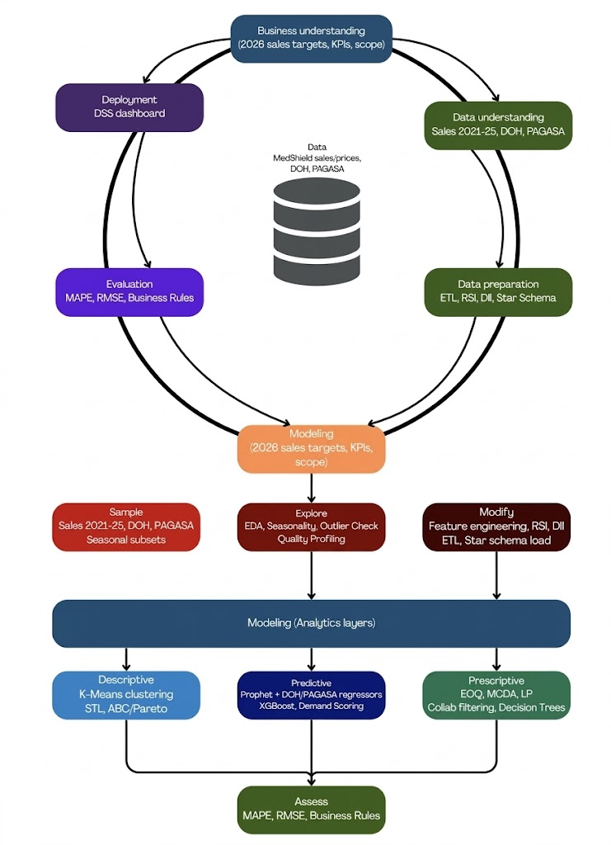
Figure 3.1 Combined CRISP-DM + SEMMA Framework with BA Process
A hybrid analytical process framework based on Cross-Industry Standard Process for Data Mining (CRISP-DM) and Sample, Explore, Modify, Model, and Assess (SEMMA) approaches will guide the MedShield Decision Support System project. While CRISP-DM will offer the business context of the project within the scope to its operational deployment, SEMMA will further elaborate CRISP-DM's modeling phase to ensure that the data sampling, exploration, transformation, and model building will be conducted in a disciplined and reproducible manner. Together, the two frameworks will create a complementary methodology to meet the needs of the Capstone Project Proposal.
CRISP-DM is an accepted, vendor-neutral, phase-based process model in the data analytics and data science domain. It guides projects along six discrete, yet interrelated, phases, Business Understanding, Data Understanding, Data Preparation, Modeling, Evaluation, and Deployment, in an iterative manner. CRISP-DM has been widely adopted in research, and the framing of the Capstone Project Proposal's approach to the analytics lifecycle using CRISP-DM is well supported by the literature on the methodology. First formalized as a process standard for data mining across disciplines by Wirth and Hipp (2000), the success of CRISP-DM stems from its emphasis on linking business goals with analytical tasks. Even as modeling techniques have become more complex, a recent meta-review by Schröer et al. (2021) found CRISP-DM to be adaptable and relevant for machine learning projects in the twenty-first century. Moreover, Chapman et al. (2000) and related works have documented CRISP-DM's effectiveness for similar project types within the health and pharmaceutical space by utilizing varied data sources such as operational data, epidemiological statistics, and environmental factors, within a singular decision-support system, a characteristic directly mirrored by the project.
In contrast to the project governance focus of CRISP-DM, the SEMMA approach is designed by the SAS Institute as a focused, technically-oriented approach for the modeling sub-pipeline of a data science project. Its five steps (Sample, Explore, Modify, Model, and Assess) guide data scientists through disciplined processes of drawing data from the dataset, profiling its attributes, transforming it into a suitable format for analysis, and then building and evaluating the predictive model before the findings are presented to end-users. The inclusion of SEMMA into the Modeling phase of CRISP-DM is particularly valuable for applied analytics, since it ensures data are not fitted too early and enforces an iterative evaluation process before final deployment (SAS Institute, 2020).

Table 3.1 Mapping of CRISP-DM/SEMMA Phases to MedShield DSS Activities
Phase | Framework | Pipeline layer | MedShield DSS activity
Business understanding | CRISP-DM | Data Source Layer | Identify data assets: Sales data 2021–2025, DOH data, PAGASA data w/ WeatherAPI. Define 2026 sales KPIs, forecasting scope, and MedShield's strategic targets.
Data understanding | CRISP-DM | Data Source Layer  ETL – Staging | Source and profile internal sales records, DOH disease surveillance, and PAGASA meteorological files.  Call WeatherAPI.  Validate staging area inputs (Source File Validation) via the Analytics Staging Area (PostgreSQL).
Data preparation | CRISP-DM | ETL Process | Extract: Parser (CSV, Excel, PDF), OCR (PDF), Ingestion (Azure Blob); External Transformation Step (pre-processing, coordination mapping, probabilistic parsing, temporal grain normalization).  Transform: Clean & Deduplicate, Feature Engineering, Standardize Records; engineer Season variable, RSI score, Disease Intensity score, Territory cluster.  Load: Schema Creation (Galaxy Schema), ETL Verification, Final Data Load into constellation schema.
Sample | SEMMA | Analytical Storage | Draw representative subsets from DimTrendTime, DimProduct, DimArea, DimCustomer, FactSales, FactExternal (DOH / PAGASA), and FactOutput. Scope by region, product category, and seasonal period.
Explore | SEMMA | Analytical Storage / Fact Layer | EDA across fact and dimension tables: detect seasonality, trend breaks, and outliers. Validate RSI Definition, DII Feature Definition, and Territory cluster feature definitions. Profile monthly granularity and regional summaries in the Fact layer.
Modify | SEMMA | ETL – Transform / Analytical Storage | Finalize engineered features: RSI score, RSI Definition (weighted rainfall index), Disease Intensity (aggregated from DOH), Territory cluster (area-adjusted forecast). Load modified datasets into product-level summaries and FK-linked dimension tables.
Model | SEMMA | Analytics Layer | Descriptive: 80/20 analysis, STL decomposition, Predictive: Facebook Prophet (with DOH/PAGASA external regressors, DII–Disease Intensity integration,, Adjusted forecast outputs.  Prescriptive: Outbreak alerting, EOQ & ROP, MCDA priority ranking, Collaborative filtering. Model Selection gate before analytics execution.
Assess | SEMMA | Analytics Layer | Descriptive: Rule-Based Encoding, STL decomposition, 80/20 analysis. Predictive: Facebook Prophet with DOH/PAGASA regressors, XGBoost Demand Urgency Scoring, ABC Classification (XGBoost). Prescriptive: EOQ and ROP, MCDA priority ranking, LP allocation, Collaborative filtering, Alert-based thresholding.
Evaluation | CRISP-DM | Analytics Layer / Insights | Evaluate model outputs using MAPE and RMSE. Validate prescriptive recommendations against MedShield business rules. If thresholding fails (IF Thresholding Fail path), route back to Model Selection for re-tuning.
Deployment | CRISP-DM | Consumption Layer | Deliver validated models via the DSS Dashboard: Demand heatmaps, SKU-level forecasting, Risk alerts & territory reports, Inventory optimization recommendations. Governed end-to-end by Orchestration and Data Governance layer.

For MedShield, the integration of CRISP-DM and SEMMA will be realized by performing the six CRISP-DM phases as shown in the table above, from determining the 2026 sales target to the final interactive dashboard.

3.1.3 Data Collection and Integration Plan
Timely acquisition and reliable integration of three data sources will be crucial for the success of the DSS, which will draw on MedShield's internal sales records as its primary analytical foundation, supplemented by DOH epidemiological surveillance data and PAGASA meteorological data as external demand signals. Because these three sources differ in their access mechanisms, ownership structures, reporting cadences, and file formats, they cannot be ingested through a single unified procedure. Each source will therefore be acquired, validated, and prepared independently before the three streams will be aligned to a common temporal and geographic structure and loaded into the constellation schema as an integrated analytical dataset.

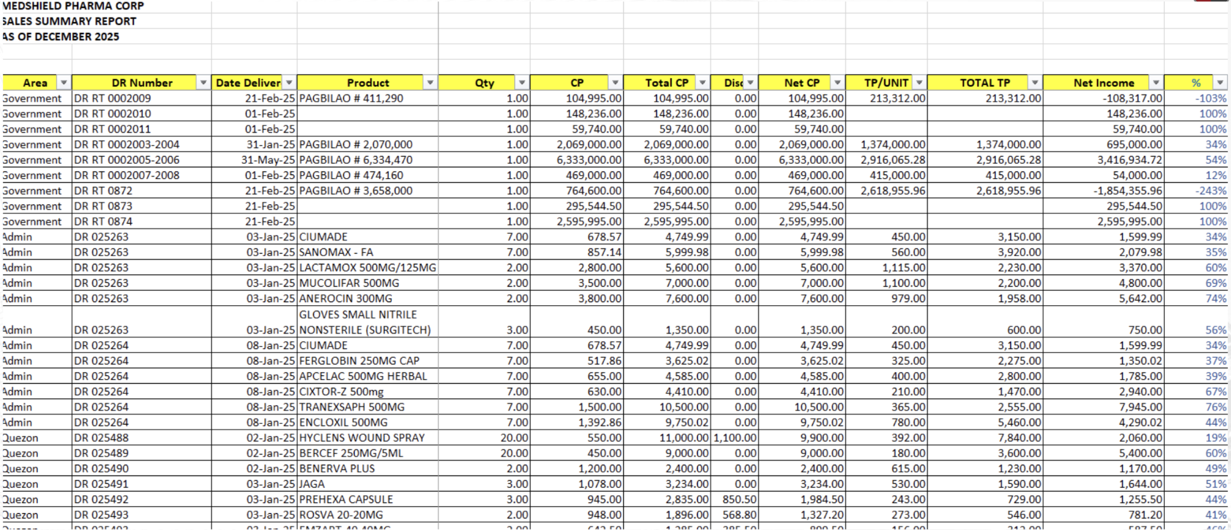
Figure 3.2 Portion of MedShield Sales Summary Report (2025)
MedShield's internal sales data exists in the form of Sales Summary Reports maintained as Excel spreadsheets, covering all transactions from 2021 to 2025 across MedShield's nine delivery territories. These files contain delivery area information, delivery receipt numbers, transaction dates, product names, quantities sold, discount rates, transfer prices, and net revenue figures. Figure 3.2 will present a sample view of MedShield's internal sales dataset, illustrating the structure and fields available for extraction and transformation.

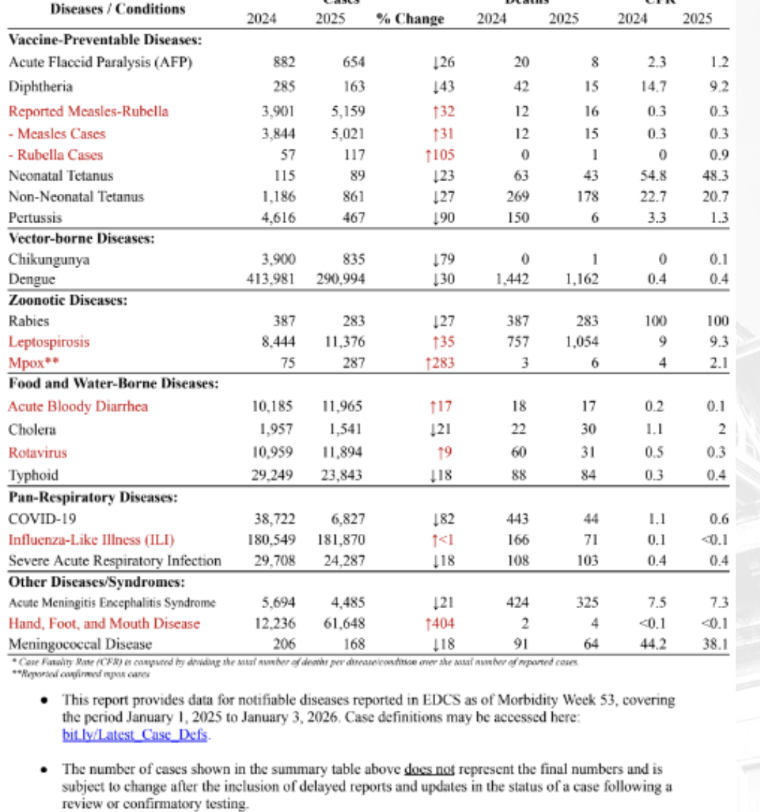
Figure 3.3 An excerpt of Morbidity Week 53 of DOH EDCS data for 2025
DOH epidemiological data will be accessed through two channels. As will be depicted in Figure 3.3, publicly available health statistics and disease surveillance reports will be downloaded directly from the DOH website at doh.gov.ph/health-statistics, covering weekly disease case counts by region and disease type.

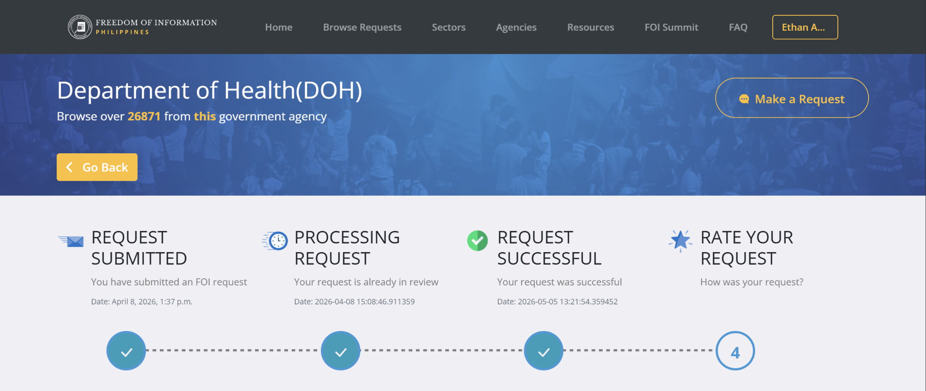
Figure 3.4 FOI request for DOH epidemiological dataset

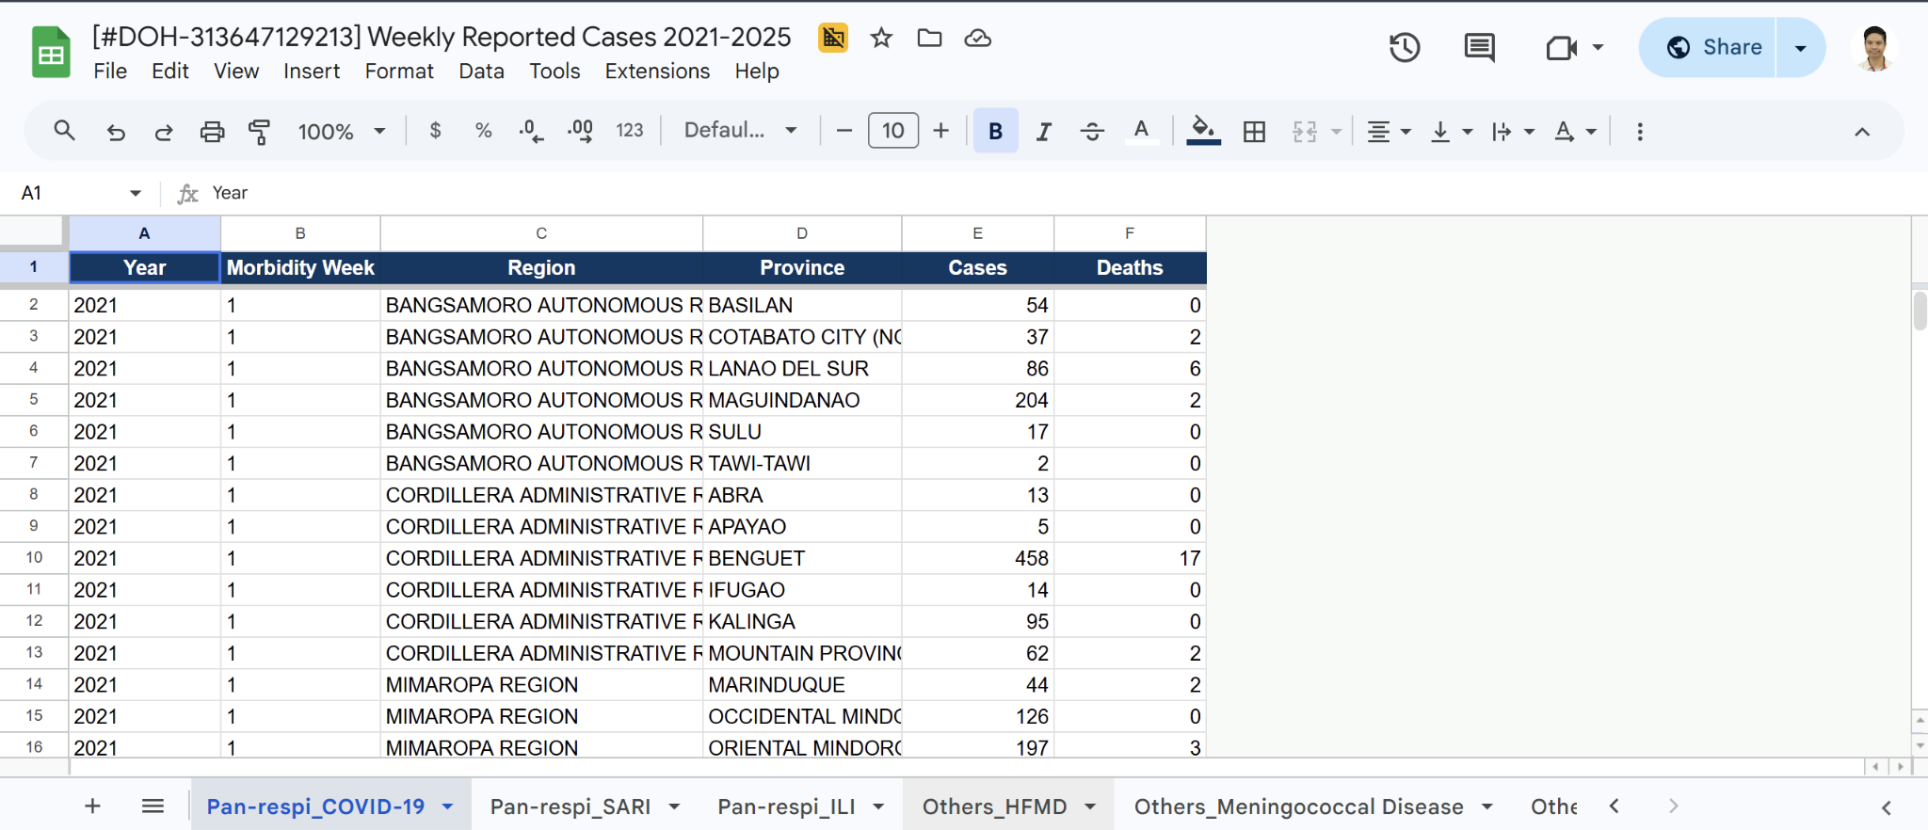
Figure 3.5 DOH epidemiological dataset as received via FOI (COVID-19 excerpt)
For records not yet released through the public portal, a formal Freedom of Information request will be filed through foi.gov.ph. Figure 3.4 will illustrate the FOI request process, showing the submission interface through which the request specifying disease categories, regional scope, and temporal coverage will be filed and tracked. Figure 3.5 will present a sample of the DOH epidemiological dataset as it is received, showing the structure of disease incidence records by region and reporting period prior to DII computation.

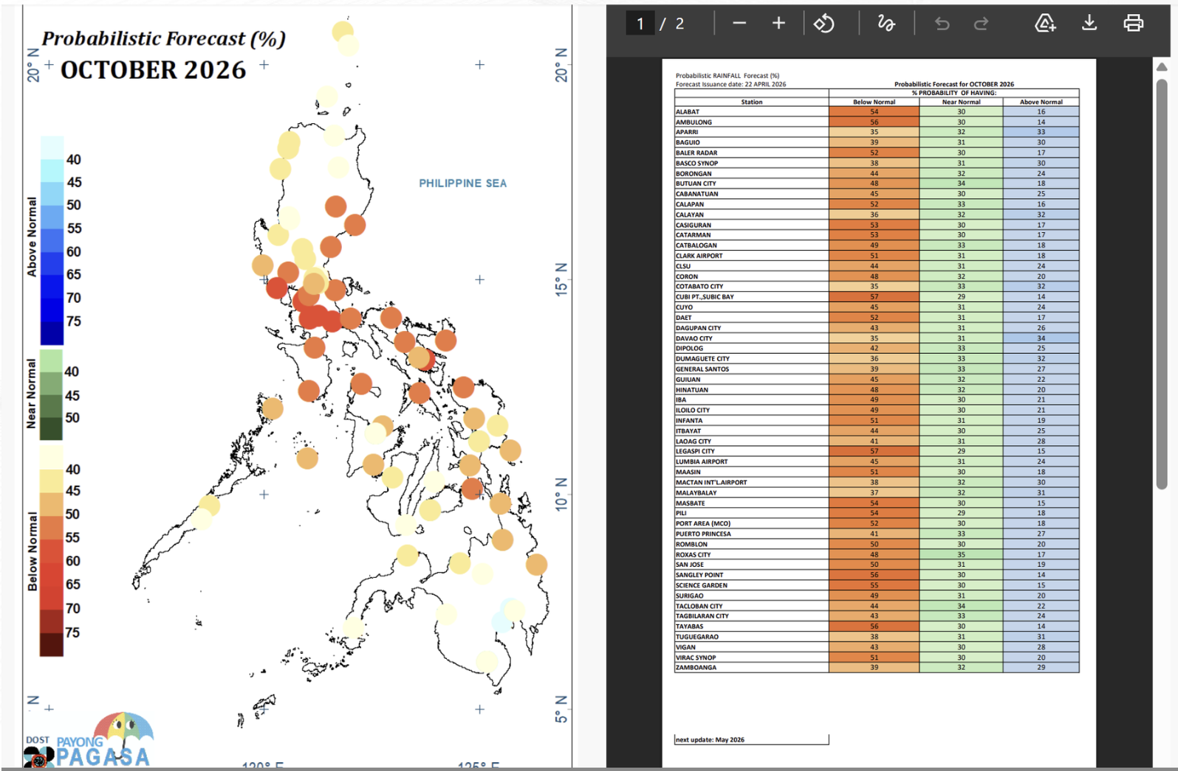
Figure 3.6 PAGASA Probabilistic Forecast (October 2026)
PAGASA meteorological data will likewise be accessed through two channels. As will be shown in Figure 3.6, current seasonal outlook publications and provincial rainfall probability forecasts will be downloaded directly from the PAGASA website at pagasa.dost.gov.ph/climate/climate-prediction/seasonal-forecast.


Figure 3.7 Excerpt of the Climate Data Request for Students and Researchers Form

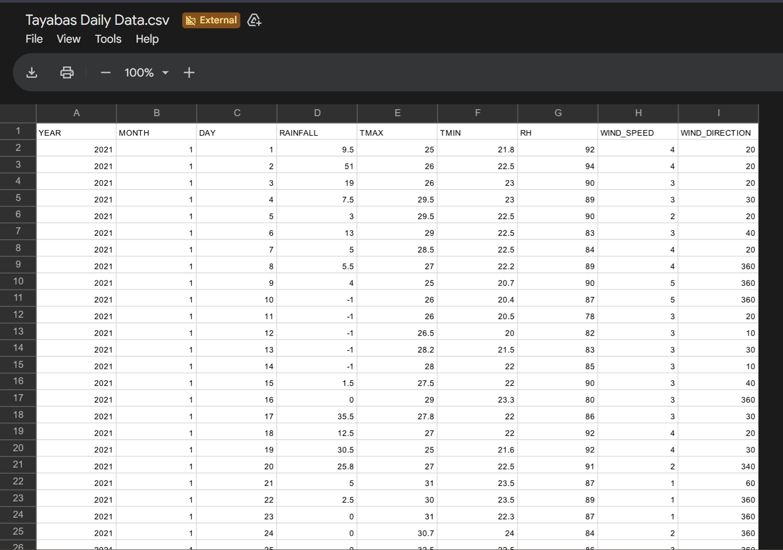
Figure 3.8 Excerpt of PAGASA Daily Data for Tayabas, Quezon AWS
Meanwhile, for historical meteorological records not covered by current public releases, a formal data request will be submitted to PAGASA's Climate and Agrometeorological Data Section. Figure 3.7 will illustrate the CADS request procedure (through Google Forms), showing the formal request channel through which provincial rainfall variables and the required temporal coverage will be specified. Figure 3.8 will present a sample of the PAGASA seasonal forecast dataset as received, showing the historical rainfall outlook structure by province using the location nearest to the PAGASA’s automated weather station (AWS) and season prior to RSI computation. For example, since MedShield is located in Lucena City, the nearest AWS will be in Tayabas, Quezon. All PAGASA data will then be validated to the WeatherAPI to check for accuracy and error handling purposes.
Table 3.2 summarizes the full collection procedures for all three sources.

Table 3.2 Data Collection Procedures by Source
Dimension | MedShield Internal Sales Data (Internal) | DOH Epidemiological Data (External) | PAGASA Meteorological Data (External) | WeatherAPI Meteorological Data (External – Validation)
Primary Source | Excel files covering 2021–2025; any paper-based records encoded before ETL | Public health statistics and surveillance reports at doh.gov.ph/health-statistics | Seasonal outlook publications and forecast reports at pagasa.dost.gov.ph/climate/climate-prediction/seasonal-forecast | WeatherAPI REST endpoint (api.weatherapi.com); historical and current weather data queried by province
Supplementary Source | Not applicable | FOI request filed through foi.gov.ph for records not yet publicly available | Formal CADS request for historical records not in current public releases | Not applicable
Variable Focus | All sales transactions across MedShield's product portfolio | Disease categories relevant to MedShield's therapeutic product lines | Rainfall probability, seasonal outlooks, and typhoon signal warnings | Rainfall intensity, precipitation probability, and general weather conditions used for cross-validation of PAGASA RSI inputs
Geographic Scope | Nine delivery territories across Southern Luzon, CALABARZON, MIMAROPA, and Bicol Region | All regions within MedShield's service areas | Provincial scope covering MedShield's nine delivery territories | Provincial scope covering MedShield's nine delivery territories across CALABARZON, MIMAROPA, and the Bicol Region
Temporal Scope | 2021–2025 | 2021 to most recent available reporting week | 2021 to current period | Aligned with the PAGASA coverage period; queried for the same provinces and time periods as PAGASA data
Access Timeline | Immediate upon MedShield data sharing | 15 working days; possible 15-day extension per Executive Order No. 2, s. 2016 | Standard CADS processing fees and schedule | On-demand via API key; no formal request lead time required
Pre-loading Treatment | Cleansed for format inconsistencies, duplicates, and out-of-sequence records | Normalized to monthly granularity; aligned to region-disease-period structure for DII computation | Normalized to monthly granularity; aligned to province-period structure for RSI computation | Not loaded independently into the constellation schema; used solely to flag a discrepancy threshold, to be empirically calibrated during the data preparation phase by comparing PAGASA and WeatherAPI readings across the 2021–2025 baseline periods
Confidentiality | Controlled approximations used where actual figures are restricted; documented in governance log | Not applicable | Not applicable | Not applicable
All sources will be normalized to a common monthly temporal granularity for model training, forecast generation, and recomputation cycles. Raw MedShield sales transactions will be retained at daily granularity within FactSales to support STL decomposition and Reorder Point disaggregation, which require daily-level inputs, but all external data from DOH and PAGASA will be aligned to monthly aggregates before loading into the constellation schema. Once all three sources have been individually validated and prepared, they will be joined within the constellation schema through the shared DimTime and DimArea dimension keys, allowing the analytical pipeline to cross-reference internal sales performance against external epidemiological and meteorological conditions without requiring separate data transformations at query time. The completeness and structural integrity of each source will be verified through the data governance layer before each monthly recomputation cycle, ensuring that no analytical output will be generated from an incomplete or misaligned dataset.

3.2 Data Preparation
The entire analytical process will depend on data preparation which will serve as the core component according to the CRISP-DM framework. The team will need to combine three different data sources which include MedShield's internal historical sales together with epidemiological surveillance data from the Department of Health (DOH) and meteorological forecasts from PAGASA into a single environment before they can begin their analysis work. The different sources will require a data pipeline which will need to be developed through organized and intentional processes because they use different data formats to present their information.

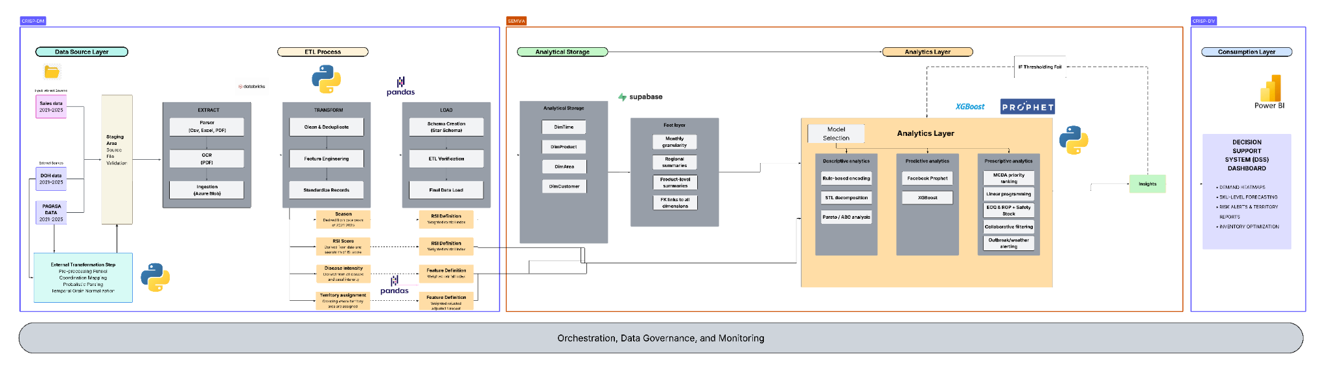

Figure 3.9 Data Pipeline

3.2.1 Data Source Layer
The pipeline will start at the data source layer, where all input datasets will be identified and categorized before any processing takes place. Two classes of sources will feed the DSS. Internal sources will come directly from MedShield and will include multi-year sales transaction records spanning 2021 to 2025, made available as CSV or Excel files. External sources will consist of epidemiological surveillance data from the Department of Health and meteorological forecast data from PAGASA, both covering the same temporal range, to be obtained through publicly available repositories or formal data-sharing arrangements via the Freedom of Information process.
It is important to acknowledge that not all data will be able to be obtained in its complete or ideal form. MedShield enforces strict internal confidentiality policies, which means that certain granular records will be either restricted or available only in aggregated form. In cases where actual figures are unavailable, controlled approximations will be used and to be stated, to maintain traceable estimates that will be inserted into the dataset.

3.2.2 Staging Area
All source files will then reach a staging area prior to any manipulation. the area will act as the point of entry and validation into the pipeline. Internal files will go through format-specific parsing, with structured spreadsheet and CSV files processed directly and PDF documents processed through OCR to extract machine-readable content. All parsed records will then be validated for source completeness and file integrity before being ingested into Azure Blob storage. External datasets will then undergo a parallel external transformation step that will handle pre-processing funneling, coordination mapping, probabilistic parsing, and temporal grain normalization to align them with the internal data's geographic and time-series structure. The output of the step will be a raw, identifiable starting dataset kept in the PostgreSQL Analytics Staging Area, where all rows will be present and ready to be loaded by the ETL process.

3.2.3 ETL Process
Once all source data has been prepared and validated, the pipeline will then proceed to the ETL phase, which will clean, augment and structure the integrated dataset in a systematic manner.

3.2.3.1 Extract
In the stage, records will be formally pulled from the staging environment and consolidated into a unified working dataset. The extraction step will ensure that all source files, internal and external alike, will be represented and that their temporal and geographic scopes will be aligned before any modifications are made.

3.2.3.2 Transform
Transformation will be where the data is reshaped into a format suitable for analytical modeling. It will begin with a data cleaning and deduplication stage to eliminate inconsistencies, and will handle missing values through various imputation methods or data exclusion. Then, categorical data, such as the product names, the area names, and the buyer type, will be standardized, and date fields will be put into a coherent time-series format. Finally, the individual transactions will be summarized daily and by region/product level to allow detection of trends and to create forecasts.
In addition to cleaning, feature engineering will be applied to create four new analytical variables that cannot be represented by the initial dataset: the Season variable (to be assigned based on the calendar date, indicating each data point's placement within the yearly cycle), the Rainfall Severity Index (RSI, to be generated from both PAGASA's probabilistic forecasts and historical automated weather station data through a weighted rainfall scoring formula, converting meteorological data to a single value indicating intensity). Prior to RSI computation, PAGASA rainfall probability values will be cross-checked against WeatherAPI historical weather readings for the same provinces and reporting periods. The difference between PAGASA-sourced and WeatherAPI-sourced rainfall readings is a discrepancy threshold to be determined during the ETL validation phase based on observed variance between the two sources. Only PAGASA values that pass the cross-validation check will proceed to the weighted RSI scoring formula, ensuring that meteorological inputs entering the Prophet model are verified against an independent source before feature engineering is applied. The Disease Intensity score (to be derived from DOH reports by region and period, transforming epidemiological counts to a scaled value representing disease burden relative to the historical baseline) and the Territory Assignment (a direct lookup against the Area field that will map each transaction to one of MedShield's nine documented delivery territories, standardizing geographic labels for downstream forecasting and prescriptive segmentation). Imece and Beyca (2022) demonstrated that hybrid models incorporating external variables of the kind achieved meaningful improvements in forecast accuracy over single-method approaches in the pharmaceutical industry, which is the principle motivating their inclusion here. A final standardization pass will be applied to all records before loading begins.

3.2.3.3 Load
Transformed records will then be loaded into the target analytical environment following schema creation and an ETL verification step that will confirm structural integrity and referential consistency across all tables. Once verified, the final data load will be executed and the dataset will enter the analytical storage layer.

3.2.4 Analytical Storage
All the processed data will be kept in one PostgreSQL data mart with a constellation schema. In the database design, transactional events will be separated from their descriptive data, and multi-dimensional queries will be able to be made without redundancy and complex joins.
At the center of the schema, FactSales will store each sales transaction record at daily granularity, capturing quantity sold, total sales, net sales, and discount rate applied per transaction. Although FactSales will retain daily granularity to support STL decomposition in the descriptive layer and daily demand disaggregation in the Reorder Point computation, the primary analytical and forecasting granularity of the DSS will be monthly. Prophet will generate monthly demand projections, EOQ reorder quantities will be computed from annualized monthly forecasts, and all model outputs stored in FactOutput will be produced and refreshed on a monthly recomputation cycle. A companion table, FactExternal, will hold the integrated DOH and PAGASA variables and will link environmental and epidemiological conditions to the same temporal and geographic dimensions used by the sales records. Both fact tables will connect to four shared dimension tables. DimTime will organize records by date, month, quarter, and year to support seasonal and cyclical analysis. DimProduct will classify each pharmaceutical item by type, category, dosage form, and standard price. DimArea will map delivery locations across MedShield's operational coverage in Southern Luzon from regional down to provincial level. DimCustomer will segment buyers into three institutional classifications, Government, Hospital, and Pharmaceutical, enabling the DSS to differentiate demand behavior across distinct buyer profiles. Because all dimension keys will be shared across both fact tables, cross-referencing sales performance against external conditions will be straightforward by design.

3.2.5 Orchestration and Data Governance
At the core of the entire pipeline will lie an orchestration and data governance layer which will continuously underlie each layer, enabling the coordinated movement of data and the ordered execution of processing stages while ensuring that all data transformations will be auditable and reproducible. The governing layer will support consistent naming, data types and referential integrity through the pipeline and will also record any approximations made during the staging process and will make the end analytical data sets fully transpIn addition, WeatherAPI responses queried during the meteorological cross-validation step will be retained as secondary verification records within the governance log. Each RSI value produced during the Transform stage will be traceable to both its originating PAGASA probabilistic forecast and its corresponding WeatherAPI reading for the same province and period, ensuring full auditability of the meteorological input layer. Any RSI values derived from PAGASA readings that could not be verified against WeatherAPI due to API unavailability or missing coverage will be explicitly annotated in the governance log, and the associated downstream outputs will be flagged as conditionally validated in the FactOutput table.

3.3 Data Design: Fact Constellation Schema
The analytical database will be structured around a fact constellation schema, also referred to as a galaxy schema, which will extend the conventional star schema by supporting multiple fact tables that share a common set of dimension tables. The design will be chosen over a single star schema because the DSS will need to store and query two fundamentally different categories of measurable events, namely transactional sales data and external environmental and epidemiological indicators, within the same analytical environment. By allowing both fact tables to draw from the same dimensions, the schema will eliminate redundancy while enabling the analytics layer to cross-reference internal performance data against external conditions with minimal complexity.

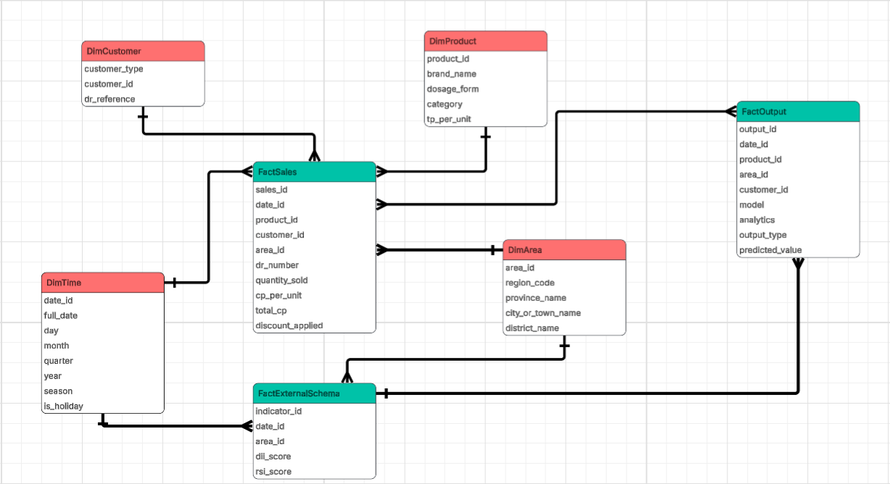
Figure 3.10 Data Model Design
The schema will be composed of three fact tables and four dimension tables, all managed within a centralized PostgreSQL database.

3.3.1 Fact Tables
FactSales will be the fact table on the transactional part of the schema. A record in FactSales will be one single sale transaction and will store five foreign keys out to each of the dimensions (date_id, product_id, customer_id, area_id and dr_number as delivery reference). Its measures will store financial information and key operational performance measurements of each transaction, such as quantity_sold, cp_per_unit, total_cp, discount_applied and net_revenue. Because sales records will be compiled at daily granularity, the table will become the primary source for demand trend analysis, revenue performance tracking, and product-level forecasting across time, geography, and customer segment.
FactExternalSchema will contain external contextual data to provide the environmental and epidemiological basis of the forecasting models. Rather than denormalizing indicators into the sales facts, the schema will contain separate fact tables for external factors joined to the DimTime and DimArea dimension tables using their common foreign keys. Four fact attributes in each fact record will be dii_score (a computed Disease Intensity Index from DOH surveillance reports), rsi_score (a computed Rainfall Severity Index from PAGASA probabilistic forecasts), disease_type (the type of disease causing the intensity score), and typhoon_signal (the storm warning level for that area/time period). The sales fact table will remain concise but external data will still be joinable if any models need it.
FactOutput will be the analytical fact table that will store all model-generated results produced by the descriptive, predictive, and prescriptive layers of the DSS, serving as the single source of truth for every insight surfaced on the dashboard. Each record will represent one output instance such as a forecasted demand value, a 80/20 concentration ranking, an EOQ recommendation, or a regional priority score linked through foreign keys to the four shared dimensions (date_id, product_id, area_id, and customer_id) and to FactExternal via external_factor_id. The model field will identify the algorithm that will produce the result (e.g., Facebook Prophet, XGBoost, MCDA), while the analytics field will categorize the output by analytical layer (descriptive, predictive, or prescriptive). The output_type field will further distinguish the specific kind of result (e.g., forecast, alert, classification, recommendation), and the accompanying measures will store the predicted value and its associated confidence or evaluation score. By centralizing all model outputs in a single fact table tied to the same dimensions as FactSales, the DSS will be able to directly compare predicted values against actual sales, attribute every recommendation back to its underlying data, and ensure full traceability between analytical results and operational decisions.

3.3.2 Dimension Tables
DimTime will be the backbone that will add a temporal layer to the schema. In addition to all basic date fields (day, month, year), the dimension will also have fields representing quarters, half-years, and year breakdown, along with two analytically engineered fields: season (a label indicating each period's placement within the Philippine season timeline) and is_holiday (a flag indicating whether a particular day is a national or regional holiday). These fields will be engineered as part of the dimension to make calculations faster and uniform.
DimProduct will catalog every pharmaceutical item in MedShield's inventory. Each product will be described by its brand_name, dosage_form, and category, with tp_per_unit recording the standard transfer price. The dimension will support product-level performance analysis, margin benchmarking, and category-level demand comparison across the entire analytical layer.
DimArea will capture the full geographic hierarchy of MedShield's operational coverage, which in particular, will be based around Southern Luzon. The levels of the records will range from the broadest, regioncode and regionname, through the levels of province_name, city_or_town_name, district_name, down to the finest levels. Through the structure, the DSS will be able to disaggregate or aggregate demand patterns at any level of hierarchy from the whole region down to small delivery zones without extra tables for each level.
DimCustomer will profile each institutional buyer in MedShield's client base. Fields will include customer_type and dr_reference, the last of which will link customer records back to delivery references in FactSales. The customer_type field will segment buyers into three types— Government, Hospital, and Pharmaceutical — enabling the analytics layer to isolate and compare demand behavior across these distinct institutional profiles.

3.3.3 Schema Relationships
All three fact tables will share the same four dimension tables which will be the defining characteristic of a fact constellation design. FactSales will connect to all four dimensions directly. FactExternalSchema will connect to DimTime and DimArea, reflecting the nature of environmental data as a time-and-place observation rather than a product or customer event. The FactOutput will be related to the four dimension tables and it will also have an external_factor_id that will point to the external condition stored in the FactExternalSchema. As a consequence, a question regarding season trend of sales, disease prevalence by region or generated forecast of demands from a model will all be able to be answered from the same schema and without any data movements.

3.4 Business Analytics Framework
The Decision Support System to be developed for MedShield Pharmaceutical Corporation will be organized around three sequential and interdependent analytics layers: descriptive, predictive, and prescriptive. These layers will not operate in isolation. The descriptive layer will first surface patterns embedded in MedShield's 2021–2025 sales history, grouping records by area, industry type, and revenue concentration. The patterns and rankings it will produce will then be consumed by the predictive layer, which will use them to project forward-looking demand forecasts enriched by external disease and weather signals from the Department of Health (DOH) and the Philippine Atmospheric, Geophysical and Astronomical Services Administration (PAGASA). The forecasts generated by the predictive layer will, in turn, drive the prescriptive layer, which will convert demand projections into specific, actionable inventory and procurement recommendations for MedShield's 2026 planning cycle. Each layer will build directly on the outputs of the one before it, forming a coherent analytical pipeline from historical observation to operational decision.
3.4.1 Descriptive Analytics
Descriptive analytics will consolidate and summarize MedShield's historical sales data to recognize the relationships, trends, and patterns pertinent to sales volume and demand. Analyzing the company's internal records from 2021 to 2025, the layer will outline how demand fluctuates over time, across product types, delivery areas, and customer segments. It will align with the understanding that pharmaceutical supply chain analytics allow organizations to mine historical information and make decisions grounded in these records (Nguyen et al., 2021). The descriptive layer will be essential because it will form the foundation upon which the predictive and prescriptive layers will rely: the area and industry groupings it produces will determine how forecasts are segmented, and the revenue concentration rankings it produces for products will serve as reference data for the ABC classification carried out by the XGBoost classifier in the predictive layer, which will determine which SKUs receive priority treatment in inventory optimization.

3.4.1.1 Descriptive Methods and Models
The descriptive analytics layer will employ three analytical approaches, each matched to the nature of the segmentation or summarization task at hand. Rule-Based Encoding will assign predefined categorical labels to areas and industry types by direct lookup against existing structured fields in MedShield's sales records. STL Decomposition will isolate seasonal and trend components from the time-series sales data. The 80/20 Analysis will rank customers and products by cumulative revenue contribution to surface concentration patterns, producing revenue rankings that serve as reference data for the ABC classification carried out by the XGBoost classifier in the predictive layer.

3.4.1.1.1 Rule-Based Encoding
Rule-Based Assignments will be applied to two segmentation tasks in the descriptive layer, both in the area and industry types where the categorical labels are already present as structured fields in MedShield's sales report. Because the groups are predefined and exhaustive, no algorithm will be needed to discover them; a deterministic lookup on the relevant field will be sufficient and methodologically appropriate. Applying an unsupervised method such as clustering to pre-labeled data would be circular, producing groups that already exist by definition rather than revealing any new structure.

3.4.1.1.1.1 Area Encoding
Geographic delivery areas will be determined by direct lookup against the Area field in MedShield's sales records to one of the company's documented delivery territories: Batangas, Quezon, Marinduque, Cavite, Laguna, Camarines Norte, Camarines Sur, and Albay. Such assignments will establish the geographic dimension of the descriptive analysis, enabling the DSS to disaggregate sales volume, revenue contribution, and demand behavior by province. The area encodings produced here will be used downstream to segment Prophet demand forecasts at the territory level in the predictive layer and to supply the Revenue Rank and Demand Growth Rate inputs to the MCDA regional prioritization module in the prescriptive layer.

3.4.1.1.1.2 Industry Type Encoding
Institutional customer types will be determined as well by direct lookup against the customer_type field in the DimCustomer dimension table, which will encode each buyer as one of three categories: Government, Hospital, or Pharmaceutical. Such segmentation will allow the DSS to compare demand behavior across buyer types, revealing differences in purchasing frequency, product mix, and sensitivity to external demand drivers. Government and hospital accounts have been identified in the Philippine pharmaceutical procurement literature as structurally distinct in their purchasing patterns and regulatory constraints (Abrigo et al., 2021; Ball & Salenga, 2017). In MedShield's 2021–2025 sales data, Government accounts contributed approximately 59% of total revenue and Hospital accounts approximately 25%, confirming that these two institutional types dominate the company's revenue base and warrant dedicated analytical treatment. The encoded industry type outputs will feed into the customer concentration analysis performed by the 80/20 Analysis module and into the collaborative filtering system in the prescriptive layer.

3.4.1.2 STL Decomposition
STL (Seasonal and Trend decomposition using Loess) will decompose MedShield's daily sales time series into three additive components

$Yt = Tt + St + Rt$ (1)
Where:
- Yt = observed sales value at time t
- Tt = trend component representing the long-term direction of MedShield's sales trajectory, estimated using Loess smoothing
- St = seasonal component capturing recurring periodic patterns in demand, such as the December-January peak in antiparasitic medications driven by the amihan season
- Rt = residual component representing irregular variation unexplained by trend or seasonality, including demand shocks or data anomalies

3.4.1.2.1 Sales Data Analysis
STL Decomposition will be applied to MedShield's daily sales data from 2021 to 2025 to separate the underlying trend in sales volume from short-term fluctuations and noise. The trend component Tt extracted from the analysis will reveal the long-term growth or contraction of demand across MedShield's product portfolio and delivery territories. the trend output will serve as the foundational growth signal that Facebook Prophet will use in the predictive layer to calibrate its piecewise linear trend function for the 2026 demand forecast.

3.4.1.2.2 Seasonal Trend Analysis
The seasonal component St extracted by STL will capture recurring, periodic demand patterns in MedShield's sales data. Predictable seasonal cycles are shaped by climatic and ecological drivers, producing recurring pharmaceutical demand patterns: respiratory treatments peak during cooler, wetter seasons; gastrointestinal treatments rise in warmer months; and antiparasitic medications surge during the amihan season (Martinez, 2018). The pattern is evident in MedShield's data, where Antizoal IV Infusion sales consistently peak from December to January across all five years. Seasonality must be explicitly incorporated into forecasting models and cannot be reliably inferred from raw sales data alone (Martinez, 2018). The seasonal component produced here will therefore be passed directly into the configuration of Facebook Prophet in the predictive layer, ensuring that the seasonal structure identified descriptively will be structurally embedded in the forward-looking demand forecasts.

3.4.1.3 80/20 Analysis
The 80/20 Analysis extends the Pareto principle, which observes that roughly 80% of outcomes stem from 20% of causes, into a structured ranking framework that distributes observations across cumulative contribution bands. Rather than applying a single 80/20 cut or assigning categorical labels, the analysis ranks all observations by cumulative revenue contribution to surface concentration patterns across the portfolio. The analysis’ output is strictly descriptive, cumulative revenue rankings and concentration patterns. No categorical labels or performance groupings are assigned at this stage; those outputs are produced by the ABC classifier in Section 3.4.2.1.2.1. The cumulative contribution formula is expressed as:

$C_{i}=\frac{\sum_{j=1}^{i}{}V_{j}}{\sum_{j=1}^{N}{}V_{j}}×100$ (2)
Where:
- Ci = cumulative percentage contribution of the top i observations, sorted in descending order of value
- Vj = value (total revenue or transaction count) of the j-th ranked observation
- N = total number of observations (customers or products)
- The 0–80% cumulative contribution band contains the top revenue-contributing observations
- The 80–95% band contains mid-range contributors
- The 95–100% band contains the remaining low-contribution observations

3.4.1.3.1 Customer Concentration Analysis
Customer concentration analysis will apply 80/20 Analysis to MedShield's client accounts, using Delivery Receipt (DR) numbers matched with client names grouped by area and industry type. The analysis will determine which accounts contribute disproportionately to total revenue and require dedicated inventory and distribution attention, and it will measure transaction frequency to differentiate regularly active accounts from those with declining activity. Each account's percentage contribution to total sales will be computed to measure each account's relative revenue share.
The customer concentration outputs from this analysis will serve as input to the collaborative filtering system used in the prescriptive analytics layer, which will predict product demand based on historical account-level data through region- and client-segment-specific matching (Sari & Yilmaz, 2025).

3.4.1.3.2 Product Prioritization
Product prioritization will apply 80/20 Analysis to MedShield's product portfolio, ranking all 3,631 SKUs by cumulative revenue contribution across the 2021–2025 period. The analysis will reveal that 449 products account for the top 80% of cumulative revenue, 835 fall in the 80–95% band, and 2,347 make up the remaining portion. The top-performing products identified will be the primary focus of inventory prioritization and replenishment planning, while the lowest-contributing SKUs will be flagged for review regarding stocking levels or potential discontinuation (Dela Cruz et al., 2025). The Pareto principle will direct analytical resources toward the items that will produce maximum benefit (Puruhito & Falani, 2021), and these revenue concentration findings will subsequently serve as reference data for the XGBoost product performance classifier described in Section 3.4.2.1.2.1.
The outputs of the descriptive analytics layer such as area groupings, industry type labels, revenue concentration rankings, seasonal trend components, and customer concentration rankings, will collectively form the structured analytical foundation that the predictive layer will draw on to generate forward-looking demand forecasts.

3.4.2 Predictive Analytics
Predictive analytics will be applied to estimate future pharmaceutical demand, revenue movements, and product-level sales patterns based on the patterns surfaced in the descriptive layer and supplemented by external demand signals from DOH and PAGASA. Building on the seasonal trend components from STL Decomposition and the revenue concentration rankings from the 80/20 Analysis, predictive models will be trained on MedShield's 2021–2024 sales data and evaluated against 2025 actuals to generate forward-looking forecasts that will support inventory planning and procurement decisions. The models will align with the finding of Imece and Beyca (2022) that combining time series techniques with regression methods in the pharmaceutical sector yields hybrid models that achieve significantly better forecasting accuracy than single-technique approaches.

3.4.2.1 Predictive Models
The predictive analytics layer will be built around two models selected based on their suitability for different data structures and forecasting tasks. Facebook Prophet with External Regressors will handle the time-series demand forecasting task at both the aggregate and territory level, with disease and weather signals from DOH and PAGASA incorporated as external inputs derived through the Disease Intensity Indicator (DII) and the Rainfall Severity Index (RSI). XGBoost will handle the product-level demand urgency scoring task, operating on tabular feature vectors rather than time series. Both models will be trained on 2021-2024 data and evaluated on 2025 actuals.

3.4.2.1.1 Facebook Prophet with External Regressors
Facebook Prophet will be the primary model used for demand forecasting. It is selected over traditional ARIMA-based approaches because it will handle missing data, outliers, and multiple seasonality patterns more robustly, and will allow the researchers to incorporate domain knowledge about MedShield's known demand events directly into the model configuration (Taylor & Letham, 2018). The full model with external regressors will take the form:

$y(t) = g(t) + s(t) + h(t) + β₁×DII_{lag}(r, d, t) +$ (3) $β₂·RSI_flag(r, t) + εt$

Where:
- y(t) = forecasted pharmaceutical demand at time t
- g(t) = trend function representing the long-term growth or decline in MedShield's sales trajectory, will be seeded by the trend component from STL Decomposition
- s(t) = seasonality component capturing recurring demand patterns, will be configured using the seasonal component from STL Decomposition
- h(t) = event effects accounting for irregular demand drivers such as regional government bidding cycles or DOH procurement campaigns
- β₁ = regression coefficient for the disease intensity lag variable, will be estimated from training data
- β₂ = regression coefficient for the rainfall severity indicator, will be estimated from training data
- εt = residual error term representing unexplained variation
The configuration will allow the model to adjust its demand forecasts in response to disease incidence signals from DOH and weather severity signals from PAGASA, capturing the external demand drivers that pure sales-history models cannot account for. When external data is unavailable or when only internal historical patterns are required, the model will reduce to the baseline forecast by setting both regression coefficients to zero. The three forecasting sub-tasks to be addressed by the model are described below.

3.4.2.1.1.1 Baseline Demand Forecasting
Baseline demand forecasting will generate aggregate monthly demand projections for MedShield's service areas in Southern Luzon, CALABARZON, MIMAROPA, and the Bicol Region, using only historical sales data as input (both DII and RSI coefficients set to zero). These forecasts will provide management with a macro-level view of expected sales volume and revenue, which will serve as the primary basis for company-wide procurement planning and financial target-setting aligned with MedShield's 2026 strategic objectives. At the territory level, forecasts will be disaggregated by the geographic areas classified in Section 3.4.1.1.1.1 to capture localized demand behavior that aggregate models may obscure. Territory-level forecasting will be particularly important given the geographic diversity of MedShield's service areas, where demand patterns differ significantly across urban centers, rural municipalities, and island provinces in MIMAROPA.

3.4.2.1.1.2 Disease-Adjusted Forecasting
Disease-adjusted forecasting will incorporate epidemiological data from the DOH Epidemic-Prone Disease Case Surveillance reports as an external regressor in the Prophet model. Rather than mapping individual diseases directly to specific SKUs, the DSS will operationalize disease activity through the Disease Intensity Indicator (DII), a normalized ratio derived for each region-disease-time combination:

$DII(r, d, t) =\frac{Cases(r, d, t)}{AvgCases(r, d)}$ (4)
Where:
- r = region (e.g., CALABARZON, MIMAROPA, Bicol Region)
- d = disease type (e.g., Dengue, Influenza-like Illness, Acute Diarrhea)
- t = time period (week or month)
- Cases(r, d, t) = reported case count for disease d in region r at time t
- AvgCases(r, d) = historical average case count for that disease-region pair computed from the 2021-2025 baseline period

A DII value greater than 1.0 will indicate above-average disease activity and will trigger an upward demand adjustment for the related therapeutic product categories.
What the score means:
- DII = 1.0 → exactly average, no unusual burden
- DII > 1.0 → above-average disease activity → DSS triggers an upward demand adjustment for related drug categories (anti-leptospirosis, antibiotics, IV fluids)
- DII < 1.0 → below average → no adjustment needed
To account for the delay between disease onset and observable changes in pharmaceutical procurement, a lag variable will be constructed:

$DII_{lag}(r, d, t) = DII(r, d, t - k)$ (5)
Where k will represent the lag period in weeks determined from MedShield's procurement lead time and the incubation-to-treatment timeline in the historical data. the lagged variable will be incorporated as the β₁ regressor in the Prophet model. Elevated Dengue case counts, for instance, will correspond with increased demand for antipyretics and intravenous fluids, while rising Influenza-like Illness incidence will correspond with higher demand for respiratory and fever-related medications (Amuta et al., 2022).

3.4.2.1.1.3 Weather-Adjusted Forecasting
Weather-adjusted forecasting will incorporate meteorological data from PAGASA as an additional external regressor to account for the influence of climate variability on pharmaceutical demand, which will be particularly relevant for MedShield's service areas in Southern Luzon that is frequently affected by the habagat, the amihan, and typhoon activity that will significantly alter disease transmission dynamics and healthcare access conditions. The DSS will operationalize PAGASA data through the Rainfall Severity Index (RSI):

$RSI(r, t) = P(above-normal rainfall | r, t)$ (6)
RSI risk levels will be classified as:
- Low Risk (RSI < 40%)
- Moderate Risk (RSI 40-44%)
- High Risk (RSI ≥ 45%).
The RSI flag will be incorporated as the β₂ regressor in the Prophet model, applying a demand multiplier to the baseline forecast α:
- 0.10-0.15 for moderate risk (flu medications, vitamins, respiratory drugs)
- 0.20-0.30 for high risk (antibiotics, anti-leptospirosis medications)
- 0.35-0.50 for sustained high risk, with stock alerts issued for the affected provinces

3.4.2.1.2 XGBoost
XGBoost (Extreme Gradient Boosting) will serve two distinct product-level roles in the predictive layer, both operating on the same feature-rich tabular dataset rather than a time-series structure. Chen and Guestrin (2016) demonstrate that XGBoost consistently outperforms other gradient boosting implementations in speed and predictive accuracy on structured tabular data, making it appropriate for both tasks. Both roles will be trained on 2021–2024 product-level data and evaluated on 2025 actuals. Both share the following feature vector for each product i:
$xi = [SalesVolume, RevenueContribution, CVdemand,$ (7)
$TherapeuticCategory, DIIscore, RSIflag]$
Where:
- SalesVolume = historical average monthly units sold
- RevenueContribution = percentage share of total MedShield revenue
- CVdemand = coefficient of variation of monthly demand, which will measure volatility
- TherapeuticCategory = encoded product classification from MedShield's sales records
- DIIscore = Disease Intensity Indicator for diseases related to the product's therapeutic category
- RSIflag = rainfall risk level for the product's primary delivery region

3.4.2.1.2.1 Product Performance Classification (ABC Analysis)
XGBoost will be trained as a supervised classifier to apply ABC groupings to MedShield's full product portfolio of 3,631 SKUs. ABC Analysis extends the 80/20 principle into a three-band classification framework, designating products as A, B, or C based on cumulative revenue contribution, A covering the top 80%, B the 80–95% band, and C the remaining portion. Juran (1954) established ABC classification as a predefined downstream step that follows from concentration ranking, with predetermined category boundaries that govern inventory policy rather than groupings discovered from data. While products with sufficient sales history can be directly ranked through 80/20 Analysis, new and low-history SKUs lack sufficient transaction records for direct ranking. 80/20 Analysis will supply revenue concentration findings for products with sufficient history as reference data to train the classifiers as they are predefined revenue concentration bands grounded in the Pareto principle (Juran, 1954; Flores & Whybark, 1986). Since the categories are predetermined, a supervised classifier is the methodologically appropriate choice rather than having to use clustering techniques (Ng, 2007; Ramanathan, 2006). XGBoost addresses the coverage gap by learning the relationship between a product's observable features and its observed revenue performance, then independently assigning ABC groupings to all SKUs including those that fall outside the concentration ranking. Umadevi and Umamaheswari (2023) establish that ABC groupings directly govern differentiated inventory policies and procurement frequencies across the product portfolio, confirming that accurate grouping assignment for new and low-history SKUs is not a secondary concern but a prerequisite for the prescriptive layer to function correctly.
The classifier will be trained on 2021–2024 product-level data and evaluated on a held-out test partition of products with sufficient observed sales history, using their revenue concentration findings from 80/20 Analysis as the reference point. Classification accuracy, precision, recall, and F1-score per grouping will serve as evaluation metrics, with per-class reporting applied across all three groupings to ensure that performance is not dominated by correct predictions in the largest grouping. The ABC groupings produced by the module will feed directly into the prescriptive layer's EOQ reorder computations and LP allocation optimization, determining which products receive priority inventory attention.

3.4.2.1.2.2 Demand Urgency Scoring
XGBoost will also be applied for product-level demand urgency scoring, complementing the time-series output of Prophet with a product-specific ranking of inventory priority. Unlike Prophet, which will operate on time-series structure, XGBoost will be trained on the feature-rich tabular dataset and will output a Demand Urgency Score for each product in MedShield's portfolio. Chen and Guestrin (2016) demonstrate that XGBoost consistently outperforms other gradient boosting implementations in speed and predictive accuracy on structured tabular data, making it appropriate for product-level scoring in the DSS. The model will be trained on 2021-2024 product-level data and will be evaluated on 2025 actuals using MAE, RMSE, and MAPE.
Product demand scores will be computed using a gradient boosting model that will evaluate the feature vector xi described in Section 3.4.2.1.2.1 for each product i. The model will output:

$Score(i) = Σ fk(x_{i}), fk ∈ F$ (8)
Where fk will represent individual decision trees in the XGBoost ensemble and F will be the space of all regression trees (Chen & Guestrin, 2016). Products with the highest urgency scores will be flagged for priority inventory attention and will feed directly into the EOQ reorder computations and LP allocation optimization in the prescriptive layer. The adjusted Prophet demand forecasts, incorporating baseline, disease, and weather signals, and the XGBoost urgency scores will together form the demand picture that the prescriptive layer will convert into specific inventory and procurement recommendations.

3.4.3 Prescriptive Analytics
Prescriptive analytics will translate the demand forecasts and urgency scores produced by the predictive layer into specific, actionable inventory and procurement recommendations for MedShield's management. The prescriptive layer will operate through seven modules executed in a defined sequence: MCDA will first score and rank regions, whose priority weights will then be consumed by the LP allocation model to optimize stock distribution across territories. EOQ, ROP, and Safety Stock will compute the inventory parameters that will constrain the LP optimization. Collaborative Filtering will independently recommend product-region pairings for stocked SKUs. Alert-Based Analytics will run in parallel, issuing procurement alerts triggered by disease outbreaks and typhoon conditions that will override normal inventory parameters when activated.

3.4.3.1 Prescriptive Models and Alerts
The prescriptive modeling layer will employ a coordinated suite of analytical techniques to convert demand signals into operational guidance. Multi-Criteria Decision Analysis (MCDA) will establish strategic regional priorities that will weight the Linear Programming (LP) model, which will optimize stock allocation across territories. Inventory parameters will be defined through Economic Order Quantity (EOQ), Reorder Point (ROP), and Safety Stock modules to minimize costs while maintaining service levels. Simultaneously, Collaborative Filtering will identify new product-region opportunities, while Alert-Based Analytics will provide a rule-driven override mechanism to handle disease outbreaks and typhoon contingencies. Together, these models will ensure that MedShield's procurement and distribution activities are aligned with both historical patterns and real-time environmental risks.

3.4.3.1.1 Multi-Criteria Decision Analysis (MCDA) for Regional Prioritization
Multi-Criteria Decision Analysis will be used to rank MedShield's delivery territories by procurement priority, incorporating three dimensions that will reflect both commercial and epidemiological considerations (Halim et al., 2019). MCDA will run before the LP allocation model because the priority scores it produces will serve as the objective weights that LP will maximize. Lepenioti et al. (2019) establish that the distinguishing value of MCDA in prescriptive analytics is precisely the property: it makes the trade-off logic explicit and auditable, allowing management to understand and if necessary contest why a particular territory was ranked above another. Each area will receive a composite Priority Score computed as:

$Priority_Score(area) = w₁ · Revenue_Rank +$ (9)
$w₂ · Demand_Growth_Rate +w₃ · Outbreak_Risk_Index$

Where:
- w₁ = revenue weight
- w₂ = growth weight
- w₃ = epidemiological risk weight
The Revenue Rank will be sourced from the area and sales data in the descriptive layer. The Outbreak Risk Index will be derived from current DOH disease alert levels in each region, linking the MCDA scoring directly to the disease signals used in the predictive layer. These priority scores will guide procurement allocation decisions when supply is constrained and will be passed directly to the LP allocation model as its optimization objective.

3.4.3.1.2 Linear Programming for Product Allocation Optimization
Linear Programming will be the optimization engine of the prescriptive layer. Halim et al. (2019) present linear programming as a proven framework for pharmaceutical supply chain network optimization, demonstrating that LP-based allocation reduces procurement costs while maintaining service levels across complex, multi-territory distribution environments. It will receive the MCDA regional priority scores as its objective weights and will determine the optimal distribution of stock across MedShield's territories, maximizing MCDA-weighted demand fulfillment subject to real-world operational constraints. The LP formulation will maximize:

$OF: Max Z = x +y$ (10)
Subject to:
$x + y ≤ S (supply)$
$C_{1}x +C_{2}y ≤B (budget)$
$x ≥ A_{1}, y ≥ A_{2} (safety stock)$
$x + y ≤K (warehouse capacity)$
Non-negativity Function (NNF):
$x, y ≥ 0$
Where:
- x = Inventory units allocated for Product 1
- y = Inventory units allocated for Product 2
- Z = The total priority score you want to maximize
- S = Total available stock/supply
- C1, C2 = Cost per unit for each product
- B: Total budget
- A1, A2 = Safety stock minimums
- K = Total warehouse capacity

3.4.3.1.3 Economic Order Quantity
The Economic Order Quantity formula, formally derived by Harris (1913) and extensively applied in pharmaceutical supply chain contexts since, will determine the optimal reorder quantity for each product by minimizing total inventory cost, which is the sum of ordering cost and holding cost. It will use the Prophet demand forecast as its primary input:

$EOQ = \sqrt{\frac{2DS}{H}}$ (11)
Where:
- D = forecasted annual demand in units (Prophet output)
- S = ordering cost per purchase order in PHP, estimated from MedShield's procurement records
- H = holding cost per unit per year in PHP
EOQ values will be recomputed monthly as updated demand forecasts are generated, ensuring that reorder quantities remain aligned with current demand trends. Woosley et al. (2009) demonstrate that EOQ-based reorder practices in healthcare supply chain contexts reduce stockout frequency by 22 to 35% compared to experience-based approaches, establishing the operational justification for its application here. The computed EOQ values will feed into the supply constraint parameters of the LP allocation model.

3.4.3.1.4 Reorder Point
The Reorder Point (ROP) will determine the inventory level at which a new purchase order must be placed to avoid stockouts during the supplier lead time:

$ROP = (Average Daily Demand × Lead Time) + Safety Stock$ (12)
Average Daily Demand will be derived from the Prophet forecast disaggregated to the daily level. Lead Time will be the supplier replenishment lead time in days estimated from MedShield's procurement records. Safety Stock will be the buffer computed in Section 3.4.3.1.5. ROP values will be recomputed monthly alongside EOQ values and will be surfaced on the DSS dashboard as reorder trigger thresholds for each SKU (Woosley et al., 2009; Bello et al., 2026).

3.4.3.1.5 Safety Stock
Safety Stock will absorb demand uncertainty during the replenishment lead time, ensuring that MedShield will maintain service levels even when demand or lead times deviate from their expected values:

$Safety Stock = Z × σd × √L$ (13)
Where:
- Z = calibrated to maintain expiry-driven wastage at or below the 5% ceiling established as the operational benchmark for the Capstone Project Proposal, grounded in the wastage evidence of Mohammed et al. (2021) and Guadie et al. (2023)
- σd = standard deviation of daily demand derived from historical sales variability in the 2021-2025 records
- L = supplier lead time in days
Safety Stock values will be computed per product and enforced as minimum allocation constraints in the LP allocation model, ensuring that the optimization will not deplete buffer inventory in pursuit of higher MCDA-weighted fulfillment scores.

3.4.3.1.6 Collaborative Filtering for Product-Region Matching
Collaborative Filtering will be applied to identify historically successful product-region pairings and recommend which products should be prioritized for stocking in specific areas. The module will operate independently of the LP allocation pipeline, focusing specifically on unstocked SKUs that could represent expansion opportunities. Cosine similarity is the standard metric used to quantify the relationship between two demand vectors, measuring the angular distance between them in a way that captures directional similarity regardless of scale differences between territories (Patoulia et al., 2023). The similarity between two product-region demand vectors will be computed as:

$SIMILARITY(A, B) = \frac{(A · B) }{(||A|| × ||B||)}$ (14)
Where A and B will be the monthly demand vectors for two product-region combinations. Products not currently stocked in a region but exhibiting high cosine similarity scores with established pairings will be flagged as potential new SKUs for that territory. The customer concentration outputs from the 80/20 Analysis in Section 3.4.1.3 will provide the account-level demand history that will drive the similarity computation, linking the collaborative filtering recommendations back to the descriptive analytics layer (Sari & Yilmaz, 2025).

3.4.3.1.7 Alert-Based Analytics
Alert-Based Analytics will operate in parallel with the optimization pipeline, issuing condition-triggered procurement interventions that will override normal inventory parameters when disease outbreaks or typhoon conditions exceed predefined thresholds. Tiongson and Kummer (2020) demonstrate that integrating surveillance logic into healthcare supply decision systems enables proactive procurement response rather than reactive resupply after stockouts occur, which is the principle motivating the inclusion of the module in the prescriptive layer. Two alert mechanisms will be implemented.

3.4.3.1.7.1 Rule-Based Thresholding
The DSS will monitor DOH disease incidence on a periodic basis and will trigger procurement alerts when a disease indicator exceeds its historical baseline by a statistically significant margin (Tiongson & Kummer, 2020):

$ALERT(region, disease, t) = TRUE IF$ (15)
$cases(region, disease, t> μ + 2σ$
Where:
- cases(region, disease, t) = reported weekly case count for the given disease-region pair at time t
- μ = historical mean weekly case count for that disease in that region, computed from the 2021-2025 baseline period
- σ = standard deviation of weekly case counts for that disease-region pair over the same baseline period
When an alert is activated, the DSS will apply a demand multiplier to the underlying Prophet forecast for the associated product categories in the alerting region:

$D_alert(p, r, t) = D_base(p, r, t) × (1 + γ)$ (16)
Where γ will be the alert multiplier coefficient calibrated per disease category, for example 0.20 to 0.35 for dengue-related products and 0.15 to 0.25 for influenza-like illness products, estimated from historical demand-incidence relationships (Amuta et al., 2022). Alert outputs will be surfaced to MedShield management through the DSS dashboard as flagged procurement recommendations, with supporting context showing the triggering disease, the affected region, and the estimated demand uplift for each associated product category. The alert-adjusted demand will also feed back into the MCDA Outbreak Risk Index, increasing the priority score of the affected region in the next LP optimization cycle.

3.4.3.1.7.2 Typhoon Contingency Alerts
Scenario-based contingency alerts will be activated when WeatherAPI detects rainfall and wind speed that meets the criteria of the PAGASA typhoon warning signal (2 or above) for provinces within MedShield's service areas before a formal declaration will be made. Williams (2024) establishes that pharmaceutical supply chains in disaster-prone environments require pre-defined contingency protocols as a standard operational safeguard, and the World Health Organization (2024) identifies automated contingency activation as a key feature of resilient health supply chain architecture. Rather than requiring management to improvise a procurement response during an active typhoon event, the DSS encodes the response logic in advance via WeatherAPI and activates it at the moment it detects the weather patterns that meet the Warning Signal threshold. Upon activation, the DSS will execute a pre-defined emergency response: demand multipliers will be applied to wound care materials, PPE, oral rehydration salts, and antibiotics; minimum stock levels for these categories will be doubled for the affected provinces to mitigate logistics disruptions. These overrides will supersede the normal EOQ and ROP parameters for the duration of the typhoon warning, ensuring that emergency product categories will maintain adequate stock levels even under constrained supply and access conditions.

3.5 Risk Assessment and Mitigation
The development and deployment of the Decision Support System for MedShield Pharmaceutical Corporation carries two distinct categories of risk. Project-level risks will concern the team's ability to acquire data, meet milestones, and complete development within the Capstone timeline established in Chapter 1. Business analytics solution-level risks on the other hand, concern the analytical reliability and operational performance of the DSS once built. Both categories are addressed in the section, as risks in either category can affect the quality and defensibility of the final output.

3.5.1 Project-Level Risk Management
Project level risks are risks which could potentially delay or limit the development of the DSS prior to its construction. These are tied directly to the Gantt charts provided in Section 1.6 where each phase for Capstone 1 and 2 is provided with a specific development window. Risks materializing at any stage have cascading effects on future stages and the below contingency strategies aim to mitigate these downstream effects without resulting in the abandonment of the overall project timeline.
The biggest project level risk at hand relates to data acquisition. The DSS will utilize data from 3 separate sources: MedShield’s internal sales records, DOH's epidemiological surveillance records and PAGASA's meteorological data, each with their own access restrictions and uncertain delivery timelines, detailed in section 3.1.3 below. DOH and PAGASA data will also rely on the formal request time which is out of our control. Requests to DOH through the foi.gov.ph website use standard 15-working day delivery times, with the possibility of a 15-day extension due to executive order no. 2, s. 2016 and requests to PAGASA use the standard service charges and delivery times. Both requests will be sent early to avoid delays from request timelines. If the data does not reach us before the modeling phase the workarounds detailed in Table 3.2 below will be used and these will be accounted for in the data quality evaluation.
Beyond data acquisition, there can be schedule slippage if the model cannot perform up to the desired performance within the development window. If the Prophet and XGBoost models cannot hit their defined MAPE targets against 2025 actuals within the Modeling phase, the Model Selection re-tuning gate shown in Figures 3.1 and 3.9 will be applied, giving the team the additional development time within the buffer time incorporated within the project schedule. It is feasible to complete the project by mid-September 2026 as stipulated in the Capstone 2 Gantt chart and will give the team a window to perform the re-tuning without necessitating a formal extension.
All approximations, substitutions and data gaps, will be explicitly documented within the governance log across the pipeline and taken into account as a data quality issue in model evaluation, thus not being an information hidden from the client in the final deliverable.

Table 3.3 Project-Level Risk Management Matrix
Risk | Likelihood | Impact | Priority | Schedule Phase Affected | Mitigation and Contingency
DOH FOI request delayed beyond project timeline | Moderate | Moderate | Moderate | Data Preparation and Modeling (Capstone 1) | Use publicly available regional PIDSR summaries for the affected periods; DII computed on available data with reduced granularity noted.
PAGASA CADS request not fulfilled within project window | Low | Moderate | Moderate | Data Preparation and Modeling (Capstone 1) | Use publicly available seasonal forecast data; compute RSI from provincial probability forecasts rather than station-level historical records; reduced precision noted in weather-adjusted forecast evaluation.
MedShield confidentiality restrictions limiting record access | Low | Moderate | Moderate | Data Preparation (Capstone 1) | Use controlled approximations as substitute values under explicit conditions; all approximations stated transparently in the dataset and governance log.
Model accuracy targets not met within Modeling phase window | Moderate | High | High | Modeling and Assessment (Capstone 1 and 2) | Apply Model Selection re-tuning gate per Figure 3.1; allocate additional development time within the mid-September 2026 project buffer.
Milestone slippage due to compounded data preparation delays | Moderate | High | High | All phases (Capstone 1 and 2) | Compress non-critical development tasks; activate all relevant fallback data sources; target final completion within mid-September 2026 buffer as documented in Section 1.6.

3.5.2 Business Analytics Solution-Level Risk Management
Business analytics solution-level risks pertain to those risks which could impact the analytical accuracy or the operative functionality of the DSS once built. Specifically they relate to the validity of the data inputs, the accuracy of the forecasting and prescriptive models as well as the capacity of the DSS to continue functioning as the data input volume increases over time.
A significant risk is the data inconsistency present in MedShield's historical records. The sales transaction data was, in the past, tracked by spreadsheets and managed manually so format variations, duplication and non-chronological records exist within the dataset. Without losing transaction history these inconsistencies cannot simply be purged. The data preparation procedures presented in Section 3.2 will normalize entries, assign codes to valid attributes and remove erroneous records before any analytical functions take place.
Another important solution risk is the disparate format of external data sources compared to the sales data. DOH and PAGASA data is significantly different in terms of granularity, format and periodicity to MedShield sales transactions. If not managed properly, they could weaken the correlation between external predictors and sales, diminishing their explanatory capacity in forecasting models. These data points have been reconciled based on compatible intervals and relevant geographic features so that the values associated with DII and RSI will act as ancillary data instead of key drivers in the model outputs.
A risk associated with any predictive solution is the forecasting model's accuracy. Past demand may not represent present demand, and unanticipated occurrences such as a spike in demand, abnormal purchases or procurement policy changes can significantly alter demand. The DSS is designed to overcome the risk with an adaptive forecasting methodology whereby a given Prophet or XGBoost model will be refitted with the latest transactional data, thus providing future projections based on current conditions instead of past trends and having an estimation that has been communicated in ranges so that MedShield planners have flexibility.
The next solution-level risk is the credibility of the prescriptive recommendations based on a shaky pattern in the data. Therefore all recommendations are supported by multiple criteria such as trend, commodity movement patterns and comparative periods to strengthen reliability. An additional risk related to the abovementioned data issues is a degradation of the DSS performance with data volume growth, prevented by having the data structured for efficient storage and retrieval and analytical processes are scheduled to prevent unnecessary load on the DSS resources.

Table 3.4 Business Analytics Solution-Level Risk Management Matrix
Risk | Likelihood | Impact | Priority | Mitigation Strategy
Data Inconsistency from Historical Transactional Records | High | High | Critical | Apply standardized data preparation procedures: format normalization, duplicate reconciliation, chronological reorganization, and cross-validation with source records.
Misalignment of External Datasets (DOH and PAGASA) with Internal Records | Moderate | High | High | Align datasets using comparable time intervals and relevant indicators; treat external data as supporting signals rather than primary drivers.
Forecasting Inaccuracy Due to Irregular Demand Patterns | Moderate | High | High | Adopt adaptive forecasting with periodic model updates; communicate forecast outputs as estimated ranges to support flexible planning.
Weak or Unstable Data Patterns Affecting Prescriptive Recommendations | Low | Moderate | Moderate | Ground all recommendations in multiple analytical perspectives including trend analysis, product movement, and period comparisons to strengthen output validity.
DSS Performance Degradation as Data Volume Grows | Low | Moderate | Moderate | Implement structured data storage, optimized queries, and scheduled data processing to maintain dashboard responsiveness and output consistency.

3.6 Model Evaluation
The analytical models to be used within the DSS will undergo a process of development and validation to ensure that they generate sufficiently accurate and precise results that can be used at the operational level. Before any individual model will be assessed, a formal baseline will be established against which all outputs will be measured. The evaluation framework for each module will then be matched to the nature of its output type, with metrics selected based on the operational consequences of different error types in the deployment environment.

3.6.1 Baseline Definition
Before any evaluation of any of the models takes place, a benchmark against which all analytical results will be judged will be necessary. There will be two inter-related roles the baseline will be tasked with within the project. First, it will be used as a forecasting benchmark. Secondly, it will be used as an operational performance benchmark.
In its role as a forecasting benchmark, the baseline forecast will consist of the Prophet model with regression coefficients for the Disease Intensity Indicator and the Rainfall Severity Index both set equal to zero, so that the forecast generated for each medication will be purely based on MedShield's internal sales history between 2021 and 2024, without using the two exogenous inputs. Each model variation, disease adjusted and weather adjusted, will be assessed by comparison of its forecast error against the baseline forecast, such that the marginal predictive impact of each exogenous regressor can be ascertained. Imece and Beyca (2022) argue that purely historical baselines are essential when evaluating hybrid forecasts within pharmaceutical contexts, so that it is clear whether inclusion of exogenous variables resulted in any statistically significant improvement in forecast accuracy or simply in increased system complexity with no predictive advantage. Any model variant that will be no better than the baseline forecast in terms of MAE, RMSE, and MAPE against 2025 actuals will do no good in comparison to the additional data acquisition and feature engineering cost required to derive its exogenous input data.
On the other hand, as an operational performance benchmark, the baseline will refer to MedShield's current reordering process, whereby decisions about order quantities are made based on intuition, rather than using a sophisticated analytical framework. The inventory optimization results from the DSS, order quantities under EOQ and reorder points under ROP, as well as allocation recommendations under LP, will be compared to historical purchasing data during 2021 through 2025, in order to establish whether there will be an improvement in terms of cost deviation and waste rate when measured against the past reordering process. The benchmarking method is identical to the one employed by Woosley et al. (2009) within the healthcare supply chain for evaluating system performance; the DSS recommendations will be compared to past intuition-based reordering to quantify improvement relative to the status quo, thus providing the primary justification for deployment. As such, both benchmarks will be compared against actual performance on held-out data during 2025.

3.6.2 Evaluation Metrics
The three major error measurements to be used to evaluate the forecasting models will be Mean Absolute Error, Root Mean Squared Error, and Mean Absolute Percentage Error. Mean Absolute Error will give a general indication of average prediction error expressed in the same units as the forecast. Root Mean Squared Error will more severely penalize larger prediction errors, which will be useful for distinguishing models that generate infrequent but large errors. Mean Absolute Percentage Error will give the error on a percentage basis relative to the actual forecast, enabling comparison of forecasting performance across product lines and territories with differing scales of demand. Atanda et al. (2024) confirm in their comparative evaluation of ARIMA, SARIMA, and XGBoost for sales forecasting that applying all three metrics in combination reveals performance differences that any single metric alone would partially conceal, establishing the multi-metric approach as the appropriate standard for model comparison in demand forecasting contexts.
The importance of evaluating forecast errors at the channel level rather than in aggregate is established by Kmiecik (2025), whose analysis of forecast error time series across pharmaceutical distribution channels demonstrates that aggregate error metrics alone can mask systematic trend and seasonal components embedded in the residuals. For the reason stated, residual analysis using STL decomposition will be applied alongside standard error metrics to detect and correct systematic forecasting biases across MedShield's product-territory combinations before final model deployment.
For the rule-based area and industry type encodings, no model evaluation metric will be required as the assignments are deterministic lookups against structured fields in MedShield's sales records. Accuracy will be verified through completeness checking, which will confirm that every transaction record maps to a valid, non-null territory or customer type label with no unmatched values.
For the ABC classification carried out by XGBoost, validation will consist of confirming that cumulative revenue thresholds are correctly applied and that the tier distribution will be consistent with the 80/95/100 boundaries across the full 3,631-SKU portfolio.
For the XGBoost product tier classifier, evaluation will use classification accuracy, precision, recall, and F1-score per tier, computed against a held-out test partition of products with sufficient observed sales history. Sokolova and Lapalme (2009) establish that per-class precision, recall, and F1-score are the appropriate evaluation suite for imbalanced multi-class classifiers, since aggregate accuracy conceals class-level failures in minority tier, directly applicable to MedShield's skewed grouping distribution of 4449 top-contributing, 835 mid-contributing, and 2,347 low-contributing products, where overall accuracy alone would be dominated by correct predictions for the low-contributing group.
For the rule-based procurement alert module, evaluation will use precision and recall computed against historical outbreak periods in the 2021 to 2025 data. Davis and Goadrich (2006) establish that precision and recall together characterize the detection reliability of rule-based systems more completely than accuracy alone in surveillance contexts where alert conditions are rare relative to normal periods. Precision will measure what proportion of triggered alerts corresponded to genuine demand surges; recall will measure what proportion of genuine demand surges the system successfully detected. High recall will ensure that the system does not miss outbreak-driven demand spikes; high precision will ensure it does not generate excessive false alerts that would erode management confidence.
For the inventory optimization modules, operational evaluation will use cost deviation and wastage rate benchmarked against MedShield's historical procurement records, with wastage rate assessed against the 5% ceiling to be established in Section 3.4.3.1.3 and grounded in the wastage evidence of Mohammed et al. (2021) and Guadie et al. (2023). Multi-criteria decision analysis and LP stock allocation outputs will be assessed using ranking consistency across successive monthly cycles and optimization gap relative to the theoretical maximum MCDA-weighted fulfillment score, consistent with the evaluation approach used by Halim et al. (2019) for pharmaceutical supply chain optimization systems. Collaborative filtering outputs will be evaluated on coverage and relevance accuracy, following the assessment approach applied by Sari and Yilmaz (2025) in their pharmaceutical product-region matching Capstone Project Proposal.
3.6.3 Model Training and Evaluation Summary
Table 3.5 will consolidate the evaluation framework across all analytical modules in the DSS, mapping each model to its corresponding metrics, the nature of what will be being measured, and the expected performance direction. The table will distinguish between minimization targets, where lower error values indicate higher accuracy, maximization targets, where higher scores indicate better classification or recommendation reliability, and threshold targets, where the output must meet a fixed operational benchmark regardless of relative performance. Belghith et al. (2024) demonstrate in a pharmaceutical DSS context that embedding the kind of structured evaluation summary into the methodology ensures that model performance is assessed against consistent, pre-defined criteria rather than post-hoc thresholds selected after observing results, which is the approach to be adopted here.

Table 3.5 Model Training and Evaluation Summary
Model | Metric | Description | Expected Range
Facebook Prophet, Baseline Forecast | MAE, RMSE, MAPE | Evaluates forecast accuracy using internal sales history only, with DII and RSI coefficients set to zero. Serves as the reference point against which disease-adjusted and weather-adjusted variants are compared. | Minimization; MAPE target below 15%
Facebook Prophet, Disease-Adjusted Forecast | MAE, RMSE, MAPE | Evaluates incremental accuracy improvement over the baseline forecast when DII regressor is incorporated. | Minimization; must improve on baseline MAPE
Facebook Prophet, Weather-Adjusted Forecast | MAE, RMSE, MAPE | Evaluates incremental accuracy improvement over the baseline forecast when RSI regressor is incorporated. | Minimization; must improve on baseline MAPE
XGBoost — Demand Urgency Scoring | MAE, RMSE, MAPE | Assesses the predictive accuracy of product demand urgency scores against 2025 actuals. | Minimization; MAPE target below 20%
XGBoost — Product Performance Classification | Accuracy, Precision, Recall, F1-score per grouping | Evaluates how well the classifier assigns ABC groupings to new or low-history SKUs against held-out 80/20-derived labels. | Maximization (closer to 1.0)
Rule-Based Encoding (Area and Industry Type) | Completeness check | Verifies every transaction maps to a valid, non-null area or customer type label with no unmatched records. | 100% coverage
80/20 Analysis Ranking | Threshold validation | Confirms cumulative revenue ranks are correctly enforced across all 3,631 SKUs. | Consistent with 80/95/100 thresholds
Rule-Based Thresholding (Outbreak Alerts) | Precision, Recall | Validates the system's sensitivity to genuine high-demand conditions versus false positive procurement alerts. | Maximization (closer to 1.0)
Economic Order Quantity | Cost Deviation, Wastage Rate | Validates inventory reorder recommendations against historical procurement records; benchmarked against MedShield's pre-DSS procurement baseline. | Cost: Minimization; Wastage: 5% or below
MCDA and Linear Programming | Ranking Consistency, Optimization Gap | Assesses reliability and optimality of regional prioritization logic across territories and successive monthly cycles. | High consistency; minimal gap
Collaborative Filtering | Coverage, Relevance Accuracy | Measures the extent and validity of matching unstocked products to regional demand patterns in held-out historical data. | Maximization (higher = better)
The evaluation framework summarized in Table 3.5 will not be a one-time post-hoc exercise. Because the DSS will recompute forecasts, reorder thresholds, and allocation outputs on a monthly cycle, all metrics will be monitored continuously across each recomputation rather than assessed only at initial deployment. A model that performs within acceptable bounds against 2025 actuals during training may degrade as 2026 demand conditions evolve in response to disease patterns, policy shifts, or new client accounts, and that degradation will only be visible if MAE, MAPE, precision, and recall are tracked across successive cycles. The DSS dashboard will therefore surface key model performance indicators alongside the analytical outputs themselves, giving MedShield management not only the recommendations the system produces but the accuracy evidence that will determine how much confidence those recommendations warrant. If any model fails to meet its stated target during a monthly cycle, the system will route the affected output back through the Model Selection gate shown in Figure 3.1 for re-evaluation and retuning before the results will be surfaced to the consumption layer.

3.7 Tools and Technologies
The DSS that will be developed for MedShield Pharmaceutical Corporation will be built using open-source and free-to-use technologies selected based on analytical effectiveness, extensibility and appropriateness for the environment, in which the academic project is embedded. These factors are summarized as three criteria:
(1) Effectiveness in satisfying the analytical needs of the system such as time-series prediction, classification using machine learning, multi-dimensional data visualization.
(2) Availability, viability and sustainability within MedShield’s available resources and environment.
(3) Effectiveness and efficiency, as the system necessitates data acquisition from multiple sources and a structured ETL (Extraction, Transformation and Load) process.
Raw source files from all three data sources will be initially ingested into Azure Blob storage as the staging target before validation and ETL processing begin, providing a scalable and format-agnostic landing zone that decouples raw file ingestion from the structured PostgreSQL analytical environment.
The coding language will be based on Python where all the processing will take place. Pandas and Numpy have been adopted as essential libraries to effectively support the manipulation, cleaning and transformation of the data. The Pandas DataFrame structure shall enable efficient handling of MedShield's multi-year transactional records alongside DOH epidemiological and PAGASA meteorological datasets, facilitating the data alignment and feature engineering steps required by the forecasting models. Facebook Prophet will be selected as the core time-series forecasting model owing to its capacity to handle seasonal patterns, missing data, and external regressors within a single unified framework, capabilities directly relevant to pharmaceutical demand forecasting under changing disease and weather conditions.
XGBoost and Scikit-learn will be employed for product demand scoring and the classification operations. XGBoost's gradient boosting architecture is well-suited to identifying non-linear relationships between product attributes, demand history, and external indicators, while Scikit-learn provides the area, product, and customer segmentation. Model development and iterative experimentation will be conducted within Databricks, which supports integrated documentation of analytical logic and visual inspection of intermediate outputs throughout the development cycle, while actual development process is done in VSCode.
Data persistence will then be managed through PostgreSQL, hosted via Supabase, which provides a structured and scalable relational database environment compatible with the system's constellation schema data model. Supabase's cloud infrastructure shall support concurrent access and consistent data availability across the DSS pipeline without requiring significant on-premise infrastructure investment. For visualization and business intelligence, the DSS will be utilized to deliver interactive dashboards that translate analytical outputs into accessible, decision-ready formats for MedShield's management and operational staff.
r

Table 3.6 Tools and Technologies Summary
Category | Tool / Technology | Purpose in the DSS
Data Processing | Python (Pandas, NumPy) | Data extraction, cleaning, transformation, and tabular manipulation of MedShield's internal and external datasets.
Predictive Modeling | Facebook Prophet | Time-series demand forecasting at overall and territory levels, including external regressor integration.
Machine Learning | XGBoost, Scikit-learn | Product demand scoring and classification for product prioritization and customer segmentation.
Development Environment | Databricks, VSCode | Iterative development, model experimentation, and documentation of the analytical pipeline during the actual development process.
Database Management | PostgreSQL via Supabase | Structured storage and retrieval of transactional sales records, external data, and analytical outputs.
Dashboard & Visualization | Power BI | Interactive dashboards presenting demand forecasts, product insights, stock alerts, and decision recommendations.
Data Pipeline | Python (custom scripts) | Automated extraction, transformation, and loading of internal sales data and external DOH and PAGASA datasets.
Version Control | Git / GitHub | Source code management, collaborative development, and iterative version tracking throughout the project lifecycle.
Data Validation | WeatherAPI | Cross-validation of PAGASA meteorological inputs at the provincial level prior to RSI computation in the ETL Transform stage; a discrepancy threshold, to be empirically calibrated during the data preparation phase by comparing PAGASA and WeatherAPI readings across the 2021–2025 baseline period

3.8 System Output
The system output for the proposed project shall consist of a prototype that provides a visual and interactive mockup of the intended system output and shows where the descriptive, predictive and prescriptive analytics from the above sections would be displayed for the end-user. The prototype itself does not represent the entire system but the design and the display for the dashboard and output for the analytics which can be judged on their own by stakeholders to ensure they are consistent with MedShield's business decisions before building them with full frontend and backend components in Capstone 2.

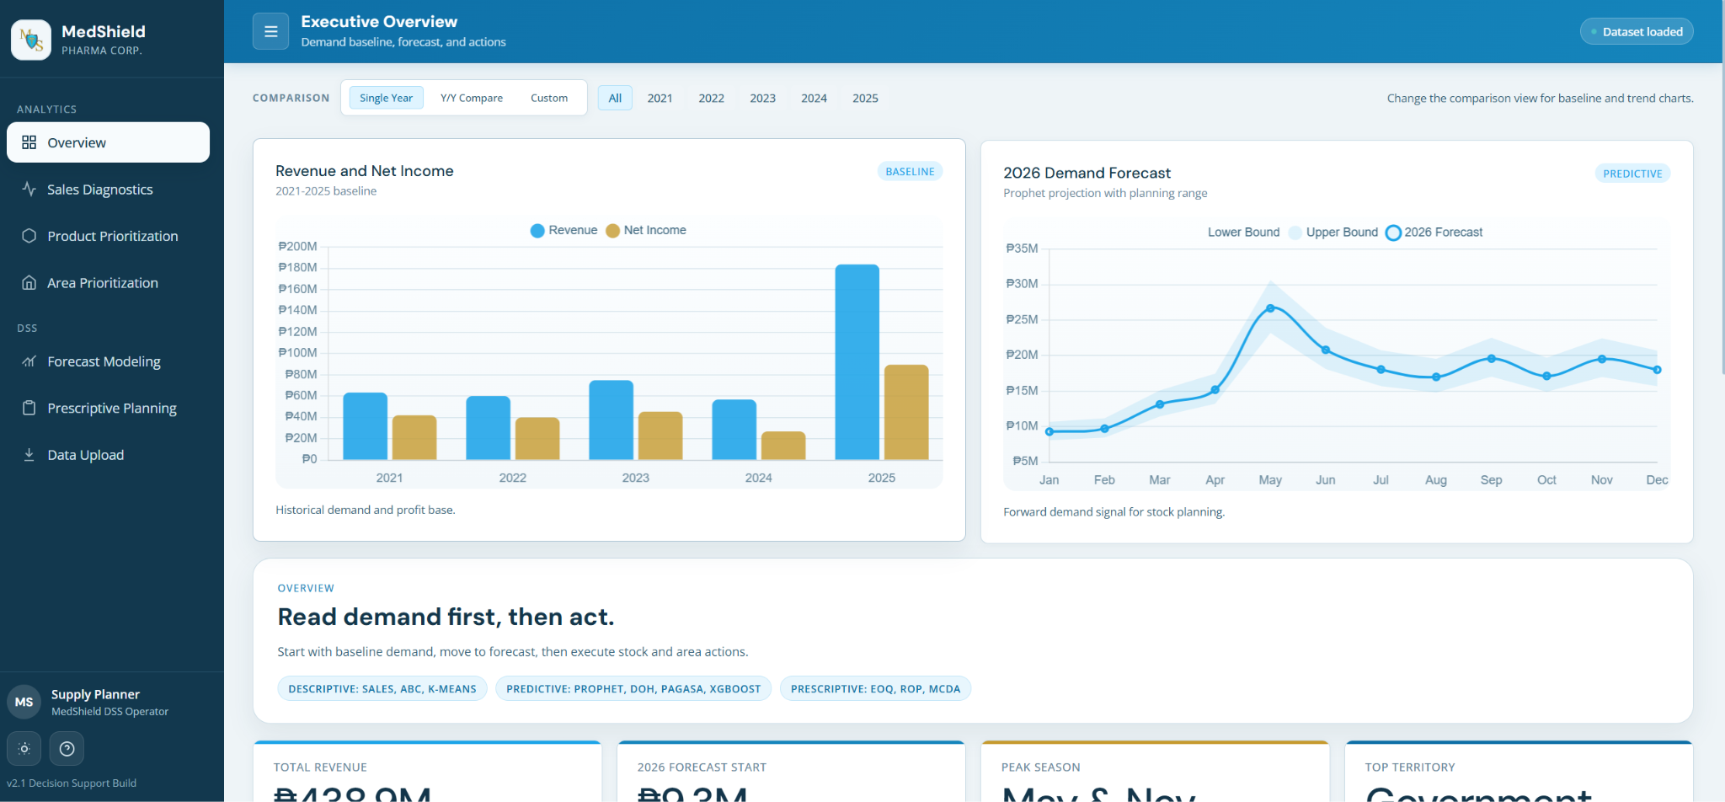Figure 3.11 MedShield Pharmaceutical Dashboard Home Page
Figure 3.11 will serve as the central entry point for the system, providing users with a high-level overview of the navigation and core metrics. It will use a consolidated dashboard layout featuring summary tiles and navigational elements to guide the user through the DSS.

Figure 3.12 Filter for Comparison
Figure 3.12 will demonstrate the system's interactive capability to drill down into specific data segments. It will show a user interface (UI) selection component that allows users to filter outputs by variables like time or region.

Figure 3.13 Overview Content Description of MedShield Dashboard
Figure 3.13 shall provide a detailed explanation of the different data modules and indicators visible on the main screen. It will use an annotated screenshot to define the specific KPIs and metrics presented to the user.

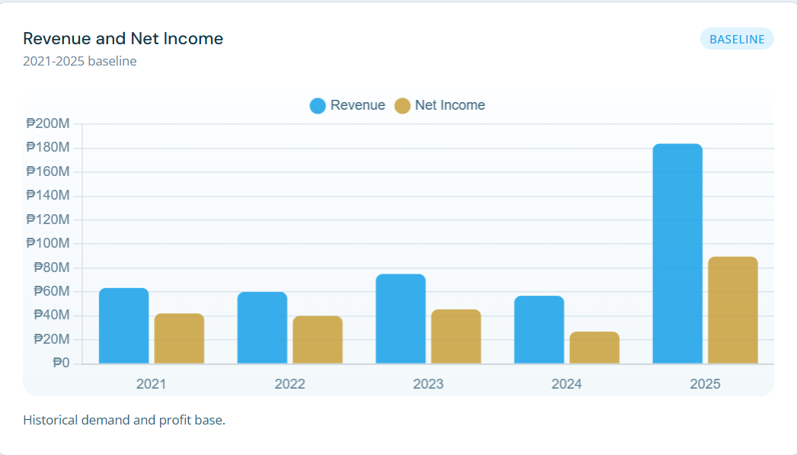Figure 3.14 Historical baseline for revenue and net income
Figure 3.14 shall establish a benchmark for financial performance by comparing past earnings against company targets. It will utilize a time-series line graph to show the fluctuations and long-term trajectory of revenue and net income.

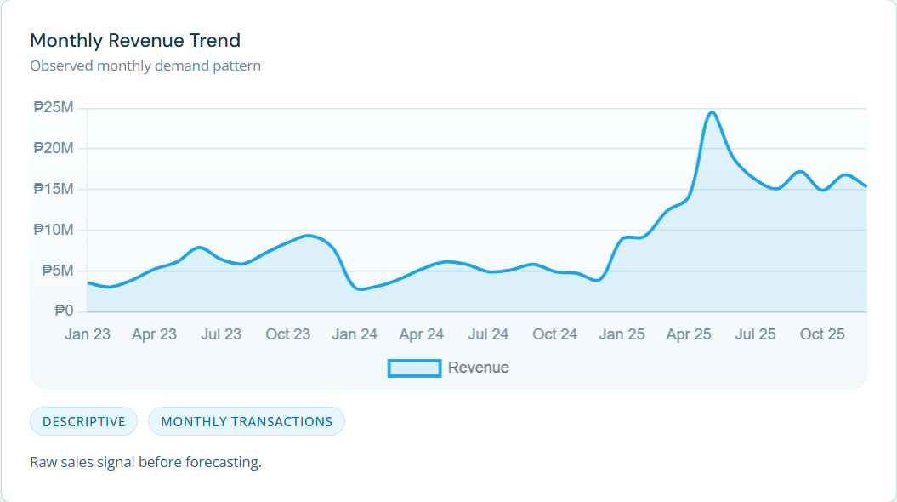Figure 3.15 Monthly demand movement before forecasting
Figure 3.15 will provide visualization employing time-series line charts to show raw historical demand. It will highlight the natural fluctuations and seasonal spikes in product volume before any predictive modeling is applied.

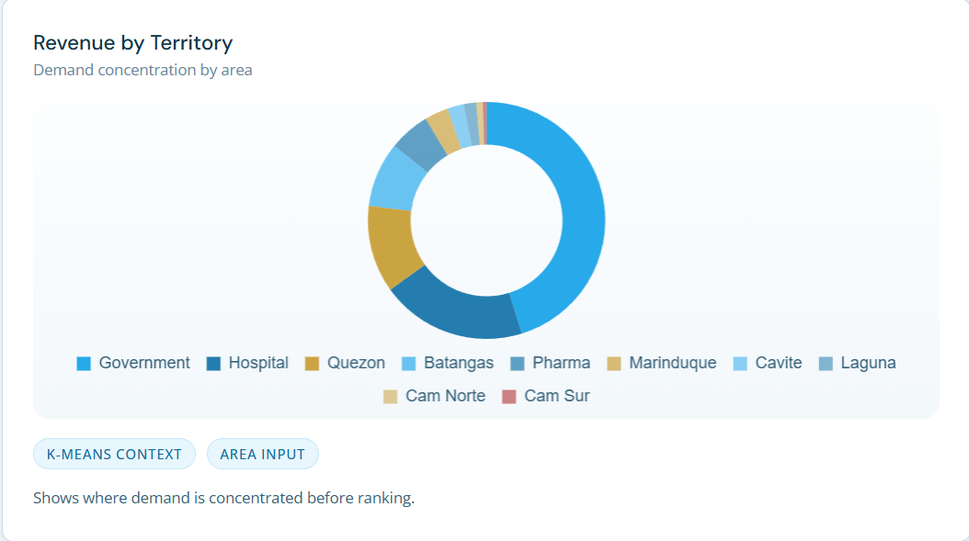Figure 3.16 Territory share used for area planning and prioritization
Figure 3.16 will provide visualization that shows the distribution of sales across different geographic regions to identify key market areas. It employs a pie chart or stacked bar graph to represent the relative percentage share of each territory in total revenue.

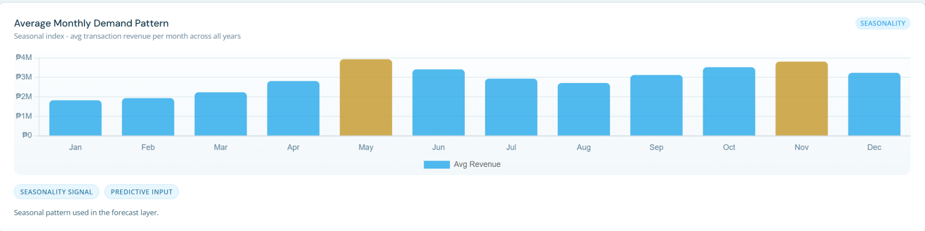Figure 3.17 Average seasonal pattern used by the forecast layer
Figure 3.17 uses a seasonal index plot to show recurring annual cycles. It visualizes the expected "lift" or "suppression" in demand for each month based on historical averages.

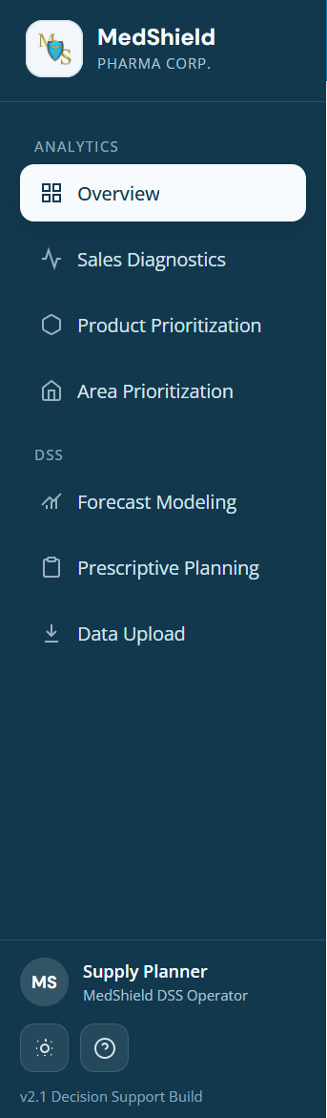
Figure 3.18 Navigation Bar
Figure 3.18 will show the primary interface for switching between different analytical modules like Sales Diagnostics and Area Prioritization. It will utilizes a UI sidebar menu to illustrate the system's ease of navigation.

Figure 3.19 Page Overview of Sales Diagnostic
Figure 3.19 shall provide comprehensive views of the diagnostic module where users can analyze sales performance in depth. They will utilize dashboard screenshots to present a mix of charts and tables that summarize historical data and identify trends.

Figure 3.20 Statistics Output of Sales Diagnostic
Figure 3.20 shall display the output that provides the year's revenue, net income, best month during the year, and average monthly revenue.

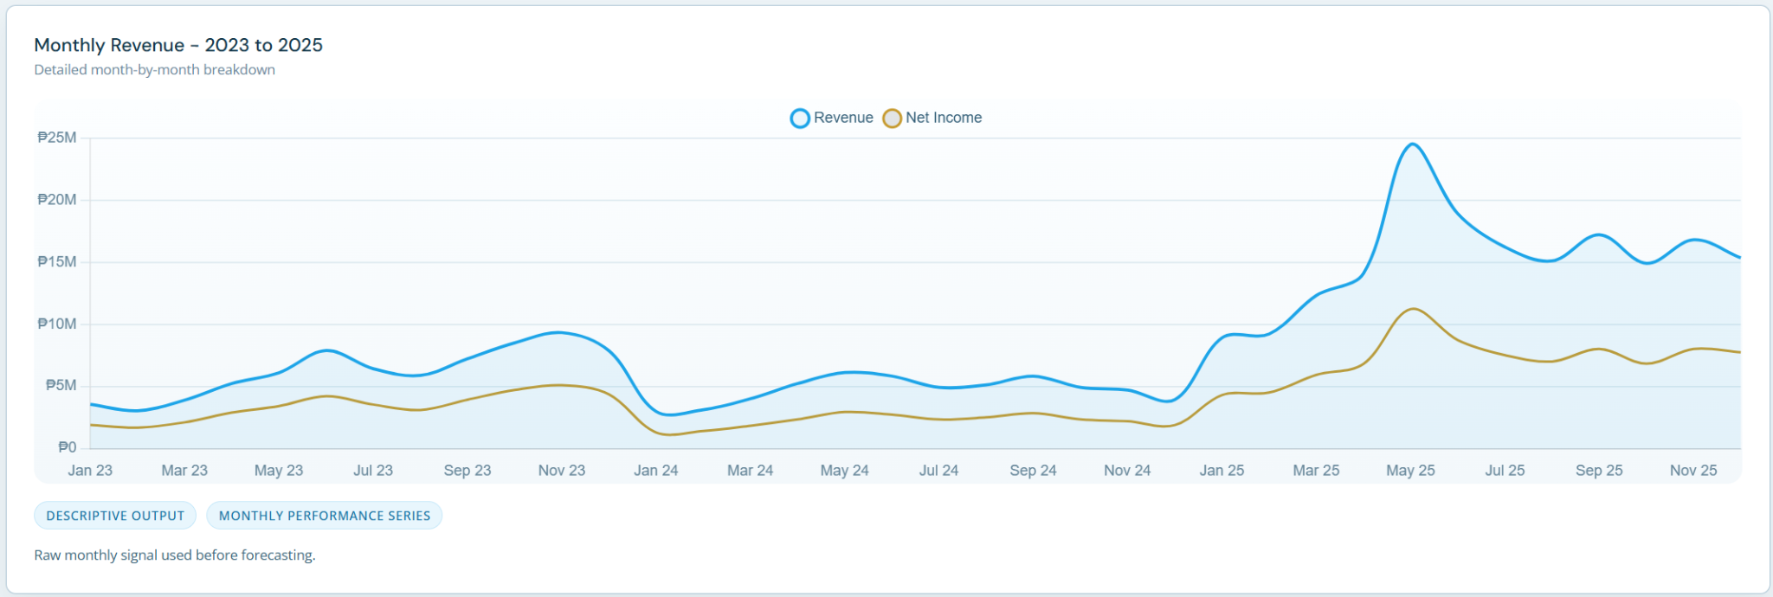Figure 3.21 Monthly Revenue month-by-month breakdown
Figure 3.21 will show the chart which displays the "noisy" monthly data points that serve as the input for predictive models. It will allow users to see the actual volatility in the market before the Prophet model smooths the trend.

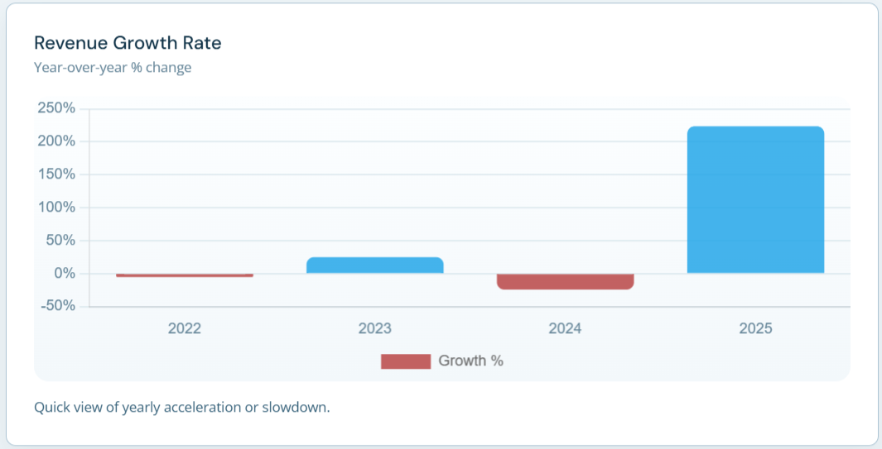Figure 3.22 Quick view of yearly acceleration or slowdown
Figure 3.22 shall show a year-over-year performance to determine if the company's growth is gaining or losing momentum. It will use comparative growth charts to visualize yearly percentage changes in revenue.

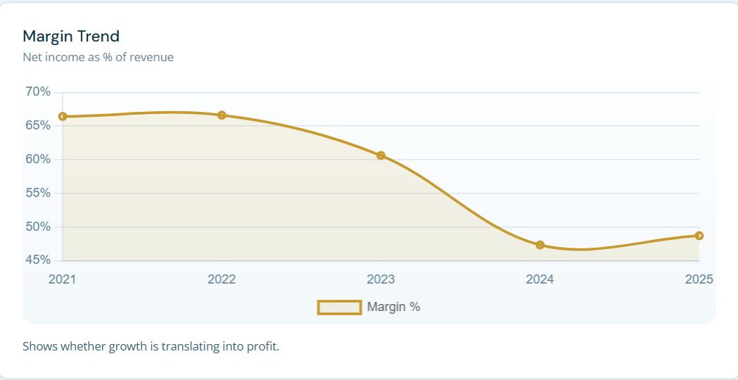 Figure 3.23 Margin Trend
Figure 3.23 will use dual-axis charts to verify if increased sales volume is successfully translating into higher profit margins.

Figure 3.24 Page Overview of Product Prioritization
Figure 3.24 will display the module used to describe what is inside the product prioritization and will include an overview of the descriptive + ML support analytics later, methodologies, and management output.

Figure 3.25 Unique Products Count, 80/20 Concentration Bands, Top Product
Figure 3.25 shall summarize the product portfolio according to its importance to total revenue. It will utilize summary tiles and rank cards to show the number of SKUs falling under 80/20 and assigned to each ABC class (A, B, or C).

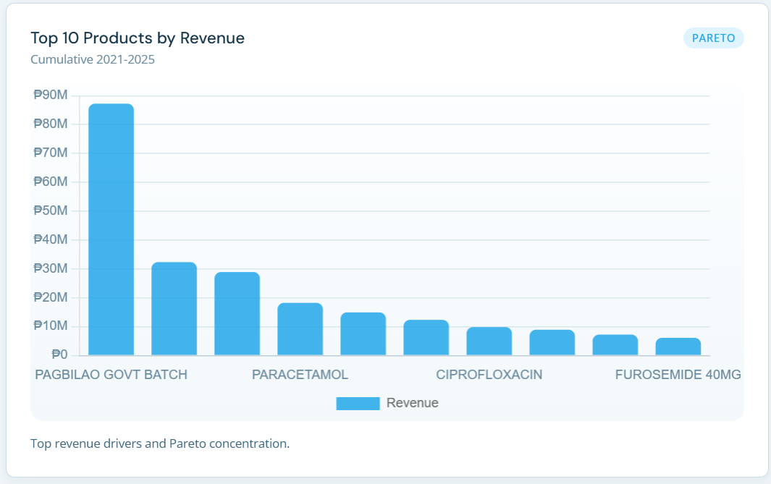
Figure 3.26 Top Revenue drivers and 80/20 Concentration
Figure 3.26 will use a bar chart to visualize the top 10 products generating the company’s revenue.

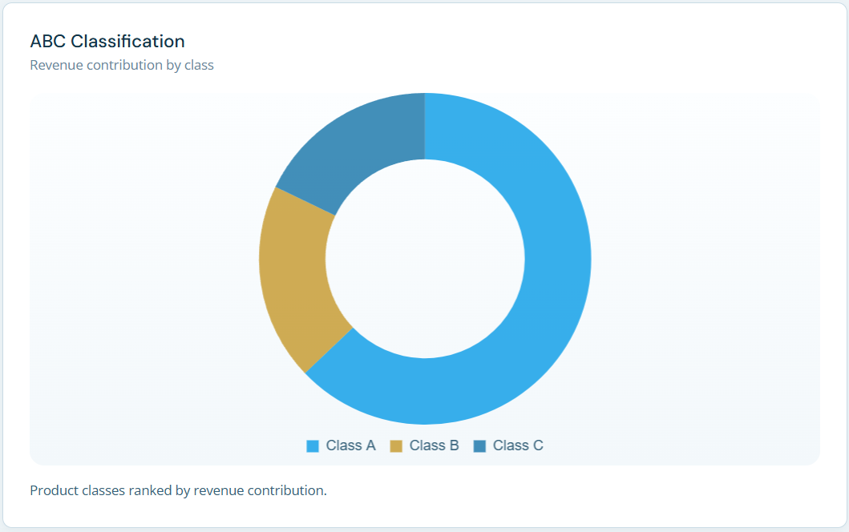
Figure 3.27 Product Classes Ranked by revenue contribution
Figure 3.27 shall identify the "Class A" products that contribute the most to the company's total revenue. It will utilize a Pareto chart, which combines a donut graph of individual contributions with a line graph showing cumulative percentage.

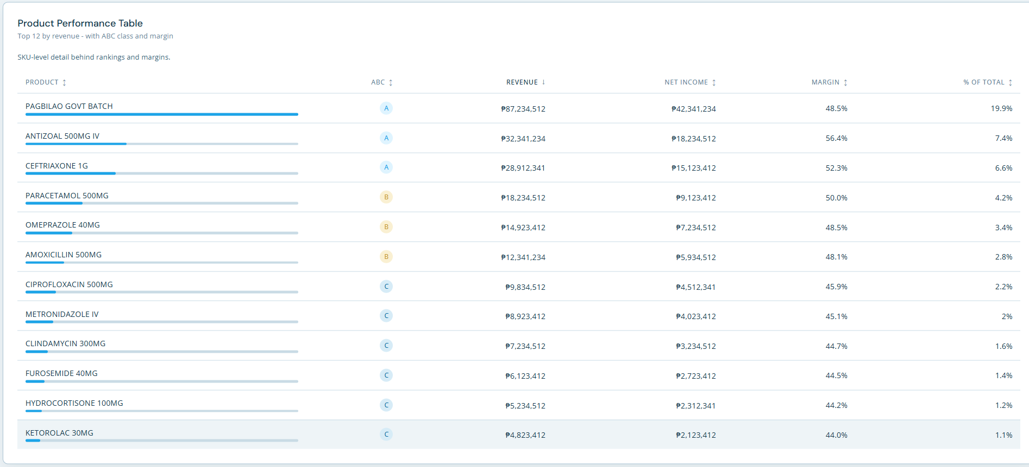Figure 3.28 Product Performance Table
Figure 3.28 shall present the data table providing granular details on individual SKUs. It will list specific metrics such as quantity sold and net revenue for a detailed review of every product in the catalog.

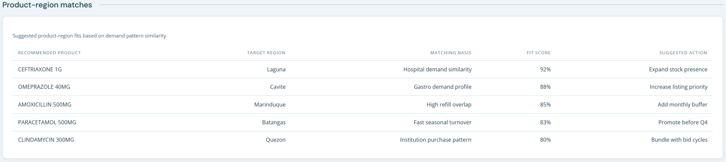Figure 3.29 Product and region matches
Figure 3.29 will display suggested product-region fits based on similar demand patterns, and will include the recommended paroduct in that region, the target region, the matching basis, the fit score, and the suggested action.

Figure 3.30 Page Overview of Area Prioritization
Figure 3.30 shall present the interface for ranking geographic regions based on market potential and risk. It will use a dashboard screenshot to show the summarized scores for different service areas.

Figure 3.31 Area Prioritization Description
Figure 3.31 shall define what the top territory, active territories, hospital variance, and government variance are.

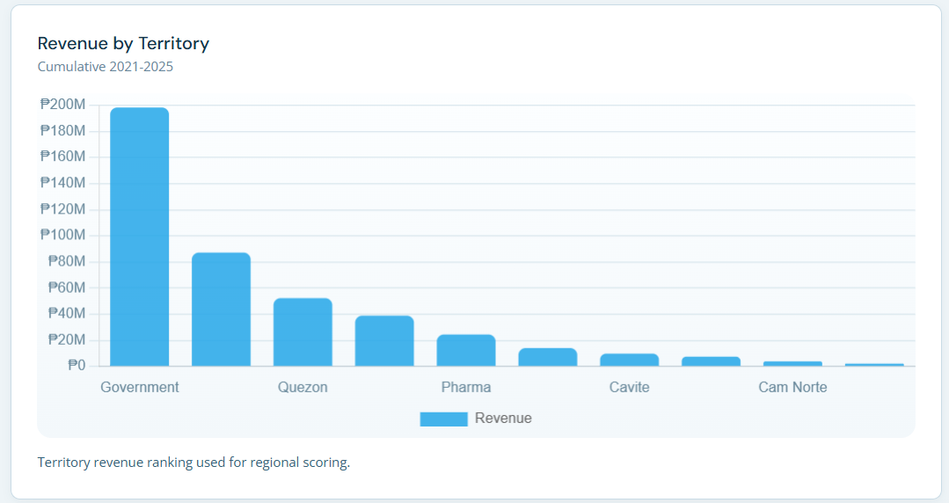Figure 3.32 Territory revenue ranking used for region scoring
Figure 3.32 will rank different geographic areas based on their financial contribution to help with resource allocation. It will use a bar chart to compare revenue across provinces and cities in Southern Luzon.

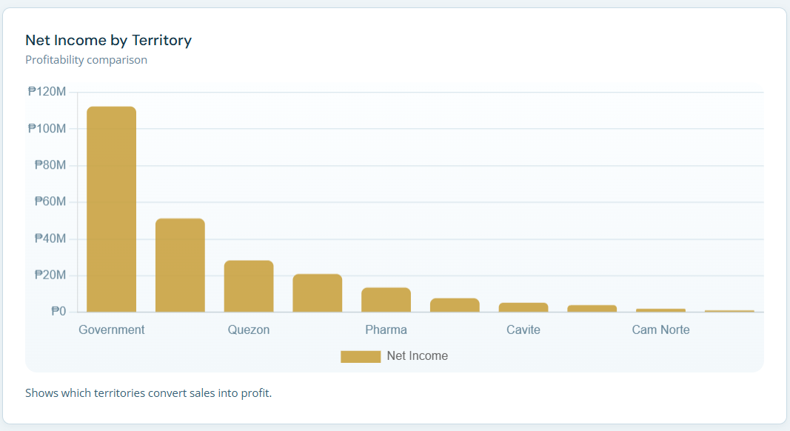Figure 3.33 Net Income by Territory Profitability Comparison
Figure 3.33 will show the net income by territory and which territories convert sales into profit.

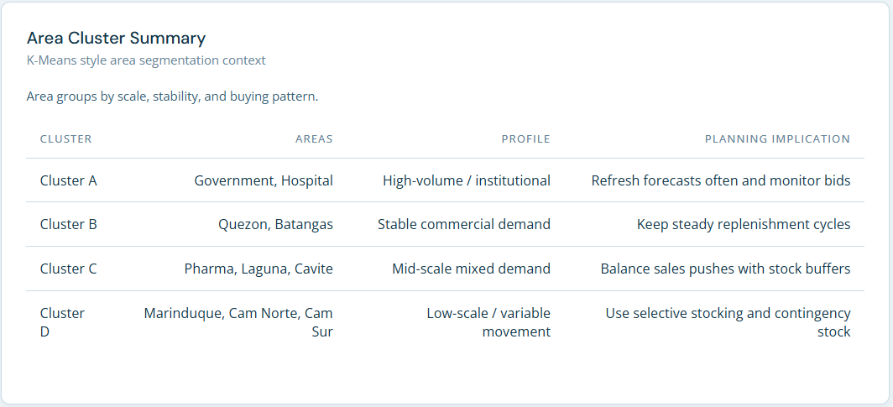Figure 3.34 Area Assignment Summary
Figure 3.34 will group areas by scale, stability, and buying pattern and includes the classification, areas, profile, and planning implementation.

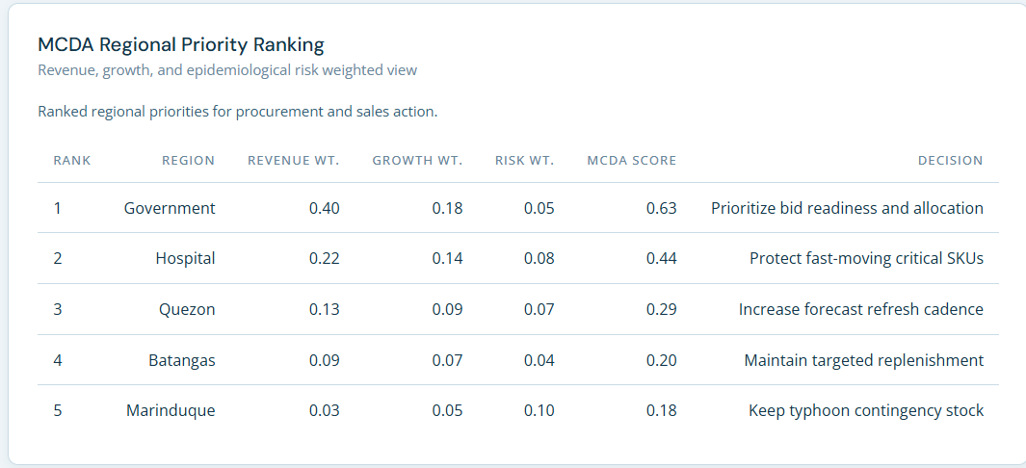Figure 3.35 Ranked regional priorities for procurement and sales action
Figure 3.35 will rank regional priorities for procurement and sales action and shows the table containing the revenue, growth, and epidemiological risk-weighted view. The table shall provide the rank of the area, region, revenue weight, growth weight, risk weight, MCDA score, and decision to do.

Figure 3.36 Page Overview of Forecast Modeling
Figure 3.36 will show the page overview of the forecast modeling page and shows the model (Facebook Prophet), the inputs, and the evaluation.

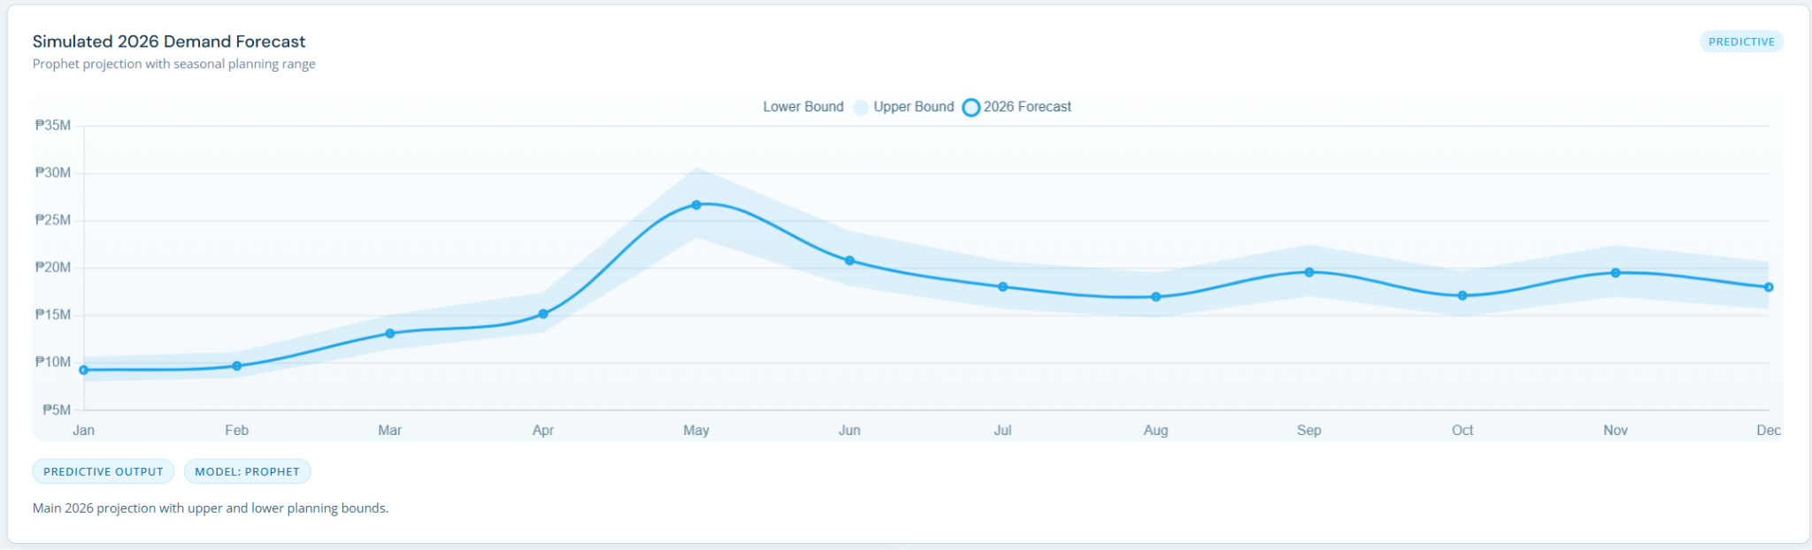Figure 3.37 Simulated 2026 Demand Forecast
Figure 3.37 will show the year-demand projection with forecast bounds, utilizing a line graph based on the historical seasonal patterns + Prophet trend projection.

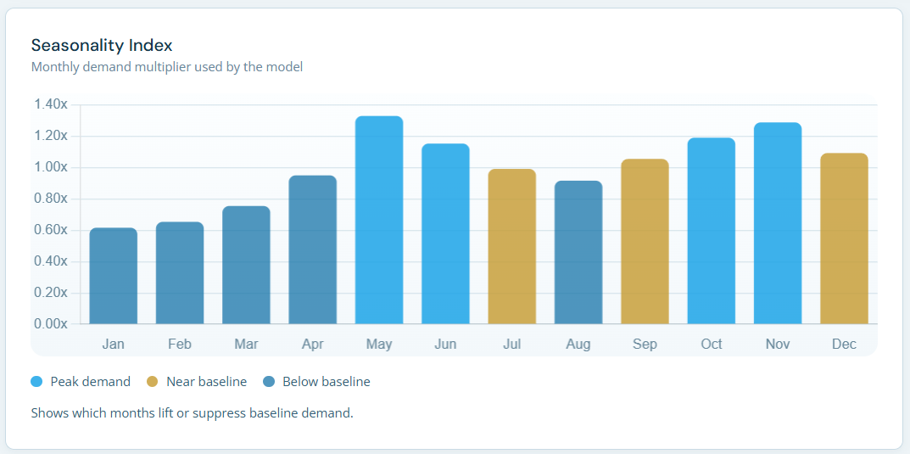Figure 3.38 Seasonality Index: Months that lift or suppress baseline demand
Figure 3.38 will show the seasonality index by each month and will describe the months that lift or suppress baseline demand.

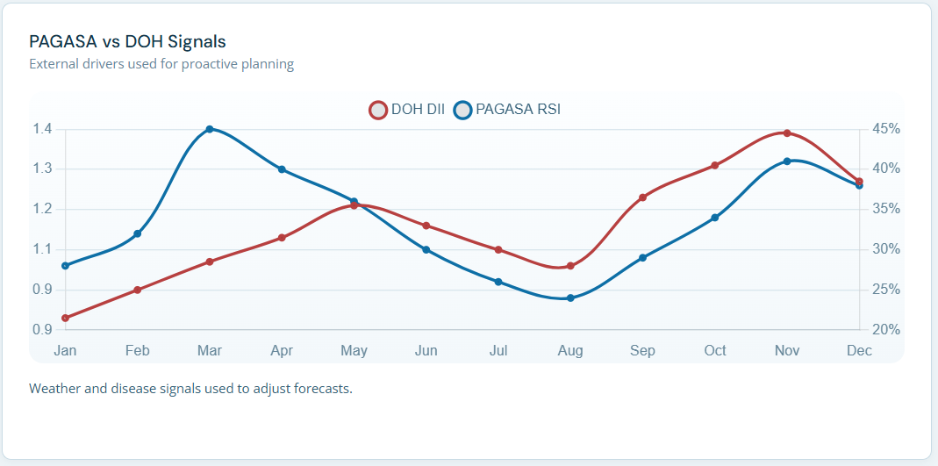Figure 3.39 External disease and weather signals used to adjust forecasts
Figure 3.39 will show the external factor signals (DOH and PAGASA) that describes the external diseases and weather signals used to adjust forecasts.

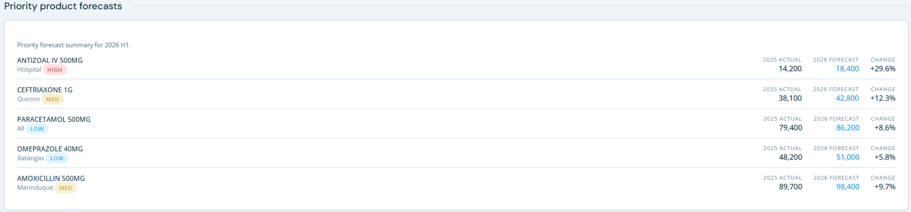

Figure 3.40 Priority Product Forecasts for the Year

Figure 3.40 will provide the forecast summary for priority products, including the product name, the area, the intensity of priority (high, medium, and low), and the actual, forecast, and change percentage for each product.

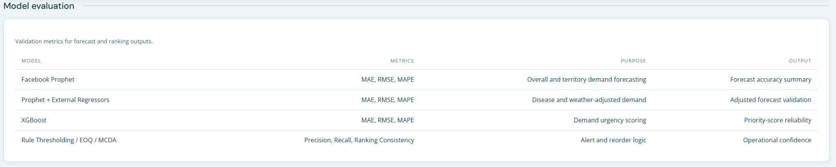

Figure 3.41 Model Evaluation Summary

Figure 3.41 will visualize the validation metrics for forecast, clustering, alerts, and ranking (the models used on each metric and functionality). the includes the model name, metrics, purpose, and output.

Figure 3.42 Page Overview of Prescriptive Planning

Figure 3.42 will show the page overview of prescriptive planning, showing the prescriptive modules, demand scoring models, and validation context that will be used in the prescriptive metrics.

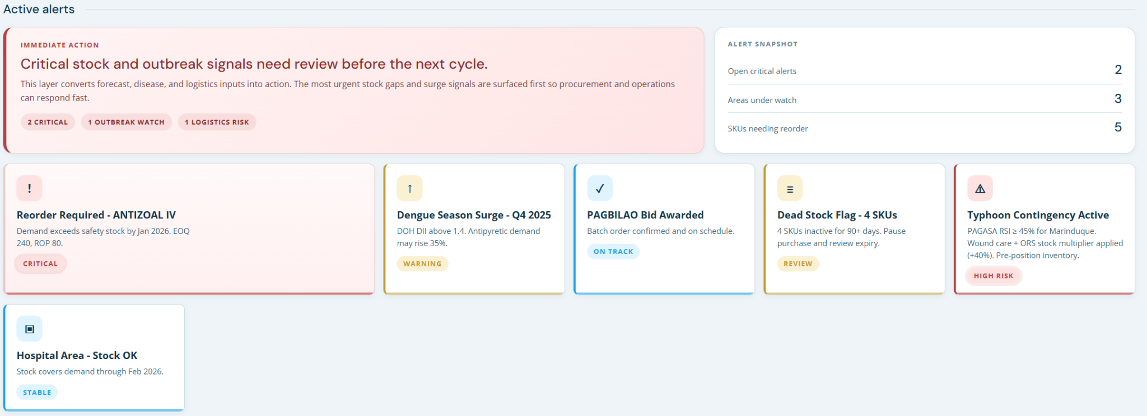Figure 3.43 Active Alerts
Figure 3.43 will show the active alerts for the prescriptive model. For example, it shows what should be reordered, the disease season surge, dead stocks, typhoon contingencies, and territorial and product metrics.

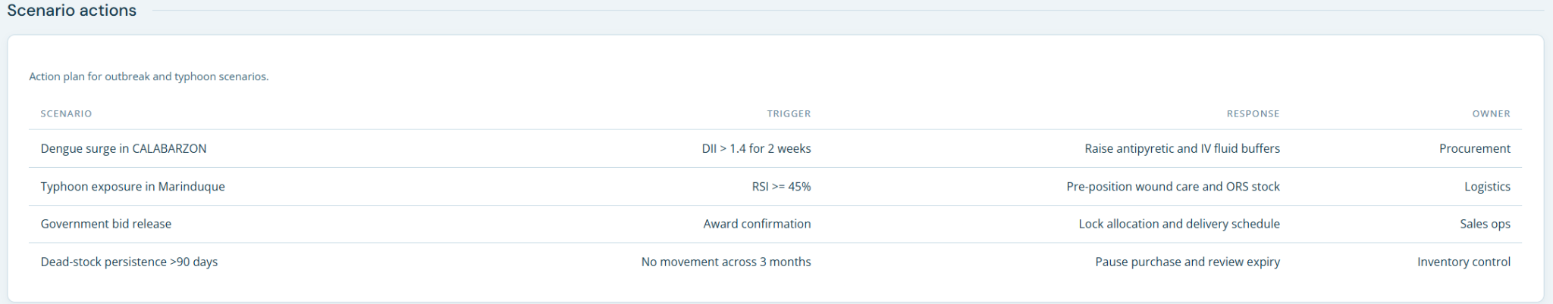Figure 3.44 Scenario-based contingency actions
Figure 3.44 will provide the action plan for outbreak and typhoon scenarios which includes the columns for scenario, trigger, response, and owner.

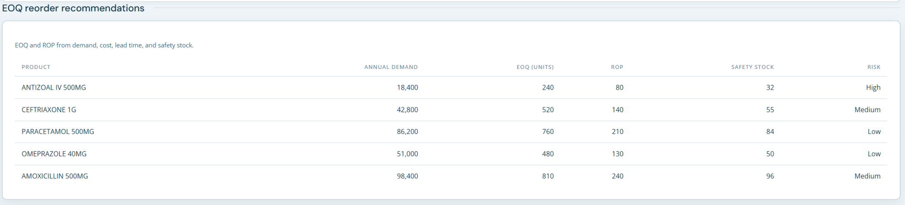Figure 3.45 EOQ Reorder Recommendation
Figure 3.45 will show the table for the EOQ and ROP based on demand, cost, lead time, and safety stock, and will include the product, annual demand score, EOQ by units, ROP, safety stock, and the intensity of the recommendation.

Figure 3.46 Page Overview of Data Upload
Figure 3.46 will show the page overview of the data upload page. the overview explains the purpose of the page, what files are accepted, and the behavior of the data upload.

Figure 3.47 Uploading Sales CSV / JSON
Figure 3.47 will show the page where to upload the sales data (CSV) or dataset (JSON).

Figure 3.48 Upload Status and Validation
Figure 3.48 will show the upload status of the uploaded file (JSON or CSV), and there’s a validation before the data goes into the analysis or insights.

Chapter 4
Results and Discussion
The chapter presents and explains the empirical results based on the development and implementation of the MedShield Pharma Corp. Decision Support System (DSS). The results were then interpreted and discussed in relation to the objectives of the study, examined in relation to the theoretical basis given, with a primary focus on the impact of the DSS results on increasing inventory stock levels and optimizing distribution directions for pharmaceutical products in peak and off-peak seasons, which included weather and disease outbreaks across the areas serviced by MedShield.

4.1 Presentation of Results
Showcase the final outputs of your project, such as system screenshots, generated reports, or processed data. Focus on "what" was achieved without yet diving into the "why."

4.2 Data Analysis
Interpret the results presented in 4.1. Discuss patterns, trends, or significant findings. Explain how the data answers your research questions or solves the identified problem.

4.3 Dashboard
The section presents the dashboard interface, which was designed and implemented for the MedShield Pharma Corp. Decision Support System (DSS), which integrates various visualizations, performance metrics, forecasts, priorities, and prescriptive actions into a single, comprehensive interface that would assist in the monitoring and decision-making process. The outputs analyzed in the DSS were aggregated into the dashboard, which then provided an integrated and convenient method to assess performance in sales, demand, inventory, and procurement.

[insert dashboard content]

4.4 Summary of Findings
Provide a concise synthesis of the most critical takeaways from the results and analysis. This should bridge the gap between your raw results and the conclusions.

Chapter 5
Conclusion and Recommendation
This chapter wraps up your project by answering the "so what?" question and proposing future steps.
This chapter presents the conclusions drawn from the development, implementation, and empirical evaluation of the MedShield Pharma Corp. Decision Support System (DSS), followed by actionable recommendations for its future application. By synthesizing the findings of the study, this chapter evaluates the extent to which the system achieved its primary objectives of improving inventory stock management and optimizing regional distribution planning. Furthermore, the insights derived from the system's performance are translated into strategic, tactical, and competitive recommendations that can support MedShield Pharma Corp. in addressing operational challenges, including seasonal weather variations and disease outbreaks. These recommendations aim to strengthen supply chain resilience and promote more effective data-driven decision-making.

5.1 Conclusions
Summarize the main points of your study. State clearly whether your project achieved its objectives and affirm the significance of your results in relation to the original problem statement.

5.2 Recommendations
Propose actionable next steps. These should be based on your findings and demonstrate how the project can be taken further.

5.2.1 For Strategic Planning
Suggest how long-term organizational or project goals can be aligned with or improved by your system.

5.2.2 For Competitive Advantage
Discuss how your solution offers a unique benefit or edge over existing methods or competitors.

5.2.3 For Tactical Decisions
Recommend specific, immediate operational changes or adjustments that users can implement using your system on a daily or short-term basis.

References
Abrigo, M. R. M., Opiniano, G. A., Tam, Z. C., Yee, S. A., & Estopace, K. M. M. (2021). Public sector procurement of medicines in the Philippines. In EconStor. Philippine Institute for Development Studies. https://hdl.handle.net/10419/256879
Amuta, M. A., Muonde, M., Mustapha, A. Y., & Mbata, A. O. (2022). A decision-support framework for allocating pharmaceutical sales territories based on epidemiological and market data. Gyanshauryam, International Scientific Refereed Research Journal, 5(5). https://gisrrj.com/paper/GISRRJ2256126.pdf
Anand, L. G. (2025). Using Machine Learning in SAP IBP for Supply Chain Optimization. In Social Science Research Network. Elsevier BV. https://doi.org/10.2139/ssrn.5240827
Attadjei, D. D., Madhwal, Y., & Panfilov, P. B. (2018). A decision phases of a supply chain management: A proposed decision support system to boost organizational decision making. International Journal of Engineering & Technology, 7(2.28), 157. https://doi.org/10.14419/ijet.v7i2.28.12901
Azevedo, A., & Santos, M. F. (2008). KDD, SEMMA, and CRISP-DM: A parallel overview. IADIS European Conference Data Mining. https://www.iadisportal.org/digital-library/kdd-semma-and-crisp-dm-a-parallel-overview
Bacani, N. D., Balitustus, D. D. C., Porcalla, C. S., Sison, A. A. R. C., Guialil, J. S., & Centeno, C. J. (2024). BOTika: A pharmaceutical management system using seasonal autoregressive integrated moving average (SARIMA) and clustering algorithm. International Conference on Innovative Computing, Intelligent Communication and Smart Electrical Systems, 1–9. https://doi.org/10.1109/icses63760.2024.10910563
Ball, D., & Salenga, R. (2017). Pharmaceutical policy in the Philippines. In Z. U. D. Babar (Ed.), Pharmaceutical policy in countries with developing healthcare systems. Adis. https://doi.org/10.1007/978-3-319-51673-8_4
Belghith, M., Ben Ammar, H., Elloumi, A., & Hachicha, W. (2023). A new rolling forecasting
framework using Microsoft Power BI for data visualization: A case study in a
pharmaceutical industry. Annales Pharmaceutiques Françaises.
Bejarano, A., Nadungodage, C. H., Wang, F., Catlin, A. C., & Hoag, S. W. (2019). Decision support for excipient risk assessment in pharmaceutical manufacturing. AAPS PharmSciTech, 20(6), 223. https://doi.org/10.1208/s12249-019-1440-x
Bello, S. S., Benjamin, U. I., & Ejiako, M. O. (2026). Development of a decision support system for inventory management in a pharmaceutical retail outlet. World Scientific News, 211(2026). https://worldscientificnews.com/wp-content/uploads/2026/01/WSN-211-2026-108-116.pdf
Board of Investments. (2025, September 22). BOI highlights implementation of PH Pharma Industry Roadmap at PCPI's 2nd GMM 2025. https://boi.gov.ph/boi-highlights-implementation-of-ph-pharma-industry-roadmap-at-pcpis-2nd-gmm-2025/
Bolikulov, F., Nasimov, R., Rashidov, A., Akhmedov, F., & Cho, Y.-I. (2024). Effective methods of categorical data encoding for artificial intelligence algorithms. Mathematics, 12(16), 2553. https://doi.org/10.3390/math12162553
Box, G. E. P., & Jenkins, G. M. (1970). Time series analysis: Forecasting and control. Holden-Day. https://www.wiley.com/en-us/Time+Series+Analysis%3A+Forecasting+and+Control%2C+5th+Edition-p-9781118675021
Burinskiene, A. (2022). Forecasting models for pharmaceutical retail. Frontiers in Medicine, 9, 582186. https://doi.org/10.3389/fmed.2022.582186
Candeias, L. D. A. (2024). Pharmaceutical Sales Representatives’ Performance and Impact on Revenue - Using a Data Mining Approach. Handle.net. http://hdl.handle.net/10362/164187
Chango, W., Salguero, A., Landivar, T., Vásconez, R., Silva, G., Peñafiel-Arcos, P., Núñez, L., & Velasteguí-Izurieta, H. (2025). SARIMA vs. Prophet: Comparative efficacy in forecasting traffic accidents across Ecuadorian provinces. Computation, 14(1), 5. https://doi.org/10.3390/computation14010005
Chapman, P., Clinton, J., Kerber, R., Khabaza, T., Reinartz, T., Shearer, C., & Wirth, R. (2000). CRISP-DM 1.0: step-by-step data mining guide. SPSS. https://www.kde.cs.uni-kassel.de/wp-content/uploads/lehre/ws2012-13/kdd/files/CRISPWP-0800.pdf
Chen, T., & Guestrin, C. (2016). XGBoost: A Scalable Tree Boosting System. ArXiv (Cornell
University). https://doi.org/10.48550/arxiv.1603.02754
Cleveland, R. B., Cleveland, W. S., McRae, J. E., & Terpenning, I. (1990). STL: A seasonal-trend decomposition procedure based on Loess. Journal of Official Statistics, 6(1), 3–73. https://www.stats.govt.nz/assets/Uploads/Methods/Documents/3-1-cleveland-et-al-STL.pdf
Davis, J., & Goadrich, M. (2006). The relationship between precision-recall and ROC curves. Proceedings of the 23rd International Conference on Machine Learning, 233–240. https://doi.org/10.1145/1143844.1143874
Dela Cruz, J., Gengania, R. K., Nacar, C. R., & Rusiana, F. (2025). Data-driven approach in forecasting of medical supply shortages and overstock: A case study of SLU-Sacred Heart Medical Center (SLU-SHMC). Journal of Global Business, 14(2). https://atiftap.org/s/JGB-19216.pdf
Dong, G., & Liu, H. (Eds.). (2018). Feature engineering for machine learning and data analytics. CRC Press. https://doi.org/10.1201/9781315181080
Dy-Liacco, C. M. M., Magsajo, T. D. C., Say, K. S., Go, C. K. C., Uy, J., & Antonio, V. A. A. (2024). Modeling pooled procurement of Philippine Department of Health drugs and medicines using OLS regression. AIP Conference Proceedings, 3132(30002). https://doi.org/10.1063/5.0213405
Fahad, A., & Kollwitz, E. (2025). The digital transformation of sales: Examining the role of technology adoption in sales enablement. https://doi.org/10.13140/rg.2.2.11555.36640
Fattah, J., Ezzine, L., Aman, Z., El Moussami, H., & Lachhab, A. (2018). Forecasting of demand using ARIMA model. International Journal of Engineering Business Management, 10. https://doi.org/10.1177/1847979018808673
Federal Democratic Republic of Ethiopia, Ministry of Health. (2015). Health sector transformation plan (HSTP) 2015/16–2019/20. Federal Democratic Republic of Ethiopia, Ministry of Health. https://www.issup.net/knowledge-share/resources/2021-05/health-sector-transformation-plan-201516-201920
Fernando, J. G., & Baldelovar, M. (2022). Decision support system: Overview, different types, and elements. Technoarete Transactions on Intelligent Data Mining and Knowledge Discovery, 2(2). https://doi.org/10.36647/ttidmkd/02.02.a003
Firas, O. (2023). A combination of SEMMA & CRISP-DM models for effectively handling big data using formal concept analysis based knowledge discovery: A data mining approach. World Journal of Advanced Engineering Technology and Sciences, 8(1), 009-014. https://doi.org/10.30574/wjaets.2023.8.1.0147
Flores, B. E., & Whybark, D. C. (1986). Multiple criteria ABC analysis. International Journal of Operations & Production Management, 6(3), 38–46. https://doi.org/10.1108/eb054719
Guadie, M., Asemahagn, M. A., Tefera, A., Melkam, W., Habteweld, H. A., & Derebe, D. (2023). Medicines wastage and its contributing factors in public health facilities of South Gondar Zone, Amhara Regional State, Ethiopia. Integrated Pharmacy Research and Practice, Volume 12(12), 157–170. https://doi.org/10.2147/iprp.s415375
Giebel, G. D., Raszke, P., Nowak, H., Palmowski, L., Adamzik, M., Heinz, P., Tokic, M., Timmesfeld, N., Brunkhorst, F., Wasem, J., & Blase, N. (2024). Problems and barriers related to the use of AI-based clinical decision support systems: Interview study. Journal of Medical Internet Research, 27, e63377. https://doi.org/10.2196/63377
Halim, I., Ang, P., & Adhitya, A. (2019). A decision support framework and system for design of sustainable pharmaceutical supply chain network. Clean Technologies and Environmental Policy, 21(2), 431–446. https://doi.org/10.1007/s10098-018-1646-8
Harris, F. W. (1913). How many parts to make at once. Operations Research, 38(6), 947–950. https://doi.org/10.1287/opre.38.6.947
İmece, S., & Beyca, Ö. F. (2022). Demand forecasting with integration of time series and regression models in pharmaceutical industry. International Journal of Advances in Engineering and Pure Sciences, 34(3), 415–425. https://doi.org/10.7240/jeps.1127844
Juran, J. M. (1954). Universals in management planning and controlling. The Management Review, 43(11), 748–761.
Juran, J. M. (1975). The non-Pareto principle; mea culpa. Quality Progress, 8(5), 8–9. https://www.juran.com/wp-content/uploads/2021/03/The-Non-Pareto-Principle-1974.pdf
Holt, C. C. (2004). Forecasting seasonals and trends by exponentially weighted moving averages. International Journal of Forecasting, 20(1), 5–10. https://doi.org/10.1016/j.ijforecast.2003.09.015 (Original work published 1957)
Hyndman, R. J., & Athanasopoulos, G. (2021). Forecasting: Principles and Practice (3rd ed.). OTexts. https://otexts.com/fpp3/
Kimball, R., & Ross, M. (2013). The data warehouse toolkit: The definitive guide to dimensional modeling (3rd ed.). John Wiley & Sons, Inc. https://www.wiley.com/en-us/The+Data+Warehouse+Toolkit%3A+The+Definitive+Guide+to+Dimensional+Modeling%2C+3rd+Edition-p-9781118530801
Kwarteng, S., & Andreevich, P. A. (2024). Comparative analysis of ARIMA, SARIMA and Prophet model in forecasting. Research & Development, 5(4), 110–120. https://doi.org/10.11648/j.rd.20240504.13
Lepenioti, K., Bousdekis, A., Apostolou, D., & Mentzas, G. (2019). Prescriptive analytics: Literature review and research challenges. International Journal of Information Management, 50, 57–70. https://doi.org/10.1016/j.ijinfomgt.2019.04.00
Martinez, M. E. (2018). The calendar of epidemics: Seasonal cycles of infectious diseases. PLOS Pathogens, 14(11), e1007327. https://doi.org/10.1371/journal.ppat.1007327
Maulana, K. R., Widiyono, W., & Darmawan, A. S. (2025). Predicting tablet drug expenditures using Python-based Facebook Prophet in pharmaceutical installations. Jurnal Teknologi Dan Open Source, 8(2), 709–721. https://doi.org/10.36378/jtos.v8i2.4907
Mohamed, G. (2025). Comparative analysis of AI-driven decision support system and traditional spreadsheets: Evaluating accuracy and consistency in business intelligence. Journal of Science and Technology, 30(4), 80–89. https://doi.org/10.20428/jst.v30i4.2765
Ng, W. L. (2007). A simple classifier for multiple criteria ABC analysis. European Journal of Operational Research, 177(1), 344–353. https://doi.org/10.1016/j.ejor.2005.11.018
Nguyen, A., Lamouri, S., Pellerin, R., Tamayo, S., & Lekens, B. (2021). Data analytics in pharmaceutical supply chains: State of the art, opportunities, and challenges. International Journal of Production Research, 60(22), 6888–6907. https://doi.org/10.1080/00207543.2021.1950937
Oguntiloye, D. (2025). Data Analytics and Visualization Dashboard for Supply Chain and Procurement as a Performance Assessment Tool. International Journal of Innovative Science and Research Technology, 10(8), 1539–1555. https://doi.org/10.38124/ijisrt/25aug975
Palacios, H. J. G., Toledo, R. A. J., Pantoja, G. A. H., & Navarro, Á. A. M. (2017). A comparative between CRISP-DM and SEMMA through the construction of a MODIS repository for studies of land use and cover change. Advances in Science, Technology and Engineering Systems Journal, 2(3), 598–604. https://doi.org/10.25046/aj020376
Patoulia, A. A., Kiourtis, A., Mavrogiorgou, A., & Kyriazis, D. (2022). A comparative study of collaborative filtering in product recommendation. Emerging Science Journal, 7(1), 1–15. https://doi.org/10.28991/esj-2023-07-01-01
Primo, R. C., & Mariano, V. Y. (2025). AFProTrack: A longitudinal training trajectory management system for army personnel using multi-platform technologies. IEEE Symposium on Wireless Technology & Applications, 1–6. https://doi.org/10.1109/iswta68114.2025.11329565
Puruhito, M. A., & Falani, A. Z. (2021). Decision support system for developing application for pharmaceutical supplies using the MMSL and Pareto Law methods. International Journal of Electrical Engineering and Information Technology, 4(1), 12–22. https://doi.org/10.29138/ijeeit.v4i1.1329
Ramanathan, R. (2006). ABC inventory classification with multiple-criteria using weighted linear optimization. Computers & Operations Research, 33(3), 695–700. https://doi.org/10.1016/j.cor.2004.07.014
Rekabi, S., Sazvar, Z., & Shakibaei, H. (2025). Designing a sustainable-resilient pharmaceutical supply chain network using a machine learning-based approach. OPSEARCH. https://doi.org/10.1007/s12597-025-00954-6
Sari, I. U., & Yilmaz, Y. U. (2025). A decision support system for developing marketing strategy in pharmaceutical industry. International Symposium on Innovative Approaches in Smart Technologies, 1–6. https://doi.org/10.1109/isas66241.2025.11101819
SAS Institute Inc. (2025). SAS Enterprise Miner 15.4: Reference help. sas.com
Schröer, C., Kruse, F., & Gómez, J. M. (2021). A systematic literature review on applying CRISP-DM process model. Procedia Computer Science, 181(1), 526–534. https://doi.org/10.1016/j.procs.2021.01.199
Shimaoka, A. M., Ferreira, R. C., & Goldman, A. (2023). The evolution of CRISP-DM for Data Science: Methods, processes and frameworks. SBC Reviews on Computer Science, 1(1). https://doi.org/10.13140/RG.2.2.22493.42721
Shang, J., Tadikamalla, P. R., Kirsch, L. J., & Brown, L. (2008). A decision support system for managing inventory at GlaxoSmithKline. European Journal of Operational Research, 190(1), 222–235. https://doi.org/10.1016/j.ejor.2007.06.015
Silveira, R. F., Lima, A. L., Gross, I. P., Gelfuso, G. M., Gratieri, T., & Cunha-Filho, M. (2024). The role of artificial intelligence and data science in nanoparticles development: a review. Nanomedicine, 19(14), 1271–1283. https://doi.org/10.1080/17435889.2024.2359355
Sokolova, M., & Lapalme, G. (2009). A Systematic Analysis of Performance Measures for Classification Tasks. Information Processing & Management, 45(4), 427–437. https://doi.org/10.1016/j.ipm.2009.03.002
Sun, Z. (2024). Data Analytics for Business Intelligence. CRC Press. https://lccn.loc.gov/202402956
Taylor, S. J., & Letham, B. (2018). Forecasting at Scale. The American Statistician, 72(1), 37–45.
https://doi.org/10.1080/00031305.2017.1380080
Tiongson, J. H. V., & Kummer, M. G. C. (2020). Rural health unit decision support system with mapping. International Journal of Recent Technology and Engineering, 9(3), 611–616. https://doi.org/10.35940/ijrte.c4681.099320
Umadevi, G., & Umamaheswari, S. (2023). Advancing healthcare service efficacy by optimizing pharmaceutical inventory management: Leveraging ABC, VED analysis for trend demand. International Journal of Statistics in Medical Research, 12, 283–293. https://doi.org/10.6000/1929-6029.2023.12.33
Williams, S. J. (2024). Supply Chain Management. Cambridge University Press. http://www.cambridge.org/9781009325288
Winters, P. R. (1960). Forecasting sales by exponentially weighted moving averages. Management Science, 6(3), 324–342. https://doi.org/10.1287/mnsc.6.3.324
Wolny, M., & Kmiecik, M. (2024). Unveiling Patterns in Forecasting Errors: A Case Study of 3PL Logistics in Pharmaceutical and Appliance Sectors. Sustainability, 17(1), 214–214. https://doi.org/10.3390/su17010214
Woosley, J. M., Wiley-Patton, S., Kelle, P., & Schneider, H. (2009). Decision support in healthcare supply chain management and pharmaceutical inventory control. AMCIS 2009 Proceedings, 522. https://aisel.aisnet.org/amcis2009/522
World Health Organization. (2024). Digital transformation handbook for health supply chain architecture. https://www.who.int/publications/i/item/9789240101197

